**PHOTOCATALYTIC ACTIVITY OF LAYERED PEROVSKITE-LIKE OXIDE H2La2Ti3O10 INTERCALATED WITH *n*-OCTYLAMINE**

Davydov N. A. *1*, Rodionov I. A. *1*

*1Saint Petersburg State University, Russia;*

*nikita.davidov02@yandex.ru*

Perovskite-like layered oxides are compounds with a specific structure composed of alternating blocks with perovskite structure (layers) and blocks with a different structure (interlayer). In such structures the interlayer cations typically can be replaced by other cations (ion-exchange reactions) and also introduction of guest molecules into the interlayer space (intercalation) is possible. Perovskite-like layered oxides are known as efficient and promising photocatalysts for hydrogen production from water or organic compounds. Our recent studies showed, that the intercalation of organic amines into the interlayer space of some layered oxides leads to a dramatic increase in photocatalytic activity [1,2]. In this work we use the platinized *n*-OcNH2-intercalated layered titanate H2La2Ti3O10 as a photocatalyst and investigate the dependence of hydrogen production rate on the methanol content in the water-methanol mixture under UV-light.

Initially the titanate was obtained in its alkaline form K2La2Ti3O10 by conventional solid-state synthesis. The protonated form H2La2Ti3O10 was obtained from K2La2Ti3O10 by treatment with hydrochloric acid. Then the two-step intercalation was accomplished: at the first step methylamine was introduced into the interlayered space and then it was substituted by *n*‑octylamine. Platinum nanoparticles were loaded on the obtained sample by irradiating its suspension in 1% methanol aqueous solution containing H2PtCl6 with UV-light.

Photocatalytic activity was measured by irradiating the suspensions of obtained sample in water-methanol mixture with alcohol content varying from 0 to 90 mol.% with UV-light in a special designed reaction cell attached to a gas circulation system. The amount of evolved hydrogen was determined every 5 min by gas chromatography. The final dependence of the reaction rate on the alcohol content is shown on Fig. 1. It can be satisfactorily approximated by a Langmuir – Hinshelwood type equation and reaches saturation at ca. 10 mol.%.

Additionally, we discussed the meaning and applicability of the term «reaction order» concerning our system. A theoretical study was carried out to link the reaction order with the partial molar reaction rates in a concentrated solution. Finally, we applied the derived equations to our experimental data and calculated a 3D-surface that displays the dependence between reaction orders with respect to water and methanol and the composition of the solution.

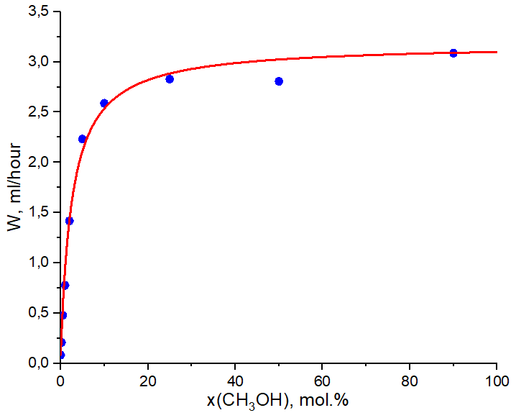

|  |
| --- |
|  |
| **Figure 1.** Dependence between hydrogen evolution rate and methanol content . |

[1] S. Kurnosenko, V. Voytovich and O. Silyukov, *Catalysts*, 2021, 11, 1278.

[2] I. Rodionov, E. Maksimova and A. Pozhidaev, *Frontiers in Chemistry*, 2019, 7, 1.

This work was supported by the Russian Science Foundation (project №19-13-00184).

Authors are grateful to Saint Petersburg State University Research Park: Center for X-ray Diffraction Studies, Center for Thermal Analysis and Calorimetry, Center for Chemical Analysis and Materials Research