**Searching for new SPAAC reagents based on heterocyclononynes fused to heterocycles.**

Aleksandra Vidiakina

Saint Petersburg State University / Karlsruhe Institute of Technology

G-RISC Project number: **L-2021b-2_d,** funding period: 02.08.2021 – 04.09.2021, Principal Investigator – Vidiakina Aleksandra

**Summary.**

Currently, there are different approaches for introducing fluorescent labels into living organisms. One approach is to carry out click reactions between an azido-modified biomolecule and a fluorescent and strained cycloalkyne. The reaction proceeds independently of the presence of other functional groups, with a high yield, rather quickly and under mild conditions. The problem lies in the small number of available cycloalkynes for click reactions. Therefore, this work is devoted to the development of new cycloalkynes that are sufficiently stable, but at the same time active for conducting click reactions in living organisms and subsequent visualization of cells. During the project, a general synthetic route for cycloalkynes was developed. This synthetic approach allows for variations in the natures of both the heterocycle and heteroatom to reach the optimal stability/reactivity balance for these new strained systems. Three new cycloalkynes active in click reactions were synthesized, the applicability of heterocyclononynes for in vitro bioconjugation was exemplified by labeling and visualization of HeLa cancer cells isocoumarin-fused azacyclononyne **IC9N-BDP-FL**.

1. **Introduction**

Bioconjucation is a chemical strategy to form a stable covalent bond between two molecules, at least one of which is a biomolecule (lipids, proteins or carbohydrates). To perform bioconjugation in living organisms bioorthogonal click reactions are used. [1,2] Nowadays, click chemistry and, in particular bioorthogonal reactions, is a newly and rapidly developing field of chemistry that is widely used in biomedicine. [3]

For example, one of the orthogonal reaction is Cu(I)-catalyzed azide-alkyne cycloaddition (CuAAC), [4,5] has been widely utilized for fluorescent labeling and subsequent biovisualisation of specific biomolecules (such as proteins, DNA, nucleic acids) in cancer cells and complex tissues. [6] However, utilization of Cu(I) eliminates the possibility of using this orthogonal reactionin living systems, because of the high toxicity of copper(I). Due to this reason, further studies have been focusing on using not toxic reagents for bioconjucation.

The alternative strategy in absence of toxic metal catalyst is strain-promoted azide-alkyne ycloaddition (SPAAC). [7,8] This new type of click-reaction, i.e. the interaction of strained alkynes with organic azides resulting in 1,2,3-triazoles, could be proceeded in living systems without affecting their natural metabolism, and without being exposed to external influences: cycloalkynes chemoselectively interact only with azide functional groups. At the same time, an azide group is not represented originally in living systems, but it can be easily introduced into biomolecules by metabolic labeling.

The possibility of bioimaging cells, in particular cancerous tumors, is extremely essential for the early diagnosis of diseases. Therefore, the development of new reagents for bioconjugation in living organisms is an urgent problem. Our project was aimed to develop new SPAAC reagents and to demonstrate the applicability of newly developed cyclononynes as efficient SPAAC reagents for bioconjugation in cells. Oxo- and azacyclononynes fused toisocoumarin and benzothiophene fragments were chosen as our target molecules (Figure 1.)

*Fig. 1. Structure of target cycloalkyne molecules.*

1. **Methods**

This project has been divided into 2 main parts.

The first part consisted in the synthesis of target structures from the starting compounds. Our proposed approach to the synthesis of targeted structure combines electrophile-promoted cyclization [9] with the Sonogashira coupling [10] for the construction of a heterocycle and the introduction of essential functional groups for the further key step − the Nicholas reaction [11] aimed at closing a medium-sized strained alkyne ring, subseqent decomplecsation allows to obtain target strusture − cyclononyne. It is notable that the proposed approach could serve as a general synthetic route towards cycloalkynes with a different heteroatom (X) and ring size and fused to various heterocycles (Y) (Scheme 1). By following this method, both BT9N-NH2, IC9NH and IC9O-COOMe were synthesized without any difficulties and in high overall yields (Scheme 1).



*Scheme 1. The general retrosynthetic route towards heterocyclononynes-cobalt complexes fused to a heterocycle; synthetic target structures* ***BT9N-NH2, IC9NH, IC9O-COOMe*** *are placed in a frame.*

Further modifications of BT9N-NH2 and IC9NH were carried out using commercially available dyes.

Purification of substances at each stage was carried out using column chromatography. The structures of the substances were confirmed using nuclear magnetic resonance spectra (NMR 1H, 13C, DEPT) in deuterated solvents, as well as using electrospray ionization mass spectrometry (ESI MS). For the substance IC9O-COOMe, the structure was also confirmed using X-ray diffraction analysis. For the substance IC9O-COOMe, the opticalproperties were investigated, namely, the absorption, excitation and emission spectra were recorded on a spectrophotometer and spectrofluorimeter.

The second part consisted in the study of the biological properties of the obtained compounds on HeLa cancer cells using confocal fluorescent microscopy.

1. **Results and Discussion**
   1. First part of the project (synthetic).

*3.1.1 Results for IC9O-COOMe.*

The synthesis was carried out according to the scheme presented below (Scheme 2). The yields and reaction conditions are shown in the scheme 2. The overall yield was 7%, which is quite good for such a strained and complicated structure.



*Scheme 2. Synthesis of IC9O-COOMe*

Subsequently, we planned to carry out the hydrolysis of the ester group for further modification with a commercially available dye. Unfortunately, however, the stage of hydrolysis using LiOH / H2O turned out to be impossible. First we tried it with IC9O-COOMe. Despite the fact, that these conditions have been successfully applied for other cycloalkynes [12] (e.g. COMBO) in our case we saw just many fuzzy spots in TLC and it was not possible to register a desired product. Unfortunately the same situation was observed for the esters from previous steps 4-8, which most likely indicates the decomposition of isocoumaring ring.



*Scheme 3. Planned modification of IC9O-COOMe with dye.*

Then we turned to the alternative possibility, namely, using of IC9O-COOMe itself without any modifications due to its own fluorescent properties.

Compounds of the synthetic sequence starting with substance number 4 exhibit fluorescence. IC9O-COOMe also have visible fluorescence, when irradiated with light with a wavelength of 365 nm. If the triazole retains fluorescence, then modification via the ester groupe with a dye may not be necessary. Therefore, we decided to carry out the cycloaddition with the cycloalkyne bearing unmodified ester group. The reaction of cycloalkyne IC9O-COOMe with benzyl azide proceeded in quantitative yield with the formation of regioisomeric triazoles in a 4:1ratio with the predominant formation of the 1,4-isomer. The second-order constants of the formation of 1,4- and 1,5-triazoles were calculated by NMR in acetonintrile-d3.



*Scheme 4. Click reaction of IC9O-COOMe with BnN3 forming fluorescent regioisomeric triazoles.*

Triazoles also display visible fluorescence under excitation at 365 nm. Therefore, we investigated the fluorescent properties of the starting alkyne and the major product - 1,4-triazole in aqueous solutions in the presence of 1% DMSO. It was shown that both compounds have a moderate ability to fluorescence when irradiated with light with a wavelength of 340 and 360 nm, respectively. For cycloalkyne, the maximum luminescence density falls on a wavelength of 432 nm, and for 1,4-triazole - 490 nm. (Graph 1.)

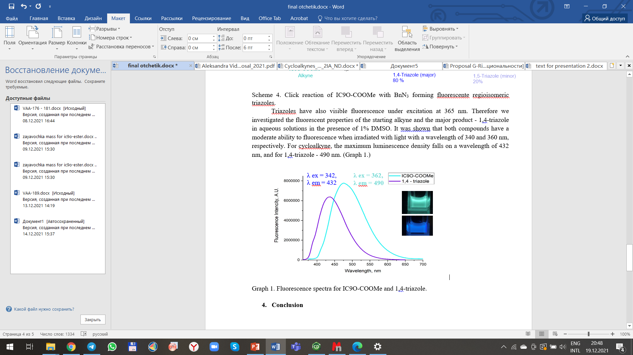

*Graph 1. Fluorescence spectra for IC9O-COOMe and 1,4-triazole.*

Quantum yield for IC9O-COOMe and 1,4 triazole in H2O / 1%DMSO is 4%.

Livetimes of IC9O-COOMe and 1,4-triazole in different mixture of solvents (1% DMSO / H2O, THF,Acetonitrile, DCM) were measured. The longest lifetimes are observed in 1% DMSO / H2O and correspond 2.2 ns and 2 ns for IC9O-COOMe and 1,4-triazole respectively. (Table 1.)

|  |  |  |
| --- | --- | --- |
| **Substance** | **Solvent** | **Lifetime (ns)** |
| **IC9O-COOMe** | DMSO/H2O | 2.2 |
| DMSO/THF | 0.8 |
| DMSO/Acetonitrile | 1.1 |
| DMSO/DCM | 0.7 |
| **1,4 - triazole** | DMSO/H2O | 2 |
| DMSO/THF | 0.6 |
| DMSO/Acetonitrile | 0.7 |
| DMSO/DCM | 0.7 |

*Table 1. Lifetimes for IC9O-COOMe and 1,4-triazole in different solvents, ns.*

* + 1. *Results for BT9N-NH2*

BT9N-NH2 was synthesized according to the following Scheme 5.



*Scheme 5. Synthesis of BT9N-NH2*

The proposed synthetic approach, as well as for the previous cycloalkyne(IC9O-COOMe), is based on 3 main reactions: the Sonogashira cross-coupling reaction [9], iodine-promoted cyclization [10] and Nicholas cyclization [11], which allows to close the 9-membered cycle.

At the stage of formation of the Co-complex during column chromatography on silica gel, two products were formed, a product with a nitro group (15), and also a product came from the reduction of the nitro group to an amino group (16). For our purposes, we just needed the reduced amino group, so the Nicholas cyclization was carried out for substrate 16.

Reduction from the nitro group into amino group has been worked out with Fe + NH4Cl too giving compound 16 in moderated yield.

To our surprise, further modification of the amino group in the target cycloalkyne BT9N-NH2 molecule turned out to be a rather difficult task. Despite the large number of references in the literature for modifying the amino group [13-16], not a single acylating agent worked in our case. The following Scheme 6 shows all the acylating agents we tested to carry out the reaction. The reagents are arranged in increased order of their acylating ability.



*Scheme 6. Approaches to modifying the amino-group in BT9N-NH2.*

Currently, we are still looking for an approach to modify this amino group.

* + 1. *Results for IC9NH*

This cycloalkyne was synthesized by the same method as IC9O-COOMe, with the difference that the nitrogen atom, not oxygen, acted as the nucleoifile in the Nicholas cyclization.

We were lucky enough, since the modification of this compound was easier than for the previous cycloalkynes, the reaction with a commercially available dye proceeded in a good yield, without any difficulties, which allowed us to modify this cycloalkyne with a dye. (Scheme 7.)



*Scheme 7. Modification of IC9NH with commercially available dye – BDP-650-665-x-NHS-ester.*

3.2 Second part of the project (biology).

*3.2.1 Results for IC9O-COOMe.*

To test whether own fluorescence of IC9O-COOMe is sufficient for labeling cancer cells, we decided to carry out confocal fluorescent microscopy with IC9O-COOMe on cancer HeLa cells.

However, it turned out that the own fluorescence of the IC9O-COOMe is insufficient, even at the maximum allowable concentration. The problem of low fluorescence could be changed by increasing the laser power, but the autofluorescence of the cells is in the same wavelength range as the fluorescence of our substance. Figure 2 shows images obtained after incubation of cancer HeLa cells with IC9O-COOMe.



*Fig. 2. Confocal microscopy of cancer HeLa cells after incubation with IC9O-COOMe*.

From the above studies, it follows that the own fluorescence of cycloalkyne IC9O-COOMe is insufficient. Therefore, we plan to try to carry out enzymatic hydrolysis of the ester group for subsequent possible modification with a dye.

*3.2.3 Results for IC9NH.*

To analyze the ability of of **IC9N-BDP-650** to penetrate cells and be detectable by confocal mycroscopy, we turned to cellular fluorescence staining of HeLa cells with **IC9N-BDP-650**. We were lucky to detect a fluorescent signal in our experiment with an optimal signal acquired after 8 h of incubation with 1 µM **IC9N-BDP-650**. As expected, due to the lipophilic nature of **IC9N-BDP-650,** we observed that **IC9N-BDP-650** enters the cells that gives a strong intracellular signal (Figure 3).



*Fig. 3. HeLa cells with* ***IC9N-BDP-FL***

It was also demonstrated that **IC9N-BDP-650** is non-toxic to cells cultured for up to 12 h, which is sufficient to complete the SPAAC reaction in living cells. Further experiments with metabolically labeled cells by azido-group are ongoing.

1. **Conclusion**

In conclusion, I would like to stressed out that, due to our collaboration with KIT we manage to synthesize three cycloalkynes: IC9O-COOMe, BT9N-NH2, and IC9N-BDP-650.

For IC9NH we selected the optimal modification with a dye and showed the applicability of this cycloalkyne IC9N-BDP-FL in cancer HeLa cells.

For IC9O-COOMe we understood that its own fluorescence is not enough to use it as a new SPAAC reagent. So in future we plan to try enzymatic hydrolysis for possible modification of the ester group via the formation of carboxylic group with amino-dye, or even change synthetic method and introduce another functional group, for which hydrolysis will not be needed at the stage of modification (e.g. OH group).

For BT9N-NH2, the entire synthetic route for obtaining this cycloalkyne was worked out. However, we were unable to test the biological properties due to the surprising chemical inertness of the amino group. Further research on its synthetic modification are ongoing.

1. **References**

[1] Sletten, E. M., & Bertozzi, C. R. Angew. Chem. Int. Ed., **48**(38), 6974, (2009).

[2] Becer, C. R., Hoogenboom, R., & Schubert, U. S. Angew. Chem. Int. Ed., **48**(27), 4900, (2009).

[3] Astakhova, K., Ray, R., et all. Mol. Pharmaceutics, **15**(8), 2892, (2018).

[4] Fokin, V. V., & Sharpless et all. K. B. Angew. Chem. Int. Ed., **41**(14), 2596, (2002).

[5] Tornøe, C. W., Christensen, C., & Meldal, M. JACS, **67**(9), 3057, (2002).

[6] Thirumurugan, P., Matosiuk, D., & Jozwiak, K. Chem. Rev., **113**(7), 4905, (2013).

[7] Jewett, J. C., & Bertozzi, C. R. Chem. Soc. Rev., **39**(4), 1272, (2010).

[8] Agard, N. J., Prescher, J. A., & Bertozzi, C. R. JACS, **126**(46), 15046, (2004).

[9] Aggarwal, T., Kumar, S., Verma, A. K. Org. Biomol. Chem., **14**, 7639, (2016).

[10] Kanwal, I., Mujahid, A. et all. Catalysts. 10, 443, (2020).

[11] Teobald, B. J. Tetrahedron *58*, 4133, (2002).

[12] B. R. Varga et all., Chem. Eur. J., **18**, 822, (2012).

[13] Cecchi A., et all., J. Med. Chem., **48**, 4834, (2005).

[14] Wang Z., et all., J. Agric. Food Chem., **55**, 6871, (2007).

[15] Gobbo P., Synlett.. **26**(09), 1169, (2015).

[16] Maslov M., et all. Bioorg. Med. Chem. Lett, **21**(10), 2937 (2011).

**Personal Impressions**

My personal impression of the G-RISC project is positive. It seems to me that collaborations between Russian and German universities open up more opportunities for various types of scientific activities. For me, as a student, it was a unique opportunity to work with biologists to study the bio-medical properties of the substances I created. This internship allowed me to find new acquaintances and useful contacts for my future career, I gained new valuable experience of working with other equipment.

In addition, a huge plus of the internship is not only gaining valuable work experience, but also the opportunity to travel, get acquainted with the culture of another country, and improve knowledge of a foreign language.

I am sure that this internship allowed me to become better, both in terms of science, there and in spiritual growth.