Article
Effect of the type of heterostructures on photostimulated alteration of the surface hydrophilicity: TiO₂/BiVO₄ vs. ZnO/BiVO₄ planar heterostructured coatings
Maria V. Maevskaya ¹, Aida V. Rudakova ¹, Alexandra V. Koroleva ², Aleksandr S. Sakhatskii ³, Alexei V. Emeline ¹ and Detlef W. Bahnemann ^{1, 4,}*
Citation: Maevskaya , M.V.; Rudakova, A.V.; Koroleva, A.V., Sakhatskii, A.S., Emeline, A.V., Bahnemann, D.W. Effect of the type of heterostructures on photostimulated alteration of the surface hydrophilicity: TiO₂/BiVO₄ vs. ZnO/BiVO₄ planar heterostructured coatings. Catalysts 2021, 11, x. https://doi.org/10.3390/xxxxx
Academic Editor: Firstname Lastname
Received: date
Accepted: date
Published: date
Publisher’s Note: MDPI stays neutral with regard to jurisdictional claims in published maps and institutional affiliations.
Copyright: © 2021 by the authors. Submitted for possible open access publication under the terms and conditions of the Creative Commons Attribution (CC BY) license (https://creativecommons.org/licenses/by/4.0/).
¹ Laboratory “Photoactive Nanocomposite Materials”, Saint-Petersburg State University, Ulianovskaia str. 1, Peterhof, Saint-Petersburg, 198504, Russia; maria.maevskaya@spbu.ru (M.V.M.);
aida.rudakova@spbu.ru (A.V.R.); alexei.emeline@spbu.ru (A.V.E.)
² Centre for Physical Methods of Surface Investigation, Research Park, Saint-Petersburg State University, Ulianovskaia str. 1, Peterhof, Saint-Petersburg, 198504, Russia; dalika@inbox.ru (A.V.K.)
³ Centre for Diagnostics of Functional Materials for Medicine, Pharmacology and Nanoelectronics, Research Park, Saint-Petersburg State University, Ulianovskaia str. 1, Peterhof, Saint-Petersburg, 198504, Russia; ale.x-man@mail.ru (A.S.S.)
⁴ Institut fuer Technische Chemie, Gottfried Wilhelm Leibniz Universitaet Hannover, Callinstrasse 3,
D-30167 Hannover, Germany
* Correspondence: bahnemann@iftc.uni-hannover.de (D.W.B.)
Abstract: Here, we report the results of the comparative studies of the photostimulated hydrophilic behavior of heterostructured TiO₂/BiVO₄ and ZnO/BiVO₄, and mono-component TiO₂ and ZnO nanocoating surfaces. The chemical composition and morphology of the synthesized nanocoatings were characterized by XPS, SEM, and AFM methods. Electronic energy structure of the heterostructure components (band gap, top of the valence band, bottom of the conduction band, and Fermi level position) were determined on the basis of experimental results obtained by XPS, diffuse reflectance spectroscopy and Kelvin probe methods. According the electronic energy structure, ZnO/BiVO₄ and TiO₂/BiVO₄ heterostructures correspond to the type I and type II heterostructures, respectively. The difference in the type of heterostructures causes the difference in the charge transfer behavior at heterojunctions: type II TiO₂/BiVO₄ heterostructure favors to and the type I ZnO/BiVO₄ heterostructure prevents the photogenerated hole transfer from BiVO₄ to the outer layer of the corresponding metal oxide. The results of the comparative studies show that interaction of the photogenerated holes with surface hydroxy-hydrated multilayers is responsible for the superhydrophilic surface conversion accompanying the increase of the surface free energy and work function. Formation of the type II heterostructure leads to the spectral sensitization of the photostimulated surface superhydrophilic conversion.
Keywords: photostimulated hydrophilicity; metal oxide surfaces; heterostructures; charge transfer; charge separation; heterojunctions; surface energy; work function

1. Introduction
Nowadays, heterostructured photoactive materials are increasingly being used in solar energy harvesting instead of individual semiconductor materials. Combination of two or more different semiconductors in one system improves the spatial separation of photogenerated charge carriers, as well as sensitizes photocatalysts to visible light [1-5].
Depending on the mutual arrangement of the energies of the electronic valence (VB) and conduction (CB)) bands of semiconductors, two-component systems can form three different types of heterostructures. These three heterostructures differ in the type and direction of electron and hole transfer at heterojunctions stimulated by photoexcitation of the entire system or one of its components. This issue is discussed in more detail elsewhere [6, 7]. A review of the literature regarding advances in photocatalysis and photoelectrochemistry shows that the formation of type II heterostructured systems is one of the common methods of increasing the efficiency of photocatalytic and photoelectrochemical systems [1, 3, 8] due to the charge separation at heterojunctions, which is a distinguished feature of the type II heterostructures.
Type II heterostructures are also of greatest interest in the mechanistic study of photoinduced changes in the surface hydrophilicity of “layer-by-layer” films composed of photoactive materials, since effective charge separation leads to the purposeful alteration in the ratio between electrons and holes concentrations comparing to that for individual semiconductor. According to the previously proposed mechanism [9, 10] of photostimulated alteration of the surface hydrophilicity, this ratio between electron and hole concentrations at the surface is responsible for the direction and efficiency of the effect.
Titanium dioxide and zinc oxide are definitely the best known and most effective photocatalysts; photoactive materials based on these oxides are used to clean wastewater, air, and to create photocells (for example, [11-17], and references therein). Due to their self-cleaning ability, titanium dioxide and zinc oxide are also the most popular objects for studying photoinduced surface hydrophilicity [11, 18, 19]. As wide bandgap semiconductors, ZnO and TiO₂ in combination with narrow bandgap semiconductors can easily form types I and II heterostructured systems. A visible light induced alteration of the surface hydrophilicity is expected to be observed for such coatings due to charge separation realizing at heterojunctions.
The photoinduced hydrophilic conversion on TiO₂ or ZnO surfaces has been comprehensively studied for TiO₂/WO₃ [20, 21], TiO₂/CdS [22, 23], TiO₂/ZnO [10], TiO₂/Cu₂O and ZnO/Cu₂O [24] layered films. The efficiency of photoinduced superhydrophilic conversion on the titanium dioxide surface increased only in the case of TiO₂/WO₃ films, while CdS, Cu₂O, and p-Si [25] substrates inhibited the process rate. These experimental data suggest that photoholes are the carrier responsible for the effect of photoinduced superhydrophilicity of TiO₂. This observation is consistent with the conclusions drawn from the results obtained by other approaches [18, 26, 27].
Bismuth vanadate is an n-type semiconductor with a band gap energy (E_{bg} = 2.4 eV) lower than that of titania and zinc oxide and corresponds to the absorption of the visible light (wavelengths ≤ 515 nm) [28]. The combination of these oxides and BiVO₄ has been shown to yield attractive results for the development of semiconductor nanocomposite materials with enhanced visible-light activity in solar to chemical conversion [7, 29-32].
This work is aimed at studying the effect of the BiVO₄ sublayer on the photostimulated alteration of the surface hydrophilicity of TiO₂ and ZnO coatings. Synthesized planar heterostructured coatings were characterized by X-ray photoelectron spectroscopy (XPS), diffuse reflectance spectroscopy (DRS) and Kelvin probe methods. A comparative analysis of the results of the photoinduced hydrophilic behavior of the surfaces of both heterostructured TiO₂/BiVO₄ and ZnO/BiVO₄, and mono-component TiO₂ and ZnO nanocoatings was performed.

2. Results

2.1. Sample characterization
The formation of coatings with desired compositions, structures, and morphologies was confirmed by XRD, SEM, AFM and XPS methods (see the Supplementary Materials). XRD patterns of film samples points to the presence of anatase, zincite and monoclinic clinobisvanite for TiO₂, ZnO and BiVO₄ films, respectively (see Figure S1).
Coatings’ surfaces present the closely packed nanoparticles with average sizes about 10-15 nm for TiO₂-topped coatings and about 15-20 nm for ZnO-topped coatings (see SEM images in Figures S2 and S3). The average roughness (Ra) of the coating surfaces does not exceed ± 6 nm (see AFM data in Figures S4 and S5), which indicates sufficient surface smoothness so as not to affect the hydrophilicity of the surface. All characteristics of the prepared nanocoatings are listed in Table 1.

Table 1. The sample characterization.
Coating | Crystalline  phase | Thickness,  nm | Average particle diameter, nm | Ra,  nm
TiO₂ | anatase | 50 | 15 | ± 1
TiO₂/BiVO₄ | anatase/monoclinic | 50/50 | 10 | ± 5
ZnO | zincite | 80 | 15 | ± 3
ZnO/BiVO₄ | zincite/monoclinic | 70/50 | 20 | ± 6

2.2. Electronic properties of the heterosstructure components
The bandgap energy values (E_{bg}) were determined using transmittance spectra of nanocoatings modified by Tauc plot approach (see Figure S6). The estimated E_{bg} values are listed in Table 2.
Table 2. Positions of the conduction and valence bands and band gap energies of the coating components with respect to vacuum energy level.
Coating  component | E_{bg}, eV | E_{F}, eV | E_{VB}, eV | E_{CB}, eV
TiO₂ | 3.2 | ‒5.1 | ‒7.2 | ‒3.9
ZnO | 3.3 | ‒5.4 | ‒8.0 | ‒4.7
BiVO₄ | 2.5 | ‒6.0 | ‒7.4 | ‒4.9
The work function characteristics (E_{F}) of the nanocoatings were measured by Kelvin probe method. They correspond to the positions of the Fermi levels.
XPS spectra recorded in low binding energy region (see Figure S7) were used to recognize the valence band positions (E_{VB}) of the components of heterostructured coatings. Corresponding values with respect to the vacuum energy level are given in Table 2.
For each coating component, the energy level of the conduction band bottom (E_{CB}) was calculated as a sum of the energies corresponding to the valence band top and optical band gap (see Table 2):
E_{CB} = E_{VB} + E_{bg} (1)

2.3. Photoinduced alterations in surface hydrophilicity of heterostructured coatings
The effect of irradiation on the surface hydrophilicity of nanocoatings was studied for strongly hydrated surface. This state of the surface is well reproducible and considered as the initial surface state for further kinetic studies of light-induced changes of surface hydrophilicity as a function of irradiation time. The hydrophilicity of this state is characterized by initial water contact angle values of 35-43º for TiO₂ and TiO₂/BiVO₄, and and 23-25º for ZnO and ZnO/BiVO₄ coatings, respectively (Figures 1 and 2). In parallel with the kinetic WCA measurements, the corresponding values of the work function and surface free energy depending on the spectral range of the acting light were determined for all coatings (Tables 3 and 4, Figure 3).
The light-induced hydrophilic behavior of TiO₂/BiVO₄ heterosystem is significantly different compared to the mono-component TiO₂ film (Figure 1, curves 2 and 1). Upon UV irradiation, its surface state turns into the superhydrophilic state with a lower efficiency with respect to that for individual film. Exposure of the TiO₂/BiVO₄ coating to visible light also leads to an increase in hydrophilicity, reaching the value of 7º (superhydrophilicity) after 1 hour of irradiation, while the hydrophilic surface state of the TiO₂ coating remains unchanged within the experimental error (Figure 1, curves 4 and 3).
Figure 1. Kinetics of the water contact angle alterations for TiO₂ (1, 3) and TiO₂/BiVO₄ (2, 4) coatings under UV (1, 2) and visible (3, 4) light irradiation. The error of the water contact angle measurement was ± 1.5º for all data sets (presented as bars).
Figure 2 shows the kinetic dependences of the photoinduced WCA alterations for the ZnO/BiVO₄ heterostructured coating and corresponding mono-component ZnO coating. UV-induced superhydrophilic conversion is observed on the surfaces of heterostructured ZnO/BiVO₄ as well as mono-component ZnO coatings (curves 2 and 1). At the same time, the surface hydrophilicity of both coatings does not undergo any changes within the WCA error limits when irradiated with visible light (curves 3 and 4). Thus, no significant differences were found in the kinetic dependences of the water contact angle under UV and visible light irradiation for surfaces of both, ZnO and ZnO/BiVO₄, planar systems.
Figure 2. Kinetics of the water contact angle alterations for ZnO (1, 3) and ZnO/BiVO₄ (2, 4) coatings under UV (1, 2) and visible (3, 4) light irradiation. The error of the water contact angle measurement was ± 1.5º for all data sets (presented as bars).
Table 3 shows the work function values for mono-component and heterostructured coatings after surface hydration (“wetted”) and after irradiation of the surface with light of different spectral composition (“UV-irradiated” and “Vis-irradiated”). To demonstrate the direction of the photoinduced alteration of the work function values for all the films studied, the data are graphically presented in Figure 3.
Table 3. Work function values (WF) after different treatments for all studied coatings.
 | Coating | WF, eV (± 0.02 eV)
 |  | as prepared |  | wetted | UV-irradiated | Vis-irradiated
 | BiVO₄ | 6.02 |  | 5.14 | 4.95 | 4.83
 | TiO₂ | 5.10 |  | 4.65 | 5.19 | 4.63
 | TiO₂/BiVO₄ | 5.56 |  | 5.17 | 5.26 | 5.36
 | ZnO | 5.40 |  | 5.18 | 5.29 | 5.00
 | ZnO/BiVO₄ | 5.69 |  | 5.09 | 5.22 | 4.94
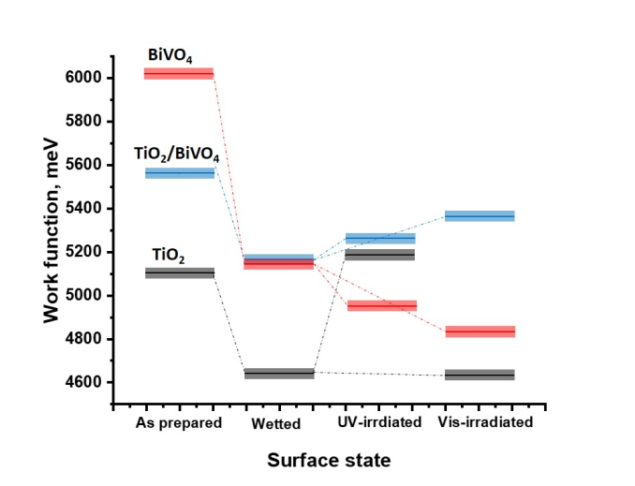 |  |  | 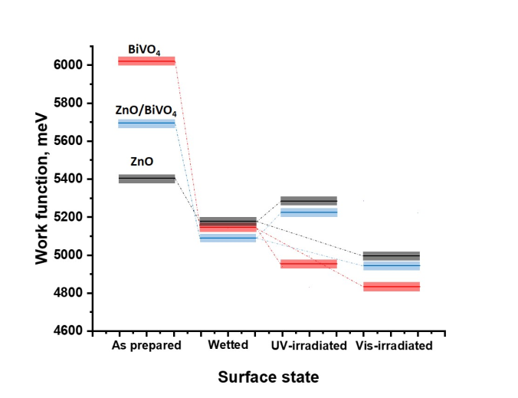
(a) |  |  | (b)
Figure 3. Evolution of the work function values for heterostructured coatings and their components depending on the treatment type: (a) TiO₂/BiVO₄, TiO₂ and BiVO₄, (b) ZnO/BiVO₄, ZnO and BiVO₄.
The strong surface hydration of TiO₂ and ZnO layers reduces the work function values for all the samples studied (Figure 3). For UV-irradiated surfaces of all planar systems, the work function values increase compared to their initial values for wetted state. This observation corresponds to the photoinduced superhydrophilic state of their surfaces (Figures 1 and 2).
Effects induced by visible light irradiation of the coating surfaces depend on the coating composition. The mono-component TiO₂ and heterostructured TiO₂/BiVO₄ coatings demonstrate the different trends in the alteration of the work function under visible light irradiation. As shown in Figure 3а, the work function of TiO₂ practically does not change, while the WF of the TiO₂/BiVO₄ heterosystem increases. These visible light-driven alterations of WFs correlate with the different Vis-induced hydrophilic behavior of TiO₂ surface for individual and heterostructured coatings (Figure 1).
The work functions for both ZnO and ZnO/BiVO₄ coatings decrease slightly when exposed to visible light and are very close in value (Figure 3b). Thus, the UV and visible light induced WF changes are similar in directions and values for both ZnO and ZnO/BiVO₄ planar systems. Thus, the trends of WF alterations also quantitatively correlate with their UV- and Vis-induced hydrophilicity changes (Figure 2).
Table 4 presents data on the total surface free energy (SFE), its dispersive and polar components, for the surface of all systems studied.
Table 4. Total (t), polar (p), and dispersive (d) surface free energies (SFE) for all coatings studied after different treatments.
Coating | SFE, mN/m (± 0.02 eV)
 | wetted |  |  | UV-irradiated |  |  | Vis-irradiated
 | t | d | p | t | d | p | t | d | p
TiO₂ | 65.7 | 39.6 | 26.1 | 79.8 | 47.6 | 32.2 | 67.0 | 40.1 | 26.8
TiO₂/BiVO₄ | 62.0 | 40.1 | 21.9 | 80.1 | 48.1 | 32.0 | 77.8 | 44.2 | 33.6
ZnO | 77.8 | 44.2 | 33.6 | 80.8 | 50.0 | 30.8 | 74.1 | 47.2 | 26.9
ZnO/BiVO₄ | 76.1 | 46.8 | 29.3 | 80.8 | 49.9 | 30.9 | 75.0 | 48.3 | 26.7
The UV-stimulated WCA change for the surface of mono-component TiO₂ coating is caused by an SFE increase mainly due to its polar component. Upon visible light irradiation, no significant deviations were observed in the SFE value (Table 4), as well as in the surface hydrophilicity (Figure 1). The transformation of the TiO₂/BiVO₄ heterostructured coating surface into a more hydrophilic state under UV irradiation as well as visible light is accompanied by an increase in SFE due to both components. However, the increase in the polar component contributes more to the alteration of the total surface free energy when TiO₂/BiVO₄ sample was exposed to visible light.
For the ZnO and ZnO/BiVO₄ coatings, the UV-induced surface transition to the superhydrophilic state is characterized by an increase in the total surface energy to value of 80.8 mN/m, mainly due to its dispersive component (Table 4). When both systems are irradiated with visible light, their surface energy slightly decreases, mainly due to the polar component.

3. Discussion
Based on the experimental results on determination of the electronic bands positions in the components (see the data in Table 2) of the formed heterostructures, the corresponding energy diagram can be plotted as shown in Figure 4. A successful formation of heterojunctions in heterostructured coatings is confirmed by the alteration of their work functions (Fermi level positions) comparing to the corresponding parameters for the individual components (see the data presented in Tables 2 and 3): the work function values of the both heterostructured coatings are located between the corresponding values of the individual components that indicates the charge separation at heterojunctions. Wetting of the surfaces of both heterostructured and mono-component coatings results in the decrease of the work function values due to formation of the hydroxy-hydrated multilayers [9, 33].
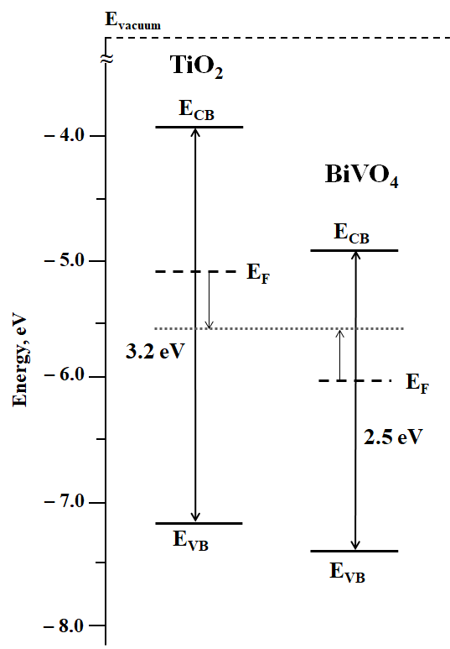 | 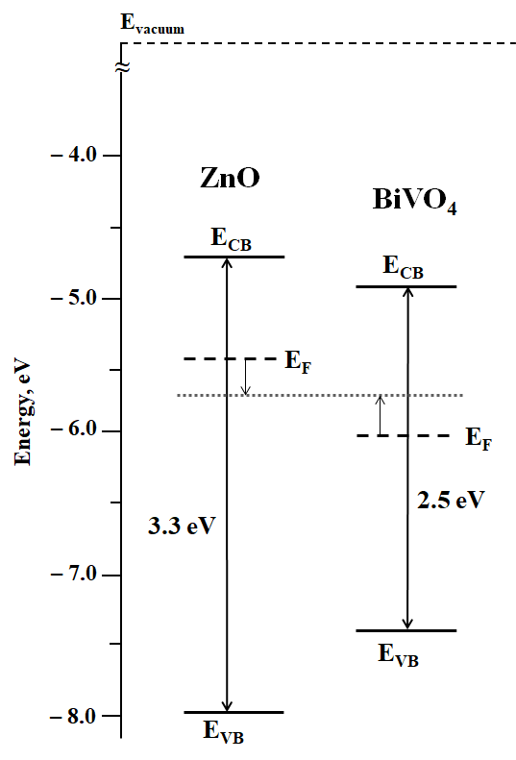
(a) | (b)
Figure 4. Energy diagrams of the positions of the top of the valence bands and the bottom of the conduction bands and Fermi level positions for TiO₂ and BiVO₄ (a) and ZnO and BiVO₄ (b) heterosystems.
According the energy diagrams, the heterostructure formed from TiO₂ and BiVO₄ corresponds to the type II and energy levels of conduction and valence bands of its components favor to the photogenerated electron transfer from TiO₂ to BiVO₄ and to the photogenerated hole transfer back from BiVO₄ to TiO₂. As a result, charge separation at heterojunction in such type of heterostructure results in hole accumulation in TiO₂ and accordingly, at the surface of the heterostructured coating. At the same time, mutual positions of the conduction and valence bands of ZnO and BiVO₄ indicate that corresponding heterostructure ZnO‒BiVO₄ belongs to the type I that means that both photogenerated electrons and holes are transferred from ZnO to BiVO₄. The possibility of forming a type I heterostructure for the ZnO/BiVO₄ heterosystem and a type II heterostructure for the TiO₂/BiVO₄ heterosystem has been mentioned earlier [7, 29-32, 34-36]. Thus, there is no charge separation at heterojunction occurred in such heterostructure and therefore, there is no alteration of the dominating charge carriers at the surface of heterostructured coating comparing to the mono-component ZnO coating.
The corresponding processes of the charge transfer and separation of photogenerated charge carriers at heterojunctions are shown for TiO₂/BiVO₄ heterostructure in Figures 5 and for ZnO/BiVO₄ heterostructure in Figure 6, respectively. Note that in TiO₂/BiVO₄ heterostructure of type II the accumulation of photogenerated holes is occurred at the TiO₂ surface under both UV and visible light photoexcitation corresponding to photoexcitation of both components and BiVO4 only, respectively. At the same time, regardless the type of photoexcitation there is no charge transfer process to ZnO component due to energy barrier for both electrons and holes preventing the charge carrier transfer from ZnO to BiVO₄. Thus, photoexcitation of the ZnO/BiVO₄ heterostructure of type I does not change the dominating type of the charge carrier at the ZnO surface.

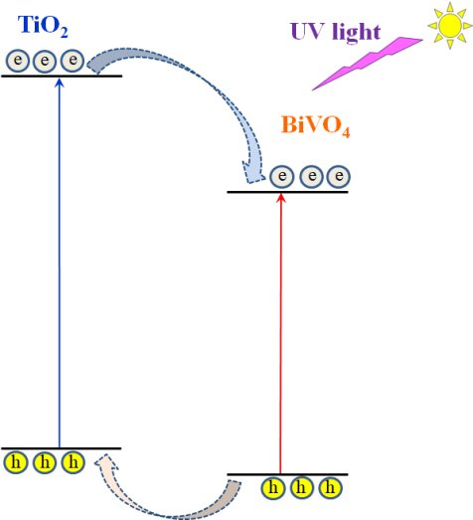 | 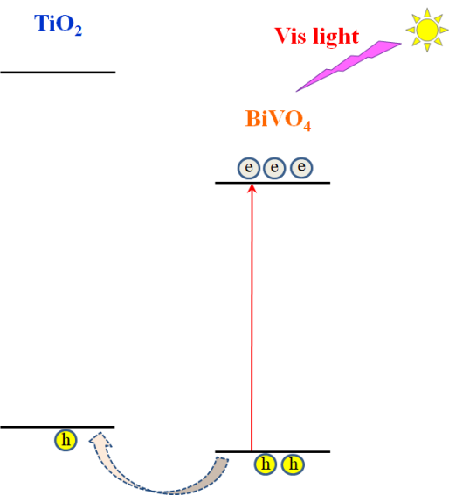
(a) | (b)
Figure 5. Schemes of the electron transfer in heterostructured TiO₂/BiVO₄ coating under UV (a) and visible (b) light photoexcitation.
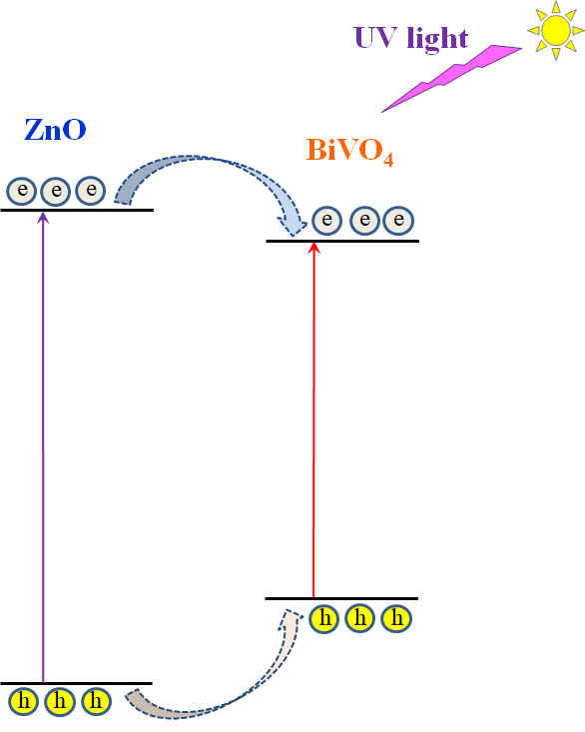 | 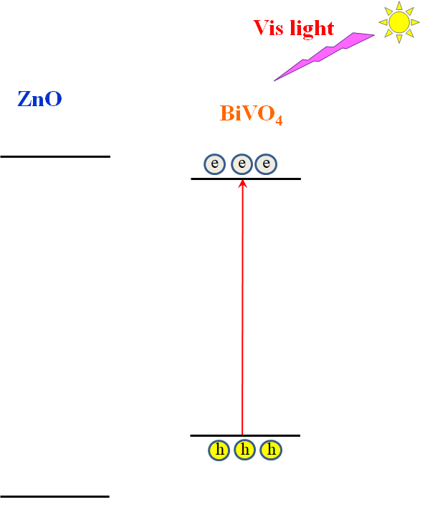
(a) | (b)
Figure 6. Schemes of the electron transfer in heterostructured ZnO/BiVO₄ coating under UV (a) and visible (b) light photoexcitation.
The difference in charge transfer processes taking place at heterojunctions of type I ZnO/BiVO₄ and type II TiO₂/BiVO₄ heterostructures explains the difference in the photostimulated surface hydrophilic behavior of both heterostructures. Accumulation of the holes at the TiO₂ surface due to charge separation at the heterojunction in type II TiO₂/BiVO₄ heterostructure takes place and results in surface transition to superhydrophilic state under both UV and visible light photoexcitation. However, both UV and visible light photoexcitation of the type I ZnO/BiVO₄ heterostructure does not lead to the interface transfer of either electrons or holes from BiVO₄ to ZnO and therefore, does not change the dominating type of the charge carriers at ZnO surface. Accordingly, the behavior of ZnO surface in heterostructured coating remains similar to that one observed for the mono-component ZnO surface.
It is wise to mention that photostimulated transition of the coating surface to the superhydrophilic state corresponds to the increase of the work function regardless of the coating structure: either mono-component or heterostructured (see data in Table 3 and Figure 3). This accordance between surface hydrophilicity and work function values can be explained in terms of the interaction between photogenerated holes and surface hydroxy-hydrated layer that change the surface dipole moment affecting the work function value.
Interaction between photogenerated holes as a dominating type of the charge carriers at the surface and hydroxy-hydrated multilayers also results in the increase of the surface free energy (see data in Table 4), mainly its polar component. This also indicates that such a reconstruction process occurred in the hydroxy-hydrated multilayer so that the surface reached a superhydrophilic state. Thus, there is a qualitative correlation between work function, surface free energy and surface hydrophilicity.
It is also wise to mention that the formation of the heterostructured coatings with type II heterojunctions favorable to hole transfer toward the outer component surface (Figure 6b), leads to spectral sensitization to visible light of the effect photostimulated superhydrophilicity.

4. Materials and Methods
The individual TiO₂ and ZnO films were prepared from their individual sols using a dip coating method (KSV Nima dip coater, Finland). All films studied were deposited on SiO₂-coated glass substrates to prevent the diffusion of sodium ions from the glass during its thermal treatment [37, 38].
To prepare titanium dioxide sol, 40 ml of titanium (IV) isopropoxide (99.999%, Sigma Aldrich) was added to 120 ml of isopropanol (99.8%, Ecos-1) and intensively stirred for 2 hours at room temperature. The velocity of withdrawing from solution was 50 mm/min. The deposited thin TiO₂ layers were annealed at 450ºC for 1 hour in ambient atmosphere [39].
For the zinc oxide sol, 2.5 ml of ethylene glycol (99.5%, LenReactiv) and 10 g of zinc acetate dihydrate Zn(OAc)₂·2H₂O (99.0%, Vekton) were mixed in a round-bottomed flask and heated at 70°C for 15 min to obtain a uniform transparent mixture. After cooling to room temperature, 150 ml of isopropanol (99.8%, Ecos-1) and 6.4 ml of triethylamine (99.5%, PanReac AppliChem) were added to the mixture to promote the hydrolysis of the zinc acetate [24]. To improve the quality of the film, 0.5 ml of glycerol (99.5%, LenReactiv) was added dropwise. The obtained clear and homogeneous solution previously stirred at 60°C for 1 hour remains to age for 24 hours at room temperature. Thin ZnO films were obtained by two dips in the solution at a withdrawal rate of 100 mm/min and with intermediate drying at 100ºC for 15 minutes. Then films were annealed at 300ºC for 1 hour in ambient atmosphere.
The BiVO₄ films were deposited on SiO₂-coated glass substrates by drop-casting method using precursor solution. For preparation of the precursor solution, 0.5 mmol bismuth nitrate pentahydrate Bi(NO₃)₃·5H₂O (99%, Chemcraft) and 0.46 mmol vanadyl acetylacetonate VO(C₅H₇O₂)₂ (98%, Sigma Aldrich) were dissolved in a mixture of 5 ml glacial acetic acid (≥99%, LenReactiv) and 0.25 ml acetylacetone (99%, AlfaAesar) with constant stirring for 1 hour. The solution was drop-cast onto the glass substrates (7.5 μL per cm²). The samples were then dried at 80°C for 30 min in a vacuum drying oven and finally annealed in a muffle furnace at 450°C for 1 hour under ambient conditions.
The “layer-by-layer” TiO₂/BiVO₄ and ZnO/BiVO₄ heterosystems were formed by deposition of TiO₂ and ZnO layers, respectively, on a thin BiVO₄ film by methods described above. To demonstrate the 100% coverage of the BiVO₄ layer with TiO₂ or ZnO layers, the survey XPS spectra of the heterostructured coatings as well as BiVO4 film for comparison are presented in the Supplementary Materials section (Figure S8). No peaks related to BiVO₄ were found there.
As a result, mono-component TiO₂ and heterostructured TiO₂/BiVO₄ TiO₂-topped coatings as well as mono-component ZnO and heterostructured ZnO/BiVO₄ ZnO-topped coatings were synthesized and studied in this work.
The surface morphology and film thickness of all synthesized films were explored by scanning electron microscopy (Zeiss Supra 40 VP system). The average roughness (Ra) of the film surface was assessed by the AFM method using NOVA 1.0.26 program. X-ray diffraction measurements with Bruker «D8 DISCOVER» high-resolution diffractometer (CuKa X-ray radiation, within the angle range of 20° ≤ 2θ ≤ 80° with a scanning speed 5.0°/min) were used for the crystal phase determination. Structural reference data were taken from ICSD database. The transmittance spectra were recorded in the 250-800 nm spectral range at ambient conditions using a Lambda 650S spectrophotometer. The XPS spectra were recorded using a Thermo Fisher Scientific Escalab 250Xi spectrometer.
Work function measurements were performed with a scanning Kelvin probe system SKP5050 (KP Technology) versus a golden reference probe electrode (probe area 2 mm²). The probe oscillation frequency was 74 Hz, and the backing potential was 7000 mV. Work function values were obtained by averaging 50 data points for five different sites of each sample. The error of the work function (WF) measurements was ± 0.02 eV.
The contact angle values were measured using optical tensiometer (Bioline Theta Lite). Ultrapure water has initial pH of 5.5. The error of the water contact angle (WCA) measurements was ± 1.5º. The surface free energy (SFE) was calculated by the Owens-Wendt-Rabel-Kaelble (OWRK)/Fowkes approach using the two-liquid method (water contact angle versus methylene iodide contact angle) [24].
The work function and contact angle values were measured after each step of the following surface pretreatment procedure. After annealing at 300ºC for 30 minutes, the state of the film surface is designated as “as prepared”. After the storage in the dark in the humid atmosphere for 10 days, the surface state is denoted as “wetted”. The third step was to irradiate the film with UV or visible light, and the corresponding surface states are referred to as “UV-irradiated” or “Vis-irradiated”, respectively.
The irradiation of the films by UV or visible light was carried out using Xenon lamp (LOMO) equipped with a water filter and either UV band-pass or Vis cut-off color filter. The transmittance spectra of employed filters are presented in the Supplementary Materials section (Figure S9). The irradiance of UV irradiation was 15.0 mW/cm² and the irradiance of the visible light irradiation was 225.0 mW/cm². The kinetics of the photoinduced water contact angle alteration is presented as a dependence of the water contact angle on the irradiation time.

5. Conclusions
We have conducted a comparative study of the photostimulated processes affected surface hydrophilicity for type I ZnO/BiVO₄ and type II TiO₂/BiVO₄ heterostructured coatings. Our results indicate that type I ZnO/BiVO₄ heterostructure does not change significantly the surface behavior of ZnO surface comparing to the surface of the mono-component ZnO coating. In turn, the type II TiO₂/BiVO₄ heterostructure demonstrates spectral sensitization to the visible light of the effect of photostimulated superhydrophilicity which is not observed for the mono-component TiO₂ coating. The difference between two types of heterostructures can be explained in terms of either realization or prevention of the hole transfer through the heterojunctions toward the outer surface of heterostructured coatings.
Regardless the type of coatings the quantitative correlation between the surface transition to the superhydrophilic state and the increase of the both work function and surface free energy values is observed. These correlations indicate the interaction of holes with hydroxy-hydrated multilayer at the surface of nanocoatings.
Supplementary Materials: The following are available online Figure S1: XRD patterns of TiO₂, ZnO, BiVO₄, TiO₂/BiVO₄ and ZnO/BiVO₄ coatings, Figure S2: SEM images of TiO₂-topped surfaces and cross-sections for TiO₂ and TiO₂/BiVO₄ coatings, Figure S3: SEM images of ZnO surfaces and cross-sections for ZnO and ZnO/BiVO₄ coatings, Figure S4: AFM image of the TiO₂ surfaces and roughness profiles for TiO₂ and TiO₂/BiVO₄ coatings., Figure S5: AFM image of the ZnO surfaces and roughness profiles for ZnO and ZnO/BiVO₄ coatings, Figure S6: Transmittance spectra and Tauc plots for TiO₂, ZnO, BiVO₄, Figure S7: XPS spectra of valence band region for TiO₂, ZnO, BiVO₄, Figure S8: Transmittance spectra of UV band-pass and Vis cut-off filters.
Author Contributions: Conceptualization, A.V.R. and D.W.B.; methodology, A.V.E.; software, M.V.M.; validation, A.V.R. and A.V.E.; formal analysis, M.V.M.; investigation, M.V.M., A.V.K., A.S.S. and A.V.E.; resources, D.W.B.; writing—original draft preparation, M.V.M., A.V.R. and A.V.E.; writing—review and editing, A.V.E. and D.W.B.; visualization, M.V.M., A.V.R.; supervision, D.W.B.; project administration, A.V.E.; and funding acquisition, A.V.E. and D.W.B. All authors have read and agreed to the published version of the manuscript.
Funding: The reported study was funded by RFBR, project number 19-32-90111.
Acknowledgments: AVE and MVM are grateful to Russian Foundation for Basic Research (RFBR) for grant N 19-32-90111 to support this research. Experimental studies were performed in laboratory “Photoactive nanocomposite materials” supported by Saint-Petersburg State University (ID: 73032813). Authors are thankful to the Resource Center (RC) “Nanophotonics”, RC “X-ray Diffraction Studies”, RC “Centre for Innovative Technologies of Composite Nanomaterials”, RC “Centre for Physical Methods of Surface Investigation”, RC “Centre for Diagnostics of Functional Materials for Medicine, Pharmacology and Nanoelectronics” and RC “Nanotechnology” of the Research Park at the Saint-Petersburg State University for helpful assistance in the preparation and characterization of the samples.
Conflicts of Interest: The authors declare no conflict of interest.

References
- Wang, H.; Zhang, L.; Chen, Z.; Hu, J.; Li, S.; Wang, Z.; Liu, J.; Wang X. Semiconductor heterojunction photocatalysts: design, construction, and photocatalytic performances. Chem. Soc. Rev. 2014, 43, 5234–5244. DOI: 10.1039/C4CS00126E
- Emeline, A.V.; Rudakova, AV.; Mikhaylov, R.V.; Ryabchuk, V.K.; Serpone, N. Electron transfer processes in heterostructured photocatalysts. In Springer Handbook of Inorganic Photochemistry, 1st ed.; Bahnemann, D., Patrocinio, A.O.T., Eds.; Springer International Publishing: Switzerland, 2020; in press, https://doi.org/10.1007/978-3-030-63713-2.
- Marschall, R. Semiconductor composites: Strategies for enhancing charge carrier separation to improve photocatalytic activity. Adv. Funct. Mater. 2013, 24, 2421–2440. DOI: 10.1002/adfm.201303214
- Wang, Y.; Wang, Q.; Zhan, X.; Wang, F.; Safdara, M.; He, J. Visible light driven type II heterostructures and their enhanced photocatalysis properties: a review. Nanoscale 2013, 5, 8326–8339. DOI: 10.1039/C3NR01577G
- Chiu, Y.-H.; Chang, T.-F. M.; Chen, C.-Y.; Sone, M.; Hsu, Y.-J. Mechanistic insights into photodegradation of organic dyes using heterostructure photocatalysts. Catalysts 2019, 9, 430. DOI: 10.3390/catal9050430
- He, X.; Zhang, C. Recent advances in structure design for enhancing photocatalysis. J. Mater. Sci. 2019, 54, 8831–8851. DOI: 10.1007/s10853-019-03417-8
- Moniz, S.J.A.; Shevlin, S.A.; Martin, D.J.; Guo, Z.-X.; Tang, J. Visible-light driven heterojunction photocatalysts for water splitting - a critical review. Energy Environ. Sci. 2015, 8, 731–759. DOI: 10.1039/C4EE03271C
- Emeline, A.V.; Rudakova, A.V.; Mikhaylov, R.V.; Bulanin, K.M.; Bahnemann, D.W. Photoactive heterostructures: How they are made and explored. Catalysts 2021, 11, 294. DOI: 10.3390/catal11020294
- Rudakova, A.V.; Emeline, A.V. Photoinduced hydrophilicity of surfaces of thin film. Colloid J. 2021, 83, 20–48. DOI: 10.1134/S1061933X21010105
- Rudakova, A.V.; Emeline, A.V.; Bahnemann, D.W. Effect of the TiO₂–ZnO heterostructure on the photoinduced hydrophilic conversion of TiO₂ and ZnO Surfaces. J. Phys. Chem. C 2019, 123, 8884–8891. DOI: 10.1021/acs.jpcc.8b12125
- Fujishima, A.; Rao, T.N.; Tryk, D.N. Titanium dioxide photocatalysis. J. Photochem. Photobio. C 2000, 1, 1–21. DOI: 10.1016/S1389-5567(00)00002-2
- Chen, X.; Mao, S.S. Titanium dioxide nanomaterials: synthesis, properties, modifications, and applications. Chem. Rev. 2007, 107, 2891–2959. DOI: 10.1021/cr0500535
- Henderson, M.A. A surface science perspective on TiO₂ photocatalysis. Surf. Sci. Rep. 2011, 66, 185–297. DOI: 10.1016/j.surfrep.2011.01.001
- Carp, O., Huisman, C.L., Reller, A. Photoinduced reactivity of titanium dioxide. Prog. Solid State Chem. 2004, 32, 33–177. DOI: 10.1016/j.progsolidstchem.2004.08.001
- Lee, K.M., Lai, C.W., Ngai, K.S., Juan, J.C. Recent developments of zinc oxide based photocatalyst in water treatment technology: A review. Water Res. 2016, 88, 428–448. DOI: 10.1016/j.watres.2015.09.045
- Ong, C.B., Ng, L.Y., Mohammad, A.W. A review of ZnO nanoparticles as solar photocatalysts: Synthesis, mechanisms and applications. Renew. Sust. Energ. Rev. 2018, 81, 536–551. DOI: 10.1016/j.rser.2017.08.020
- Zhang, H., Chen, G., Bahnemann, D.W. Photoelectrocatalytic materials for environmental applications. J. Mater. Chem. 2009, 19(29), 5089–5121. DOI: 10.1039/B821991E
- Sun, R.-D.; Nakajima, A.; Fujishima, A.; Watanabe, T.; Hashimoto, K. Photoinduced surface wettability conversion of ZnO and TiO₂ thin films. J. Phys. Chem. B 2001, 105, 1984–1990. DOI: 10.1021/jp002525j
- Miyauchi, M.; Nakajima, A.; Watanabe, T.; Hashimoto, K. Photocatalysis and photoinduced hydrophilicity of various metal oxide thin films. Chem. Mater. 2002, 14, 2812–2816. DOI: 10.1021/cm020076p
- Miyauchi, M.; Nakajima, A.; Watanabe, T.; Hashimoto, K. Photoinduced hydrophilic conversion of TiO₂/WO₃ layered thin films. Chem. Mater. 2002, 14, 4714–4720. DOI: 10.1021/cm020355c
- Kim, H.-M.; Kim, D.; Kim, B. Photoinduced hydrophilicity of TiO₂/WO₃ double layer films. Surf. Coat. Technol. 2015, 271, 18–21. DOI: 10.1016/j.surfcoat.2015.01.054
- Maevskaya, M.V.; Sivokhina, M.M.; Rudakova, A.V.; Emeline, A.V. Photocatalytic properties of layered TiO₂/CdS, TiO₂/ZnO, ZnO/TiO₂ heterostructures. Proceedings of the 6th International Conference on Semiconductor and Photochemistry, Oldenburg, Germany, 11–14 September, 2017.
- Grishina, A.E.; Maevskaya, M.V.; Rudakova, A.V.; Emeline, A.V. Photoinduced hydrophilic behavior of hydrated surfaces of TiO₂/ZnO, TiO₂/CdS, TiO₂/WO₃ composite films. Proceedings of the 9th European Meeting on Solar Chemistry and Photocatalysis, Strasburg, France, 13-17 June, 2016.
- Maevskaya, M.V.; Rudakova, A.V.; Emeline, A.V.; Bahnemann, D.W. Effect of Cu₂O substrate on photoinduced hydrophilicity of TiO₂ and ZnO nanocoatings. Nanomaterials 2021, 11, 1526. DOI: 10.3390/nano11061526
- Rudakova, A.V.; Emeline, A.V.; Romanychev, A.I.; Bahnemann, D.W. Photoinduced hydrophilic behavior of TiO₂ thin film on Si substrate. J. Alloys Compd. 2021, 872, 159746. DOI: 10.1016/j.jallcom.2021.15974
- Fujishima, A.; Zhang, X. Titanium dioxide photocatalysis: present situation and future approaches. C. R. Chim. 2006, 9, 750–760. DOI: 10.1016/j.crci.2005.02.055
- Fujishima, A.; Zhang, X.; Tryk, D.A. TiO₂ photocatalysis and related surface phenomena. Surf. Sci. Rep. 2008, 63, 515–582. DOI: 10.1016/j.surfrep.2008.10.001
- Samsudin, M.F.R.; Sufian, S.; Hameed, B.H. Epigrammatic progress and perspective on the photocatalytic properties of BiVO₄-based photocatalyst in photocatalytic water treatment technology: A review. J. Mol. Liq. 2018, 268, 438–459. DOI: 10.1016/j.molliq.2018.07.051
- Wetchakun, N.; Chainet, S.; Phanichphant, S.; Wetchakun, K. Efficient photocatalytic degradation of methylene blue over BiVO₄/TiO₂ nanocomposites. Ceramics International 2015, 41, 5999–6004. DOI: 10.1016/j.ceramint.2015.01.040
- Qian, B.; Xu, Q.; Wu, Y.; Zhang, Y.; Li, H.; Wang, Y.; Wang, B.; Li , S.; Song, X.-M. A highly efficient photocatalytic methanol fuel cell based on non-noble metal photoelectrodes: Study on its energy band engineering via experimental and density functional theory method. J. Power Sources 2020, 78, 228756. DOI: 10.1016/j.jpowsour.2020.228756
- Hu, K.; E, L.; Li, Y.; Zhao, X.; Zhao, D.; Zhao, W.; Rong, H. Photocatalytic degradation mechanism of the visible-light responsive BiVO₄/TiO₂ core–shell heterojunction photocatalyst. J. Inorg. Organomet. Polym. 2020, 30, 775–788. DOI: 10.1007/s10904-019-01217-w
- Balachandran, S.; Prakash, N.; Thirumalai,K.; Muruganandham, M.; Sillanpaä,M.; Swaminathan, M. Facile construction of heterostructured BiVO₄−ZnO and its dual application of greater solar photocatalytic activity and self-cleaning property. Ind. Eng. Chem. Res. 2014, 53, 8346–8356. DOI: 10.1021/ie404287m
- Rudakova, A.V.; Oparicheva, U.G.; Grishina, A.E.; Murashkina, A.A.; Emeline, A.V.; Bahnemann, D.W. Photoinduced hydrophilic conversion of hydrated ZnO surfaces. J. Colloid Interface Sci. 2016, 466, 452–460. DOI: 10.1016/j.jcis.2015.08.015
- Mohamed, N.A.; Safaei, J.; Ismail, A.F.; Khalid, M.N.; Jailani, M.F.A.M.; Noh, M.F.M.; Arzaee, N.A.; Zhou, D.; Sagu, J.S.; Teridi, M.A.M. Boosting photocatalytic activities of BiVO₄ by creation of g-C₃N₄/ZnO@ BiVO₄ heterojunction. Mater. Res. Bull. 2020, 125 110779. DOI: 10.1016/j.materresbull.2020.110779
- Zhang, J.; Xie, L. Synthesis and sonophotocatalytic activities of ZnO\BiVO₄\Co₃O₄ composites. Chem. Phys. Lett. 2021, 775, 138660. DOI: 10.1016/j.cplett.2021.138660
- Zhang, H.; Chen, Y.; Liang, Y. Lotus Leaf-inspired hydrothermal synthesis of composite nanoparticles and application for photocatalytic oil denitrification. Catal. Lett. 2020, 150, 2474–2486. DOI: 10.1007/s10562-020-03146-7
- Watanabe, T.; Fukayama, S.; Miyauchi, M.; Fujishima, A.; Hashimoto, K. Photocatalytic activity and photo-induced wettability conversion of TiO₂. Thin film prepared by sol-gel process on a soda-lime glass. J. Sol-Gel Sci. Technol. 2000, 19, 71–76. DOI: 10.1023/A:1008762121743
- Yu, J.; Zhao, X. Effect of substrates on the photocatalytic activity of nanometer TiO₂ thin films. Mater. Res. Bull. 2000, 35, 1293–1301. DOI: 10.1016/S0025-5408(00)00327-5
- Emeline, A.V.; Rudakova, A.V.; Sakai, M.; Murakami, T.; Fujishima, A. Factors affecting UV-induced superhydrophilic conversion of a TiO₂ surface. J. Phys. Chem. C 2013, 117, 12086–12092. DOI: 10.1021/jp400421v

