Structural properties of cobalt and gold intercalated graphene on SiC(0001) single crystal

Daria Glazkova

St. Petersburg State University, Russia / Helmholtz-Zentrum Berlin, BESSY II, Germany

G-RISC project M-2021a-1_r, Funding period: 22.09.2021 – 22.10.2021

Principal investigator: Dr. Dmitry Marchenko (Helmholtz-Zentrum Berlin, BESSY II, Germany)

Summary

In this work, we have studied the crystal and electronic structure of multilayer system: quasi-freestanding graphene grown on a SiC(0001) single crystal and intercalated with gold and cobalt. In addition, its surface was imaged with a photoemission microscope to study microscale relief and work function. Our attention was focused on the layer order of multilayer system as well as the degree of homogeneity at the microscale.

Introduction

A combination of strong spin-orbit coupling (SOC) and robust magnetism could provide a playground for the observation of the quantum anomalous Hall effect (QAHE) [1, 2]. Necessary condition for the observation of QAHE can be satisfied in this case: a bulk energy gap opened in the presence of both Rashba spin-orbit coupling and out-of-plane exchange field. It should be noted that graphene on dielectric substrate should be used for experimental measurement of QAHE.
Based on the above considerations, we have implemented a multilayer system: graphene on a SiC substrate (dielectric substrate) intercalated with gold (the possibility of spin-orbit interaction) and cobalt (the possibility of strong magnetism). It has been experimentally established that it is possible to achieve all characteristics (SOC, exchange interaction) in graphene [3]. However, in previous studies, cobalt was magnetized exclusively in-plane, and there was no evidence of the opening of the band gap at the Dirac point. Nevertheless, the gap opening is possible in principle, in case of the out-of-plane magnetization of graphene-coated thin Co layers [4, 5].
Thereby, giant Rashba SOC and out-of-plane exchange coupling in graphene induced by Au-Co interlayer (with a global bulk gap opening) can harbor the quantum anomalous Hall effect in graphene.
Aim of our current proposal is the study of homogeneity, layer order and structural features of zero-layer/SiC(0001) system intercalated by cobalt and gold atoms.

Methods

High-resolution x-ray photoelectron spectroscopy (XPS) measurements were performed at the Russian-German beamline end-station at BESSY II synchrotron facility in Berlin, Germany. And photoemission electron microscopy (PEEM) measurements were performed at the Omicron FOCUS IS-PEEM station at BESSY II synchrotron facility in Berlin, Germany.

X-ray photoelectron spectroscopy

XPS is a widely used surface analysis technique that provides valuable quantitative and chemical information from the surface of investigated material. XPS is performed by exciting the surface of the sample with monoenergetic x-ray radiation. X-ray tubes or synchrotrons are used as a source of radiation. The synchrotron is preferable, since it has the ability to change the radiation frequency. As a result of irradiation of the sample, photoelectrons are emitted from the uppermost layer with the surface thickness of 1–10 nm. The intensity of photoelectrons with certain kinetic energy is detected by the analyzer that makes it possible to identify an element and its chemical state by the photoelectron energy. By the intensities of the photoelectron peaks, semi-quantitate analysis can be performed.

Photoemission electron microscopy
PEEM is a microscopy method based on the photoelectric effect equation also. When electrons are excited by the light of a mercury lamp, they leave the solid, and their detection allows one to determine the work function of the surface at microscale. The work function, in turn, can be used to study the topography of the investigated surface.

Results and Discussion

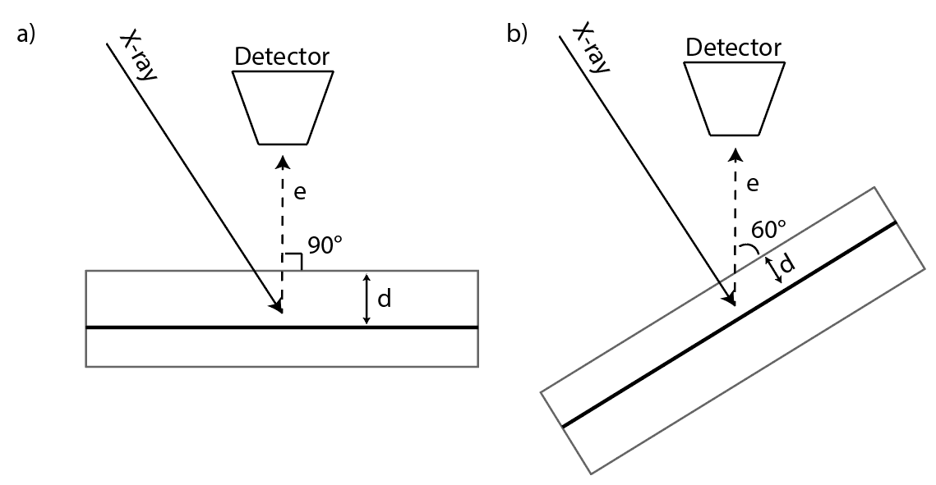
We carried out a series of XPS measurements, detecting electrons at different angles of emission to determine the order in which the compounds were found in the layered sample. The principle of extracting data from such measurements is as follows. When the electrons emitted along the normal to the surface are measured, the maximum depth of investigation of the sample is achieved, while the intensity of the peaks of deep-lying elements decreases with tilting (see Fig. 1). Moreover, the more the intensity decreases, the deeper the element lies.
Figure 1 The change in the depth d, with which the detection of electrons is possible, with a change in the angle.
In addition, each element has several peaks that detect the presence of this element in different compounds. So, for example, there is a carbon peak corresponding to graphene, and there is a carbon peak corresponding to the SiC compound (Fig. 2). The behavior of these peaks with a change in angle depends on the depth of occurrence. Thus, the method allows extracting information on the order of occurrence of various compounds from the peak intensities of one element in these compounds.
So, we have measured the peaks of all the elements in the sample. Peaks C1s, Si2p, Co2p, Au4f, O1s were measured as peaks with maximum intensity. The energy of the X-ray source was 980 eV. The measurements were taken at three angles: 0, 40 and 60 degrees.
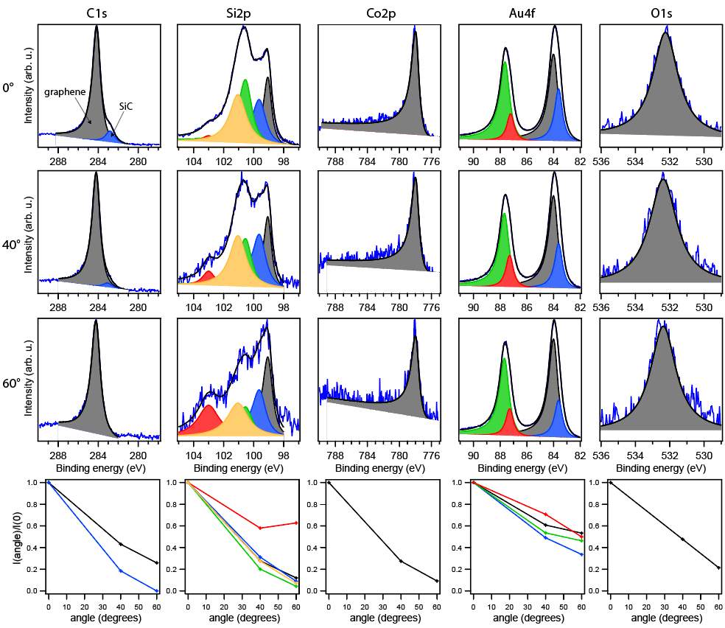
Figure 2 shows the measurement of all the indicated peaks at all three angles. The bottom line shows the intensity ratios I(angle)/I(0).
Figure 2 The first three lines show the measured XPS spectra, at zero degrees in the first line, at 40 degrees in the second line, at 60 degrees in the third line. The fourth line shows the dependence of the ratio of the intensity at a given angle to the intensity at a zero angle.
From these data, we can assume the following layer order of compounds (Fig. 3). The bottom of all is the SiC substrate. Then the elements of cobalt and silicon are located in silicides. Then there is silicon again (possibly in oxide) and oxygen. Graphene is located at the top. Gold is located under the graphene, but some amount is probably above.

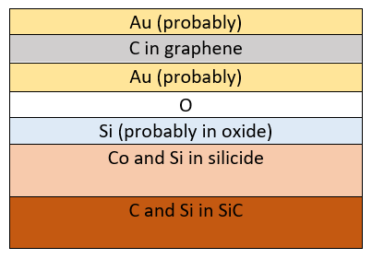
Figure 3 Structural model of near-surface layers.

Next, we carried out PEEM measurements. We studied the surface of the sample under a microscope, with scaling: from a spot diameter of 250 micrometers to a spot diameter of 10 micrometers. We found that both large plane regions and regions with clusters are present on the sample surface in equal proportions. Figure 4 shows the border of two such different regions.
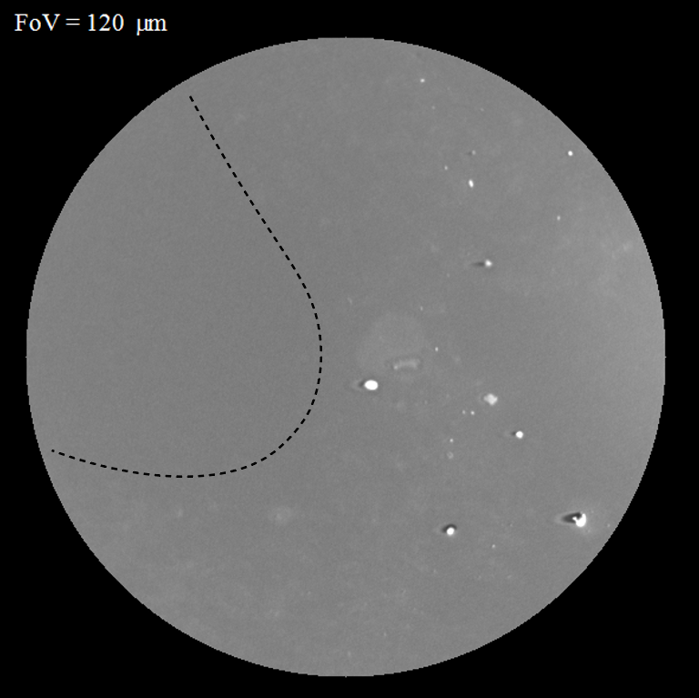
Figure 4 The boundary between a plane region and a region with clusters.
However, measuring the work function from these two different areas gives the same result (4.2 eV), which means that the surface is homogeneous in that sense. Such a measurement indirectly indicates the homogeneity of the system at microscales. Indeed, if any layer was absent, or the layers were interchanged, or other large differences of this kind were changed, it would inevitably entail a change in the work function. Unfortunately, we cannot say this for smaller scales.

Conclusion

In this work, we studied the crystal and electronic structure of multilayer system. We found that the compounds in the system are arranged as follows: SiC substrate - cobalt and silicon in silicide - silicon in oxide - gold intercalate - graphene - gold clusters on top. In addition, work function measurements indicate system homogeneity at microscale.

References

[1] Z. Qiao et al., Phys. Rev. B 82, 161414 (2010)
[2] X. Deng et al., Phys. Rev. B 95, 121410(R) (2017)
[3] A.G. Rybkin et al., Nano Lett. 18 (3), 1564-1574 (2018)
[4] F. Ajejas et al., Nano Lett. 18 (9), 5364-5372 (2018)
[5] R. Decker et al., Phys. Rev. B 87, 041403(R) (2013)

