Structure and thermodynamic properties of equilibrium and critical droplets in nucleation on charged and wettable particles
Alexander K. Shchekin, Tatyana S. Lebedeva and Dmitry V. Tatyanenko
St Petersburg State University, St Petersburg, Russian Federation
akshch@list.ru
It is well recognized fact now that kinetics of heterogeneous nucleation on charged and completely wettable particles has many similar features. This similarity is associated with possibility of barrieirless nucleation at vapor supersaturations above some threshold value and with existence of stable (equilibrium) and unstable (critical) droplets at each supersaturation between zero and the threshold. These droplets correspond to minimum and maximum of the work of droplet formation, they merge at .The density functional theory applied to small nano- and microdroplets gives us a tool to find clear answers to many problems which had been raised a long time ago but still stay actual for colloid and interface science. One of such problems is a problem of detailed thermodynamic description of stable and critical droplets corresponding to the minimum and maximum of the work of droplet formation at heterogeneous nucleation on ions and charged nanoparticles. This description requires a knowledge of a fine structure in density and polar properties of inhomogeneous liquid droplet or film in presence of strong central electric field, molecular field of the substrate and structural ordering of the solid substrate surface. Previously we have considered [1] the thermodynamics of ion- and charge-induced nucleation within the Gibbs method of dividing surfaces with account of contribution of the disjoining pressure of the thin liquid film in the central electric field of the charged particle. However we took the dielectric permittivity for a substance in the liquid film as constant and used ad hoc approximations for the structural contribution to the disjoining pressure.
As a simple but illustrative variant of the density functional theory, we used in this report the local gradient density functional approach with varying dielectric permittivity as a function of local density. This approach taken in the spirit of paper [2] is applicable both for the Lennard-Jones and polar systems, and in particular for nucleation in water vapor. It allowed us to find the density profiles for water stable and critical droplets in the cases of heterogeneous nucleation on uncharged particle with molecular field (…), charged particle without molecular field (---) and charged particle with molecular field (––) as shown in Fig.1 and 2. With the help of these density profiles, we were able to
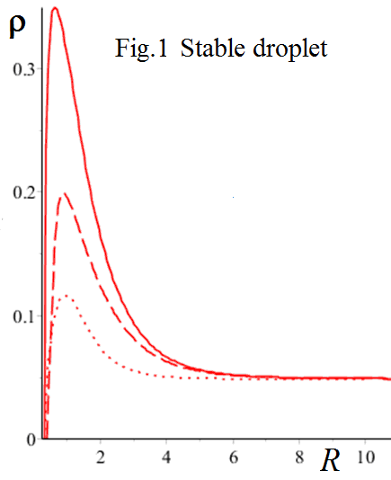 | 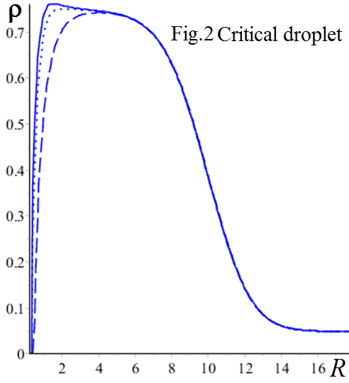
separate the contributions from surface tension, disjoining pressure, and electric field and compare them with ad hoc models.

This work was supported by St. Petersburg State University (grant 11.37.183.2014).
References

[1.] A.K. Shchekin, T.S. Podguzova, Atmospheric Research, 101 (2011), 493-502.

[2.] H. Kitamura, A. Onuki, J. Chem. Phys., 123 (2005), 124513.

