Kuzmin V.L.

Doctor of Physics, Professor, SPBPU Zhavoronkov Iu. A.

Master of Physics, graduate student, SPBU

Ul’yanov S.V.

Doctor of Physics, Professor, SPBU

Valkov A.Yu.

Doctor of Physics, Professor, SPBPU, SPBU

Probability inverse transform for the problem of radiation

transfer in a two-layer random medium

Abstract

The temporal correlation functions are simulated for a two-layer model of a highly inhomogeneous medium which can be considered as the skull-brain imitation, or phantom. The temporal decay of correlations are considered for two different mechanisms of particle movement, either the Brownian diffusion, or the random velocity square mechanism. The results obtained are turned to be highly dependent on the form of the kinetics of scatterers.

Introduction

We have developed the Monte Carlo algorithm permitting to determine the blood flow parameters. For quantitative study the crucial theoretical and numerical problem to solve is a proper account for the scattering anisotropy. The basic model to examine was two-layered system, where layers constitute a skull-brain system. The main problem of this work was to find out an impact of normalization coefficient, which did not take account previously, in probability density function on numerical calculations.

Inverse transform for the semi-infinite medium

The Monte Carlo method is widely used for simulation of the photon migration in tissue and tissue phantoms, mostly within the well-known MCML algorithm. Within the MCML the signal is contributed by the photons escaping a scattering medium, thus requiring quite a large sampling due to the fact, that the detected photons may form very small share of the incident light In the modification developed presently every photon contributes into the signal at every act of scattering, until it escapes the medium. In the approach presented every photon contributes into the signal; thus the number of photons can be diminished crucially also reducing the calculation time. In the standard MCML algorithm only escaped photons contribute to the signal. Within our approach every scattering event contributes. We present the scattering intensity as a sum in scattering orders $$J_{ω}\left(ρ\right)=\sum_{n<n_{\text{sc}}}{J_{ω}^{\left(n\right)}\left(ρ\right)}$$

where n-th order term $J_{ω}^{\left(n\right)}\left(ρ\right)$ is a statistical average over sampling of incident photons

$$J_{ω}^{n}\left(ρ\right)=\frac{1}{N}\sum_{i=1}^{N}{W_{n}^{\left(i\right)}\exp\left(-μz_{n}^{\left(i\right)}\right)}$$

Here $W_{n}^{\left(i\right)}$ and $z_{n}^{\left(i\right)}$ are, respectively, the weight of the i-th photon and its distance to the boundary from the point $r_{n}$ of the last scattering event. We consider normal incidence and normal backscattering of in- and out- going pencil-like beams along cartesian coordinate $z$ normal to the boundary $z=0$.

Inverse transform for the two-layered medium

We consider a heterogeneous medium wherein the scattering parameters depend on the depth of penetration, i.e. on cartesian coordinate z normal to boundaries; generally we put $$μ=μ\left(z\right)$$

As is seen the extinction of radiation at distance $r=\left|r-r_{0}\right|$ is determined by the exponential $exp\left(-μ\left(z\right)\right)$. Assuming that the direction of beam does not change traveling an inhomogeneous medium we present the extinction in an inhomogeneous medium as

$$μ\left|r-r_{0}\right|→{\left(\cos{θ}\right)}^{-1 }\int_{z_{0}}^{z}{μ\left(z^{'}\right)dz^{'}}$$

Thus we define the probability density for the spatial coordinate z, determining the next position of the photon as follows (as generalization of)

$$f\left(z | z_{0}\right)=C^{-1}{\exp{[\left(-\cos{θ}\right)}}^{-1 }\int_{z_{0}}^{z}{μ\left(z^{'}\right)dz^{'}}]$$

where C is the normalization coefficient. Note that the distribution depends on the initial position of the photon. We consider two-layer model consisting of layer A and layer B. The medium A occupies the space $0<z<T_{A}$, layer B- the space $T_{A}<z<T$, where $T=T_{A}+T_{B}$ is the whole thickness of the two-medium system considered.

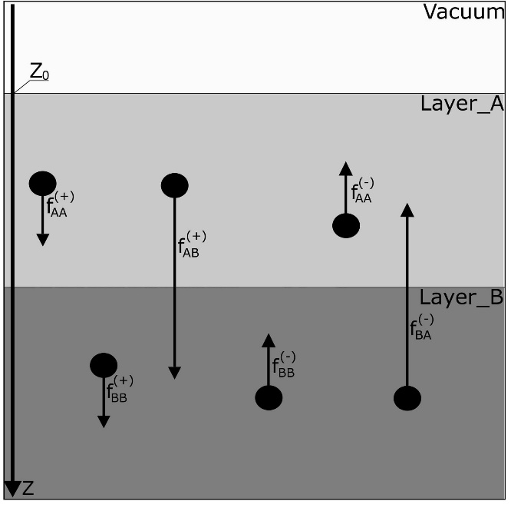

We developed first the inverse transform scheme for a photon moving inside the medium, i.e. in positive direction, $cosθ>0$, for two starting positions, $z_{0}>T$ and $z_{0}<T$.

Let the motion of the simulated photon begins at layer A, $z_{0}<T$. Performing integration with the step-wise scattering coefficient

$$μ\left(z\right)=θ\left(T-z\right)μ_{A}+θ\left(z-T\right)μ_{B}$$

we present the probability density for z0 < T as following:

$f_{A}^{\left(+\right)}\left(z | z_{0}\right)=f_{AA}^{\left(+\right)}\left(z | z_{0}\right)+f_{AB}^{\left(+\right)}\left(z | z_{0}\right)=\frac{1}{C^{\left(+\right)}}\exp\left(-θ\left(T-z\right)σ_{A}\left(z-z_{0}\right)-θ\left(z-T\right)\left(σ_{A}\left(T-z_{0}\right)+σ_{B}\left(z-T\right)\right)\right)$

The normalization constant

$C^{\left(+\right)}\left(z_{0}\right)=\int_{z_{0}}^{∞}{dz}\exp\left(-θ\left(T-z\right)σ_{A}\left(z-z_{0}\right)-θ\left(z-T\right)\left(σ_{A}\left(T-z_{0}\right)+σ_{B}\left(z-T\right)\right)\right)$

Fig. 1: Schematically photon random travel paths: (1) - traveling from point zj in medium A to zj+1 in A, with distribution (26); (2) - from A to B, with distribution (26); (3) - from medium B to B, with distribution (44); (4) -from B to B upward; (5) -from B to A; (6) - from A to A, upward. Black circle denotes the starting point, i.e. the point of previous scattering, and the arrow is the point under consideration.

Performing the inverse transform scheme, we find variable z as the function of random variable $ξ$ uniformly distributed in unit interval [0; 1] for or $ξ<ξ^{+}$, respectively

$$z=z_{0}-σ_{A}^{-1}\ln\left(1-C_{+}σ_{A}ξ\right), ξ<ξ^{\left(+\right)}$$

$$z=T-σ_{B}^{-1}\ln\left(1+\left(σ_{B}/σ_{A}\right)ξ_{A}^{-1}\left(1-ξ_{A}\right)-ξ_{A}^{-1}C_{+}σ_{B}ξ\right), ξ>ξ^{\left(+\right)}$$

REFERENCES

[1] L. Wang, S. Jacques, and L. Zheng, “MCML – Monte Carlo modeling of light transport in multi-layered tissues”, Comput. Methods Programs Biomed., vol. 47, pp. 131–146, 1995.

[2] V. Kuzmin, M. Neidrauer, D. David, L. Zubkov, “Diffuse photon density wave measurements and Monte Carlo simulations”, J. Biomed. Opt., vol. 20(10), p. 105006-1–9, October, 2015.

[3] V. Kuzmin, A. Valkov, L. Zubkov, “Photon Diffusion in Random Media and Anisotropy of Scattering in the Henyey-Greenstein and Rayleigh-Gans Models”, JETP, vol. 128(3), pp. 396–406, May 2019.