Organometallic intermediates in the synthesis of graphene nanoribbons on Ag(111)
K. A. Simonov,^{1,2,3,} A. V. Generalov,² A. S. Vinogradov,³ G. I. Svirskiy,³ A. A. Cafolla,⁴ C. McGuinness,⁵ T. Taketsugu,^{6,7} A. Lyalin,⁷ N. Mårtensson,¹ and A. B. Preobrajenski^{2,}*
¹Department of Physics and Astronomy, Uppsala University, Box 516, 75120 Uppsala, Sweden.
²MAX IV Laboratory, Lund University, Box 118, 22100 Lund, Sweden.
³V.A. Fock Institute of Physics, St. Petersburg State University, 198504 St. Petersburg, Russia.
⁴School of Physical Sciences, Dublin City University, Dublin 9, Ireland.
⁵School of Physics, Trinity College Dublin, College Green, Dublin 2, Ireland.
⁶Department of Chemistry, Faculty of Science, Hokkaido University, Sapporo 060-0810, Japan.
⁷Global Research Center for Environment and Energy Based on Nanomaterials Science (GREEN), National Institute for Materials Science (NIMS), Tsukuba 305-0044, Japan.
alexei.preobrajenski@maxlab.lu.se
We investigate bottom-up growth of N = 7 armchair graphene nanoribbons (7-AGNRs) from the 10,10’-dibromo-9,9’-bianthracene (DBBA) molecules on the Ag(111) substrate with the focus on the role of organometallic (OM) intermediates [1]. It is demonstrated that DBBA molecules on Ag(111) are partially (half) debrominated at room temperature and lose all bromine atoms at elevated temperatures. Similar to DBBA on the Cu(111) substrate, debrominated molecules form OM chains on Ag(111). However, the formation of polyanthracene chains from OM intermediates via an Ullmann-type reaction is feasible on Ag(111), in contrast to the case of Cu(111). A cleavage of the C – Ag bonds on Ag(111) occurs at temperatures below the thermal threshold for surface-catalyzed dehydrogenation, while on Cu(111) the cleavage of the C – H and the C – Cu bonds occurs in the same temperature window. Consequently, while OM intermediates obstruct the Ullmann reaction between DBBA molecules on the Cu(111) substrate, they are not an obstacle for the formation of polyanthracene chains on Ag(111). If the Ullmann-type reaction on Ag(111) is inhibited, heating of the OM chains produces nanographenes instead. Heating of the polyanthracene chains produces 7-AGNRs, while heating of nanographenes causes the formation of disordered structures with the possible admixture of short GNRs.
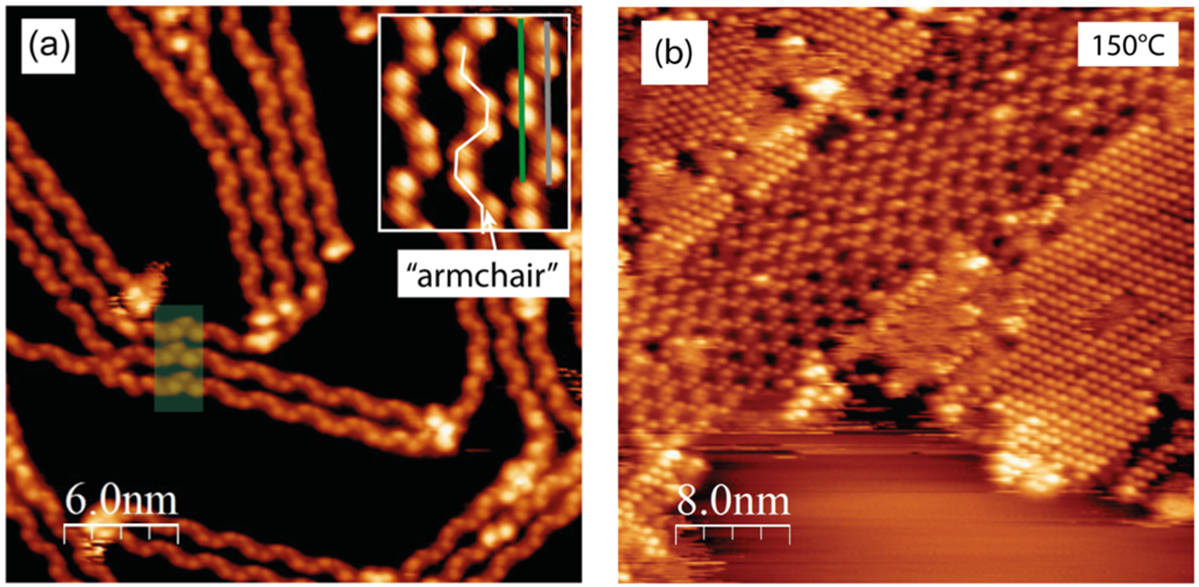
Figure: (a) OM chains grown by annealing DBBA/Ag(111) at 120°C. Inset: three OM chains with “armchair” chain pattern. (b) Transformation of OM chains to covalent chains at 150°C.
[1] K. A. Simonov et al., Scientific Reports 8, 3506 (2018), doi:10.1038/s41598-018-21704-3.

