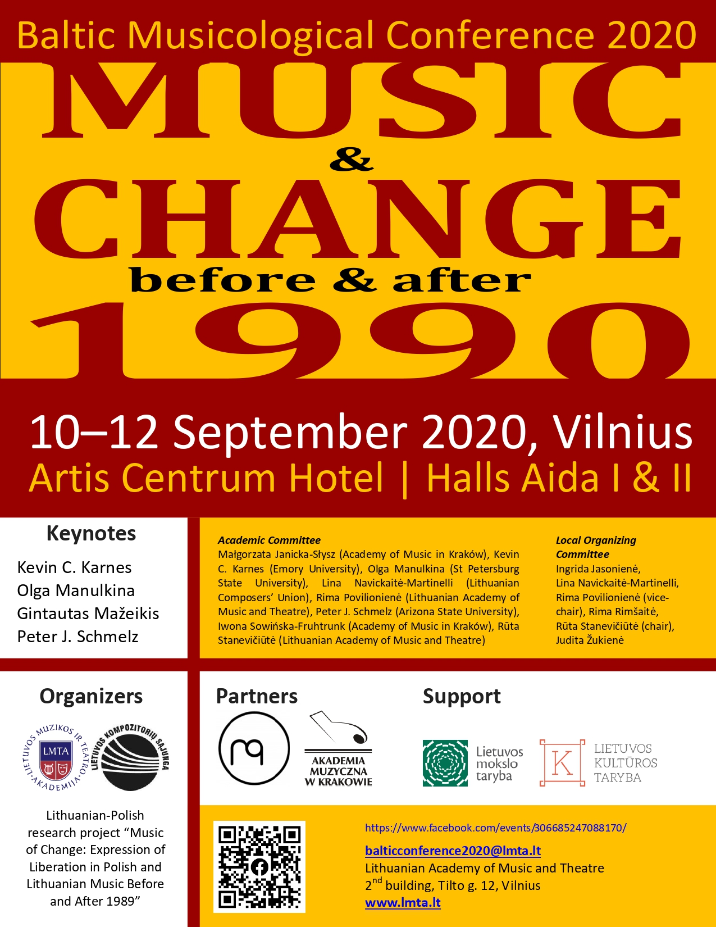
Conference Schedule
10–12 September 2020 Lithuanian Academy of Music and Theatre

10 September, Thursday

online presentations

9.00–9.45 | Registration
9.45 | CONFERENCE OPENING | Hall Aida I ZOOM Room 1
10.00–11.00 | KEYNOTE LECTURE #1 | Chair Rūta Stanevičiūtė | Hall Aida I  ZOOM Room 1  Gintautas Mažeikis. Dialectics of Music and Popular Revolutions:  Lithuania, Ukraine, Belarus
11.00–11.30 | Coffee
11.30–13.00 | Session 1 | Chair Rūta Stanevičiūtė | Hall Aida I ZOOM Room 1
 | Małgorzata Janicka-Słysz. In the Poetics of Experience: On Polish Music from the Perspective of the Affective Turn of the 1990s
 | Andrzej Mądro. On the Other Side of Freedom—the Band Miłość and the Polish Yass Scene
 | Iwona Sowińska-Fruhtrunk. The Idea of Freedom in Krzysztof Penderecki’s Works: From Experience to Expression
 | Session 2 | Chair Jūratė Katinaitė | Hall Aida II ZOOM Room 2
 | Austė Nakienė. Symbolical Events: the Centenary of Independent Republic of Lithuania and the 30th Anniversary of the Baltic Way
 | Charris Efthimiou. The German Student Movement of 1968 and Hans Werner Henze’s Development of His Musical Language
 | Beata Baublinskienė. The Renewal of Gregorian Chant as a Sign of Political and Cultural Change in Lithuania
13.00–14.30 | Lunch
14.30–15.30 | Session 3 | Chair Daina Urbanavičienė | Hall Aida I ZOOM Room 1
 | Vita Gruodytė. The (im)Perfection of Transition
 | Jānis Kudiņš. Bearslayer Always Sings For Freedom!—The Musical Inspirer of Liberation and Critic into the Post-Totalitarian Situation in Latvia
 | Session 4 | Chair Jūratė Katinaitė | Hall Aida II ZOOM Room 2
 | Audronė Žiūraitytė. The Variety of Interpretations of Eduardas Balsys’ Ballet Eglė, žalčių karalienė
 | Rima Povilionienė. Expanding the Sound Borders. On Microtonal Attempts in Lithuanian Music
15.30–16.00 | Coffee
16.00–17.00 | KEYNOTE LECTURE #2 | Chair Rūta Stanevičiūtė | Hall Aida I  ZOOM Room 1  Kevin C. Karnes. Disco Culture and the Ritual Journey in the Soviet 1980s
17.30 | Conference Reception-Concert | Traviata Restaurant Artis Centrum Hotel

11 September, Friday

online presentations

10.30–11.00 | Registration
11.00–12.30 | Session 5 | Chair Beata Baublinskienė | Hall Aida I ZOOM Room 1
 | Nana Sharikadze. Georgian Unofficial Music as a Fact of Musical Resistance (On the Example of Micheil Shugliashvili’s Works)
 | Dominika Micał. “I Would Like to Describe a Light”: Zygmunt Mycielski’s Eight Songs to Words by Zbigniew Herbert
 | Zane Prēdele. The Discourse on Internal and External Freedom in the Music Articles Published in the Latvian Newspaper “Literature and Art” (1989–1991)
Plenary, The Synergy of Musicology and Music Education
Session 6 | Chair Charris Efthimiou | Hall Aida II ZOOM Room 2
 | Emilija Sakadolskienė. Where Have All the Scholars Gone?
 | Arvydas Girdzijauskas. Music Making for the Quality of School Life
 | Rūta Girdzijauskienė. Towards Coherent Music Education: When Music Education Meets Musicology
12.30–13.00 | Coffee
13.00–14.30 | Session 7 | Chair Charris Efthimiou | Hall Aida I ZOOM Room 1
 | Jūratė Katinaitė. Opera Singer at the Crossroad of Epochs: Social, Cultural and Artistic Challenges
 | Rasa Murauskaitė. Change of Roles in Contemporary Lithuanian Opera: Who Is Who Now?
 | Baiba Jaunslaviete. Plenary Sessions and Congresses of the Latvian Composers’ Union in the 1980s as an Indicator of Sociocultural Changes
14.30–16.00 | Lunch
16.00–17.30 | Session 8 | Chair Beata Baublinskienė | Hall Aida I ZOOM Room 1
 | Mimi Mitchell. Reframing the Early Music Movement
 | Eva Vicarova. Czech Lands and Sacred Music Before and After 1989
 | Teresa Malecka. The Phenomenon of the Polish Composers’ School in the Second Half of the Twentieth Century in the Context of Cultural and Political Changes
 | Session 9 | Chair Rima Povilionienė | Hall Aida II ZOOM Room 2
 | Rūta Stanevičiūtė. Musical Dissensus: Informal Musical Communities and Affective Spaces in Soviet Lithuania
 | Danutė Petrauskaitė. Dialogues of a Soviet Nomenklatura Representative with a “Stray Bird”: Letters of Vytautas Laurušas to Jeronimas Kačinskas
 | Daina Urbanavičienė. Jazz and Cultural Liberation in Soviet Lithuania
17.30– 18.00 | Coffee
18.00–19.00 | KEYNOTE LECTURE #3 | Chair Rūta Stanevičiūtė | Hall Aida I  ZOOM Room 1
 | Peter J. Schmelz. The Russians are Coming!: The Ganelin Trio in North America, Summer 1986

12 September, Saturday

online presentations

10.30–11.00 | Registration
11.00–12.00 | Session 10 | Chair Daina Urbanavičienė | Hall Aida I ZOOM Room 1
 | Iván César Morales Flores. “Special Period in Times of Peace”: Emergence, Exodus and Evasion on the Cuban Music Map of the 1990s
 | Heli Reimann. Demythologization of the Myths of Tallinn ’67 Jazz Festival
 | Session 11 | Chair Rasa Murauskaitė | Hall Aida II ZOOM Room 2
 | Ingrida Alonderė. New Media in Choral Practice: Virtual Choir as a Prophet of the New Reality
 | David Cotter. 2020 Vision: Identity, Musicology, and Virtual Reality
12.00–12.30 | Coffee
12.30–14.00 | Session 12 | Chair Rima Povilionienė | Hall Aida I ZOOM Room 1
 | Lina Navickaitė-Martinelli. Three Tenors in Barcelona, or How Classical Performers Sought an Audience
 | Aušra Strazdaitė-Ziberkienė. The International Festival of Contemporary Music “Iš arti”: A Long-Lived Phenomenon
 | Gražina Daunoravičienė. A Typologizing Look at the Last Three Decades of Lithuanian Music Development
14.00–15.30 | Lunch
15.30–16.30 | KEYNOTE LECTURE #4 | Chair Rima Povilionienė | Hall Aida I  ZOOM Room 1
 | Olga Manulkina. The Roaring 90s: Gergiev and St. Petersburg
17.00 | Special event: Awards of the best musicological works 2019 | Halls Aida I&II

