P. E. Tovstik
Doctor of P. and M. Sciences, Professor, SPbGU
N. V. Naumova
Candidate of P. and M. Sciences, Associate Professor, SPbGU
G. V. Pavilaynen
Candidate of P. and M. Sciences, Associate Professor, SPbGU

To the effect of elastic-plastic bending of beams

The study of a deformation features of metal alloys with anisotropy of plastic properties under axial stress state and the study of alloys, which are sensitive to tension or compression loading is an important technical challenge in the design and creation of a new shipbuilding and aircraft constructions.
Different mathematical models [1,2] are used for such materials research where anisotropy parameter and SD(strength-different) parameter are taken into account. Their impact is significant during the analysis of the overall picture of the intense deformed state.We solve the problem analytically and numerically. As an example of the material with the SD-effect steel A40X is considered.
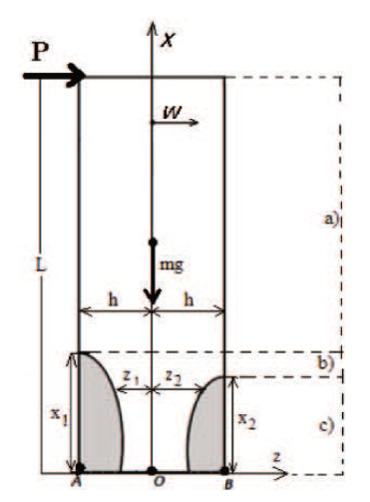
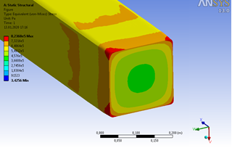

Fig.1. Mathematical model of SD-beam. Fig.2. The numerical solution of ϭ(x) at P=0,1 MN

Firstly, we study the case (c) (see Fig.1). The development zones of plasticity is asymmetric (hatched in Fig.1). After defining the functions z₁(x), z₂(x) from the equilibrium condition in cross section we get the curvature of beam as the function of x. Then we use the classical dependence between the curvature and the deflection of the beam and organize the differential equation. After integrating and using boundary conditions, we get the formula for calculating beam deflection. Then we use the procedure of "gluing" solutions for deflection along the entire length of the beam. This is possible since the deflection function must be continuous and differentiable.The solution of w(x) is analytically in the form of simple formulas.
The numerical solution is possible by the FEM [3] in softpackage ANSYS13.0 (see Fig.2). The results may be used to process experimental data.

Acknowledgement

This study was supported by the Russian Foundation for Basic Research, grant No. 19-01-00208.

Reference
- G.V. Pavilaynen, Elasto-Plastic Deformations of Ribbed Plates. Amer.Math.Soc.Providence, R.I.,1993, pp.227—233.
- G.V. Pavilaynen, Mathematical model for the bending of plastically anisotropic beams.Vestnik St. Petersburg University: Mathematics 48, pp. 275–279 (2015)
- G.V. Pavilaynen, N.V. Naumova Elastic-plastic deformations of SD-beams. In Seventh Polyachov's Reading, 2015, edited by I.C. on Mechanics (2015), p.7106764.

