# Numerical modeling of the elastic-plastic bending of SD-plates

Численное моделирование упругопластического изгиба SD-пластин

***Galina V. Pavilaynen,***

*Associate Professor of the Department of Theoretical and Applied Mechanics*

*St. Petersburg State University, St. Petersburg, Russia*

***Natalia Yu. Kropacheva***

*Associate Professor at the Department of General Mathematics and Computer Sciences*

*St. Petersburg State University, St. Petersburg, Russia*

**Key words**: SD-effect; state of biaxial stress; yield criterion; plates; anisotropy; distributed load; elastic-plastic bending

**Abstract.** The elastic-plastic bend of circular plates are considered. The metal alloys have different strength properties under tension and compression. Such materials are called plastically anisotropic or materials with SD-effect. Investigation of their properties is an important task in the design and construction of new building structures. We use the properties of SD-materials, the classical Hill’s theory of plasticity and various mathematical models in which the transversal isotropy parameter and the plastic anisotropy parameter (SD-parameter) we take into account. We present asymptotic formulas for stresses that we use for numerical modeling and graphical representation of elastoplastic properties of circular SD-plates. We obtain the numerical solution of the plate bend after calculating the system of fifth-order differential equations. We use Euler difference method or software package COMSOL 5.4. The results of the numerical solution we present in the form of figures and graphs.

**Introduction**

The classical theory of elastic and elastoplastic bending was developed in the scientific works of R. von Mises, R. Hill, L. H. Donnell. For thin isotropic plates S.P. Timoshenko was consider elasticity theory. Further development, with allowance for plasticity, belongs to V.V. Sokolovsky [1]. The material of the plate has different strength properties under tension and compression. It is called “plastically anisotropic” [2] or materials with SD-effect. Impact of the SD effect is significant for anisotropic metal alloys [3], modern structural materials and carbon plastics [4] at the biaxial stress state.

Numerous experimental studies [5, 6] show that the difference in yield stress in transversely isotropic materials reaches 40%, and the difference in yield stress in stretching and compression in SD materials reaches 25-30%.

The use of metal alloys with SD-effect in structures such as plates and shells operating under biaxial stress conditions, gives a significant increase in strength and load-bearing capacity [7]. An important problem is the estimation of the stressed state of a circular transversely isotropic plate made of a material with an SD effect [8]. In the present paper, a freely supported plate is investigated under the action of a constant distributed pressure.

To study the elastoplastic bending, various criteria of fluidity were used [9, 10]. They introduced the parameters of transverse isotropy and plastic anisotropy. The influence of these parameters on the development of plastic regions and on deflection was considered in [11].

**Mathematical model**

Let us consider the problem of elastic-plastic bending of a round freely supported SD-plate possessing the properties of transverse anisotropy and uniformly loaded with pressure p on the upper surface.

Figure 1 shows the central cross section of a curved circular plate and the following notation is introduced: ℎ is the half thickness of the plate, 𝑥1 , 𝑥2 is the radius of the plastic regions from below and from above respectively, 𝑎1 , 𝑎2 are the depths of the plastic zones from below and from above, respectively. The plastic regions are shaded. The neutral surface, in the case under consideration, does not coincide with the geometrically average surface. A solid line ― the neutral surface, a dashed line ― the geometrically the middle surface.

The beginning of the coordinate system is in the center of the plate on the neutral surface (point *O* in Figure 1.). The development of plastic zones is disturbed.

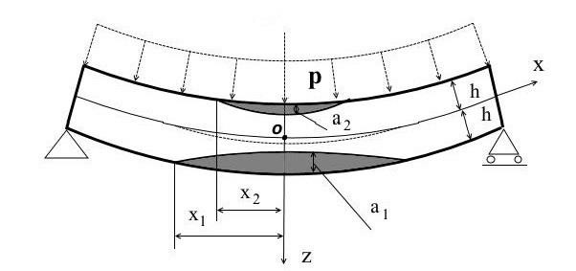

**Figure 1. Elastic-plastic bending of a circular plate from SD material.**

At first, we consider the simple case of elastic-plastic bending of the transversal isotropic plate without SD-effect and the corresponding yield criterion [8]

$σ_{p}=\sqrt{σ_{r}^{2}-Aσ_{r}σ_{θ}+σ_{θ}^{2}}$.(1)

where 𝜎*r*, 𝜎𝜃 are the stresses in the plane of the plate. In this criterion uses the transversal isotropy parameter A, which varies from 1 to 2 and calculates by the formula

$A=2-\frac{σ_{p}^{2}}{σ_{pz}^{2}}$ (2)

where 𝜎𝑝 is the yield point for uniaxial tension in the plane of the plate and 𝜎𝑝𝑧 is the yield point for uniaxial tension in a direction perpendicular to the plane of the plate.

The relationships between the stresses and the curvature parameters for a transversal- isotropic material without an SD effect were obtained in [8].

In the articles [9], [10], the mathematical model for the SD-plate was made more complicated and a new criterion of fluidity was proposed:

$\overline{k}=\sqrt{σ_{r}^{2}-Aσ_{r}σ_{θ}+σ_{θ}^{2}}+σβ$. (3)

in which a parameter β introduces. The β characterizes the plastic anisotropy property (SD effect).

For uniaxial stretching (the formula on the left) and uniaxial compression (the formula on the right), criterion (3) is equal to:

$\overline{k}=σ_{p}+\frac{1}{3}σ_{p}β$*, $\overline{k}=σ_{c}+\frac{1}{3}σ_{c}β.$*  (4)

Here 𝜎𝑝 is the yield point for uniaxial tension in the plane of the plate and 𝜎𝑐 is the yield point by uniaxial compression in the plane of the plate. Then the relationship between 𝛽, 𝜎𝑝 and 𝜎𝑐 is:

$\frac{σ_{c}}{σ_{p}}=\frac{3+β}{3-β}$ (5)

We substitute β from (5) into (3). Then:

$\overline{k}=\frac{2σ_{p}σ_{c}}{σ_{p}+σ_{c}}$ (6)

In the case of a biaxial stress state, the criterions for stretching and compression can be written accordingly:

$\overline{k}=σ_{pz}\sqrt{2-A}+\frac{2}{3}σ_{pz}β$, $\overline{k}=σ_{cz}\sqrt{2-A}-\frac{2}{3}σ_{cz}β$ (7)

or

$σ_{pz}\sqrt{2-A}+\frac{2}{3}σ_{pz}β=σ_{cz}\sqrt{2-A}-\frac{2}{3}σ_{cz}β$ (8)

then

$β=\frac{3\sqrt{2-A}}{2}\frac{\left(σ_{cz}-σ_{pz}\right)}{\left(σ_{cz}+σ_{pz}\right)}$*.* (9)

Substituting the resulting expression for 𝛽 in (9), we obtain the formula for *A:*

$A=2-\frac{{\left(σ_{pz}+σ_{cz}\right)}^{2}}{{\left(σ_{p}+σ_{c}\right)}^{2}}\frac{σ_{p}^{2}σ_{c}^{2}}{σ_{pz}^{2}σ_{cz}^{2}}$*.* (10)

The bending of the plate is considered according to the model of a plane stress state. The deformation of the transverse shear is ignored. The stress in the direction perpendicular to the plane of the plate is assumed to be zero, then the average stress is equal to:

$σ=\frac{σ_{r}+σ_{θ}}{3}$*.* (11)

Proceeding from formulas (8), (9) and (10) it is possible to establish a connection between yield strengths

$\frac{σ_{c}}{2σ_{cz}}=\left(\frac{σ_{c}}{σ_{p}}-1\right){\left(\frac{σ_{cz}}{σ_{pz}}-1\right)}^{-1}$. (12)

If the 𝜎𝑝, 𝜎𝑐, 𝜎𝑝𝑧, 𝜎𝑐𝑧, are known, then the values of 𝛽 and *A* can be calculated. To most metal alloys, 𝜎𝑝 ⩽𝜎𝑐 [6], therefore it follows from formula (9) that 𝛽 ⩾ 0, from formula (10) *A*⩽ 2.

In the article [10] shows a more complex the relationship between the stress and the curvature parameters 𝜉𝑟, 𝜉𝜃 for a transversely isotropic SD-material:

$σ_{r}=\frac{\overline{k}}{\sqrt{3\left(2-A\right)}}\left(\frac{(2ξ_{r}+Aξ_{θ})}{sign(z)ξ}-\frac{2β}{\sqrt{3}}\right)\left(1-\frac{β(ξ_{r}+ξ_{θ})\left(2+A\right)}{sign(z)\sqrt[3]{3\left(2-A\right)ξ}}\right)$*,* (13)

$σ_{θ}=\frac{\overline{k}}{\sqrt{3\left(2-A\right)}}\left(\frac{(2ξ_{θ}+Aξ_{r})}{sign(z)ξ}-\frac{2β}{\sqrt{3}}\right)\left(1-\frac{β(ξ_{θ}+ξ_{r})\left(2+A\right)}{sign(z)\sqrt[3]{3\left(2-A\right)ξ}}\right)$*,* (14)

where

$ξ=\frac{sign(z)β\left(2+A\right)(ξ_{r}+ξ_{θ})}{\sqrt[3]{3\left(2-A\right)}}+\sqrt{\frac{\left(2+A\right)\left(ξ_{r}^{2}+Aξ_{r}ξ_{θ}+ξ_{θ}^{2}\right)}{3\left(2-A\right)}}$*,* (15)

The most critical from the point of view of the evaluation of the stressed state of the plate is its center, therefore we will consider the stresses in the plastic regions near the centers of the upper and lower surfaces of the plate.

Suppose that 𝛽 ≪ 1. In this case, can propose simplified formulas with an allowable error. In the center of the plate 𝜉*r* = 𝜉𝜃, therefore 𝜎𝜃 = 𝜎𝑟 and formulas (13), (14) take the form:

$σ_{θ}=σ_{r}=\frac{\overline{k}}{a}\left(\frac{1}{sign(z)F}-\frac{2β}{3a}\left(1+\frac{1}{F^{2}}\right)+\frac{4β^{2}}{sign(z)9a^{2}F}\right)$, (16)

where

$a=\sqrt{2-A}$*, F=*1*- $\frac{sign(z)2β}{3a}$.* (17).

We introduce the new notations *F-* and *F+*.

*, .* (18)

Consider first an isotropic material with an SD effect. Then, in formula (17) *A* = 1, 𝑎 = 1, exact formula for the stress at the center of the lower surface of the plate (stretching zone) is

$\frac{σ_{+}}{σ_{p}}=\frac{3+β}{3}\left(1-\frac{2β}{3}-\frac{2β}{3}{\left(1-\frac{1}{3+2β}\right)}^{2}\right)$, (19)

and for the stress at the center of the upper surface of the plate (compression zone)

$\frac{σ_{-}}{σ_{p}}=-\frac{3+β}{3}\left(1+\frac{2β}{3}-\frac{2β}{3}{\left(1-\frac{1}{3+2β}\right)}^{2}\right)$. (20)

Expanding (19) and (20) in a Maclaurin series with respect to the small parameter 𝛽 and neglecting terms of the order of 𝛽3 and above, we write out approximate formulas for the stresses in the stretching and compression zones:

$\frac{σ_{+}}{σ_{p}}=\frac{3+β}{3}\left(1-\frac{2β}{3}\right)$*, $\frac{σ_{-}}{σ_{p}}=-\frac{3+β}{3}\left(1+\frac{2β}{3}\right)$.* (21)

**Numerical modeling**

We denote the exact values of the stress ratio 𝜎+, 𝜎- to the yield point 𝜎𝑝 as:

$=\frac{σ_{+}}{σ_{p}}$ $=\frac{σ_{-}}{σ_{p}}$ (22)

and approximate values as:

$≈\frac{σ_{+}}{σ_{p}}$ $≈\frac{σ_{-}}{σ_{p}}$ (23)

**Table 1. Comparison of the exact and approximate values $\frac{σ_{+}}{σ_{p}}, \frac{σ_{-}}{σ_{p}}$.**

|  |  |  |  |  |
| --- | --- | --- | --- | --- |
| 𝛽 | = 𝜎−/𝜎𝑝 | ≈ 𝜎−/𝜎𝑝 | = 𝜎+/𝜎𝑝 | ≈ 𝜎+ /𝜎𝑝 |
| 0 | 1 | 1 | 1 | 1 |
| 0.01 | 1.0096 | 1.0100 | 0.9969 | 0.9966 |
| 0.05 | 1.0506 | 1.0506 | 0.9826 | 0.9828 |
| 0.1 | 1.1025 | 1.1022 | 0.9638 | 0.9644 |

Comparison of the exact formulas with the approximate ones (Table 1) shows that for the parameter 𝛽 varying in the range from 0 to 0.1, the allowable error in the stretching zone does not exceed 0.3 percent, and in the compression zone 0.2 percent.

We now turn to an analysis of the mutual influence of the transversal isotropy and the SD effect. In this case, *A* > 1, ≠ 1 and the calculated formulas take the form:

$\frac{σ_{+}}{σ_{p}}=\frac{β+3}{3\sqrt{\left(2-A\right)}}\left(1-\frac{2β}{3\sqrt{\left(2-A\right)}}\right)$, (24)

$\frac{σ_{-}}{σ_{p}}=-\frac{β+3}{3\sqrt{\left(2-A\right)}}\left(1+\frac{2β}{3\sqrt{\left(2-A\right)}}\right)$. (25)

Thus, it becomes possible to estimate the influence of the parameters *A* and 𝛽 on the stresses in the plate, not solving the large problem of elastoplastic equilibrium of the plate [11].

The results of calculations using formulas (24) and (25) are given in Table 2.

**Table 2. Dependence of stresses in the plate on the parameters** 𝜷 **and** 𝑨**.**

|  |  |  |  |  |  |  |
| --- | --- | --- | --- | --- | --- | --- |
|  | *A* = 1.1 | *A* = 1.1 | *A* = 1.2 | *A* = 1.2 | *A* = 1.3 | *A* = 1.3 |
| 𝛽 | ≈ 𝜎− /𝜎𝑃 | ≈ 𝜎+ /𝜎𝑃 | ≈ 𝜎− /𝜎𝑃 | ≈ 𝜎+/𝜎𝑃 | ≈ 𝜎−/𝜎𝑃 | ≈ 𝜎+ /𝜎𝑃 |
| 0 | 1.054 | 1.054 | 1.119 | 1.119 | 1.195 | 1.195 |
| 0.01 | 1.065 | 1.050 | 1.131 | 1.114 | 1.205 | 1.185 |
| 0.05 | 1.110 | 1.033 | 1.178 | 1.094 | 1.245 | 1.150 |
| 0.1 | 1.165 | 1.0128 | 1.242 | 1.067 | 1.333 | 1.136 |

As the parameter of transversal isotropy increases, the stresses increase. An increase in the parameter *A* by 10% causes an increase in stresses at *β* = 0 by 7%, and at *β* = 0.1 by 10%, therefore, the rate of stress growth with increasing *β* increases. With an increase in *β* by 5% and a fixed *A*, the compressive stress increases by 5.5%, and the tensile stress drops by 2.3%. Analysis of the results of numerical simulation shows that for weak plastic anisotropy, the influence of the transversal isotropy parameter is greater than the effect of the SD, but with a strong plastic anisotropy, the effect of the SD increases substantially. This conclusion becomes even more

obvious if we plot the stress functions that depend on the parameters *A* and 𝛽.

*Graphical representation*

Let us turn to a graphic illustration of the calculations performed. The asymptotic formulas (24) and (25) allow one to analyze the influence of the parameters of the transversal isotropy A and the plastic anisotropy β on the stresses in the plate. Formulas (24), (25) do not depend on the level of pressure on the plate, nor on its dimensions. Therefore, they are universal.

The calculations made in the software package “MATHEMATICS 5.0”.

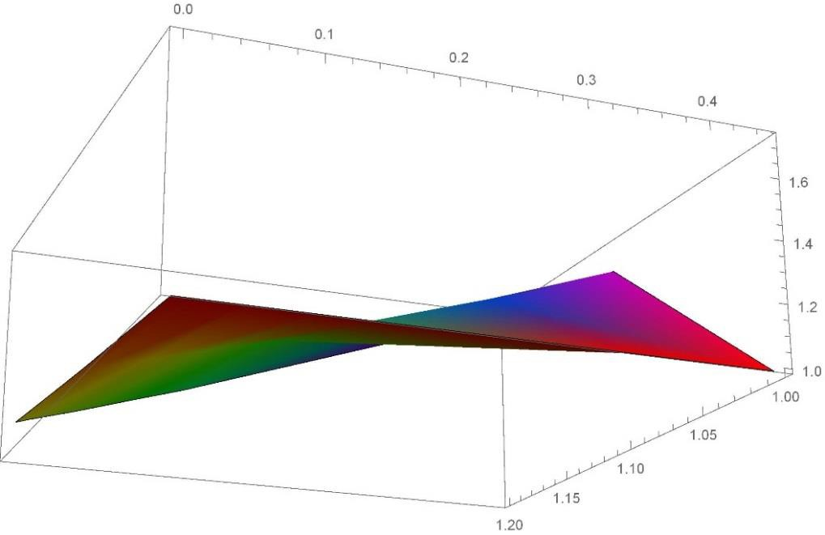

**Figure 2. Graph of the function of compressive stresses in the center of the upper surface of the plate $\frac{σ_{-}}{σ_{p}}$** (𝜷, 𝑨)**.**

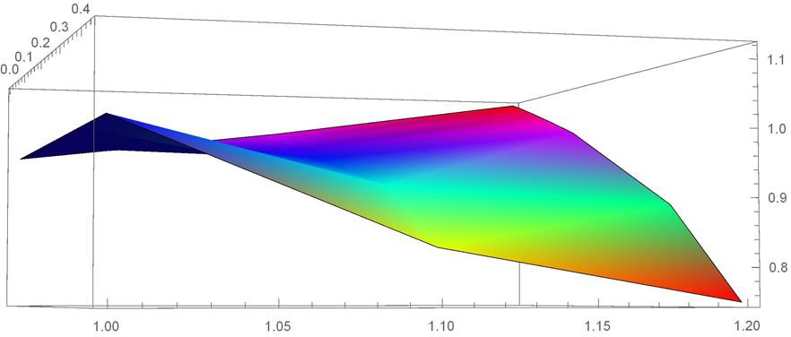

**Figure 3. The graph of the function $\frac{σ_{+}}{σ_{p}}$**  (𝜷, 𝑨) **at the center of the lower surface of the plate.**

The graphs of the functions $\frac{σ_{-}}{σ_{p}}$ (𝜷, 𝑨) and 𝜎 $\frac{σ_{+}}{σ_{p}}$ (𝜷, 𝑨) clearly show convex subsets in which we can determine the values of 𝛽, 𝐴 for which the stresses $\frac{σ_{+}}{σ_{p}}, \frac{σ_{-}}{σ_{p}}$― locally are minimal.

As a result of calculations, we know that рlasticity area in the compression zone of the plate is substantially smaller than those in the tension zone. We assume that the yield strength during compression is greater than that under tension. To calculate the bending, the COMSOL 5.4 software package is used. Depending on the pressure, we calculate the sizes of plasticity zones. According to the results of the calculation, the magnitude of the plasticity "spot" and the depth of plasticity areas significantly depends on the condition of compression or tension (see fig.4,5).

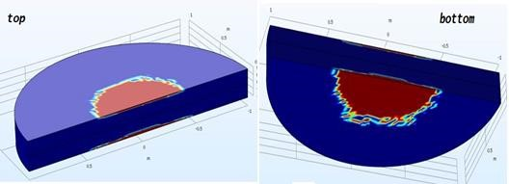

**Figure 4. The plasticity “spot” at the top of the plate.** **Figure 5. The plasticity “spot” at the bottom.**

**Conclusions**

Numerical modeling and graphical representation of the elastoplastic properties of circular transversely isotropic and plastic anisotropic plates showed that for surface stress functions a solution to the problem of optimizing the selection of the parameters of transversal isotropy and plastic anisotropy under the condition of minimum stresses is possible.

The application of the yield criterion, taking into account the transversal isotropy and the SD effect for the elastoplastic bending of a circular plate, made it possible to construct asymptotic formulas for their calculation. The formulas obtained are universal and estimate the influence of the parameters of transversal isotropy and SD effect on the stress-strain state of any material satisfying the described conditions. Asymptotic formulas allow us to make a rapid evaluation of the stress state of a plate without cumbersome calculations, which is important in engineering practice. As a result, we can conclude that the capabilities of the COMSOL software package allow us to investigate many problems of nonlinear deformation of SD-materials.

**Acknowledgement**

This study was supported by the Russian Foundation for Basic Research, grant No. 16-01-00523.

**References**

1. Sokolovskiy V. V. Theory of plasticity. Moscow: Vysshaya shkola, 1969. 608 p. (rus)
2. [Backofe](https://www.google.ru/search?hl=ru&amp;tbo=p&amp;tbm=bks&amp;q=inauthor%3A%22Walter%2BA.%2BBackofen%22)n W. A. Deformation processing. Addison-Wesley Pub. Co., 1972. 326 p.
3. Dowling N. E. Mechanical Behavior of Materials., Published by Pearson Education Limited, United Kingdom, 2014. 974 p.
4. Amelina Ye.V., Golushko S.K., Yerasov V.S., Idimeshev S.V., Nemirovskiy Yu.V., Semisalov B.V., Yurchenko A.V., Yakovlev N.O., On nonlinear deformation of carbon plastics: experiment, model, calculation. Computing technologies. 2015. Vol. 20. No 5. Pp. 27-52. (rus)
5. Kulawinski D., Nagel K., Henkel S., Hübner P., Fischer H., Kuna M., Biermann Y., Characterization of stress-strain behavior of a cast TRIP steel under different biaxial planar load ratios. // In: Engineering Fracture Mechanics. 2011. Vol. 78, pp. 1684-1695.
6. Bramfitt B. L., Structure/Property Relationships in Irons and Steels. // Metals Handbook., ASM International, 1998. pp. 153-173.
7. Rybakina O.G. The yield strength of an anisotropic material with the SD effect. Studies on the elasticity and plasticity. // Vestn. Leningr. un-ta., 1982, № 14. Pp.132-142. (rus)
8. Pavilaynen G.V. Elastic-plastic bending of a circular transversally isotropic plate. // Vestn. Leningr. un-ta., 1983, № 13. Pp. 70-75.
9. Matveyeva Ye.V., Pavilaynen G.V. Consideration of the effect of material resistance against bending of plates. // II Polyakhov’s Reading. SPb., 2009., Pp. 294-304. (rus)
10. Yushin R.YU. On the possibility of the account of plasticity anisotropy when bending round plates. // Vestn. S.-Peterb. un-ta., Ser.1. 2010, V. 1. - Pp.134-140.
11. Pavilaynen G.V., Yushin R.YU. Analysis of the account of elastic transversal isotropy and plastic anisotropy in the bending of circular plates]. // Vestn. S.-Peterb. un-ta., Ser.1. 2010, V. 4. Pp.128-137.