**Global trends in the world gas market in conditions of turbulence and high uncertainty: price convergence and changes in the structure of demand**

*Asadula* Asadulaev1, *Vladimir* Urazgaliev1[1], *Andrey* Agashin1*,* and *Galina* Menshikova 1

1 St. Petersburg State University, Faculty of Economics, 7/9 Universitetskaya nab., St. Petersburg, 199034 Russia

**Abstract**

**Research background.** At present, changes are taking place in the world gas market that affect both consumer countries and countries-suppliers of this energy resource. In a situation of high instability and non-stationarity of gas prices, their unpredictability, an unprecedented increase in prices, as in August 2022 at the Dutch TTF hub to €323.9 per 1 MWh, there was a divergence in prices for world gas markets, despite continued convergence until 2020. These changes affected a number of regional markets, especially countries with market prices, as well as the global gas market as a whole. **Purpose of the article:** consider the processes of convergence of prices and demand for gas in different regions of the world depending on price models, identify the causes of convergence or divergence in the world gas markets and assess the prospects.

**Methods:** analysis of time series stationarity, study of cointegration of natural gas prices in different regions of the world, factor analysis. **Findings & Value added:** The article contains a time series analysis of natural gas price patterns before and after 2021, the main trends in import volumes by region depending on price patterns, and the impact of reduced natural gas price convergence on the global natural gas market as a whole.

**Keywords** *world gas market; gas prices; price convergence; gas imports*

**JEL Classification:** *C32; F63; Q41*

**1 Introduction**

In the pre-crisis period of 2020, there was a steady trend towards the universal integration of global natural gas markets, which manifested itself in the convergence of world prices for natural gas and LNG for various regions of the world. In the process of globalization, liberalization and expansion of spot trade in natural gas up to 2020, there was a tendency to decrease the rate of variation in natural gas prices from 43% to almost 33% in 2005-2020 for countries where the prevailing mechanism of pricing for natural gas is the market mechanism or the so-called "liberal" pricing. For countries engaged in natural gas pricing, mainly with reference to the price of crude oil and petroleum products under the OPE pricing mechanism, the dispersion in the same period turned out to be less and was at the level of 25-30%, which indicated a low variation in natural gas prices in this group of countries. These trends persisted until recently and indicated a convergence of prices in various regions of the world against the background of an increase in LNG supplies.

After the energy crisis of 2021-2022, which affected many European countries, there were changes in the global natural gas markets - the convergence of prices in the global natural gas market for countries with a competitive market pricing mechanism, GOG "Gas–on-Gas" has sharply decreased, with a relatively stable convergence of natural gas prices in countries with pricing by the OPE "Oil Price Escalation" mechanism with reference to the price of oil and petroleum products. Against the background of an unprecedented increase in gas prices in August 2022 at the Dutch TTF hub to 323.9 euros per 1 MWh, the price discrepancy intensified, against the background of turbulence in spot gas prices and high uncertainty about the future regarding the dynamics of the latter, the convergence of natural gas prices was replaced by divergence and new global energy trends.

**2 Materials and Methods**

The research on the integration of global natural gas markets, including the analysis of the dynamics of natural gas prices before and after the energy crisis of 2021-2022, has been devoted to the work of many researchers (Urazgaliev, V., Titkov, M., 2018; Novikov, et al, 2021). For example, some of them (Novikov, et al, 2021) point to the relative independence of the gas markets in Europe, Asia, and the USA, with a possible convergence of prices against the background of their growth after the 2020 pandemic. It is impossible not to deny the existing contradictions arising in the emerging natural gas market in the global world, including those related to the transportation of natural gas and the existing gas transportation infrastructure, against the background of the geopolitical struggle for increasing LNG supplies from the United States to the EU (Urazgaliev, V., Titkov, M., 2018).

According to a number of researchers, the global energy crisis of 2021-2022 led to the need to save "blue fuel" for various sectors of industry and for the population of a number of countries, and its shortage, for example, in Germany, led to a reduction in natural gas consumption in the second half of 2022 by 23% compared to the baseline level (Ruhnau, et al, 2022). However, the decline in natural gas supplies from Russia was not the only and not the main factor that influenced the energy crisis in the EU countries. This process was primarily due to the key role of the ultra-liberal pricing mechanism and spot trading, which led to an unprecedented increase in gas prices and their stochastic nature or unsteadiness against the background of demand for natural gas and its limited supply in the EU. Despite the fact that during 1980-2020. the dynamics of prices for natural gas, as well as for many other types of energy resources, maintained a trend-stationary character (Landajo, 2021), already today it is becoming obvious that there has been an increase in the number of factors affecting price dynamics, such as the transformation of existing pricing models and the transition to competitive pricing, and the strengthening of the seasonal component in the analysis of the stationarity of time series.

In these conditions, the unpredictability and increased dispersion of prices at European gas hubs and the idea of overcoming the uncertainty of the future dynamics of natural gas prices using various modern forecasting methods, for example, predicting the volatility of natural gas prices in a cloud of uncertainty, received the most attention (Juan, et al, 2023). So, even after the COVID-2019 crisis, global uncertainty has significantly increased (Juan, et al, 2023), and in the current period, the need to achieve carbon neutrality, including overcoming uncertainty in the oil supply and demand markets, which is closely related to natural gas markets and its prices, global uncertainty has become an independent subject of research, including in relation to the study of specific regional energy markets and natural gas markets. In the context of this uncertainty, forecasting spot gas prices is one of the most important issues requiring the most modern methods of solutions (Mouchtaris, et al, 2021).

In our opinion, in the conditions of the current uncertainty, the convergence of natural gas prices may be due to their relative stability and predictability, as well as the immutability of their dispersion over time, which is the basis of such a concept as stationarity. Presumably, it is the non-stationary nature of the price dynamics of natural gas that can cause prices to diverge in different regions, while their stationarity leads to relatively less dispersion and a low coefficient of variation. In addition, in our opinion, the convergence of prices can be considered not only as a decrease in price variation in individual regions, but also as a convergence of prices in their absolute value.

**3 Results and Discussion**

Let's turn to the data presented in the report of the International Gas Union (IGU), which provides analytics on more than 100 global natural gas markets based on a database for 14 years. To assess the convergence of regional markets, the coefficient of variation (in %) (Wholesale Price Report 2022) is used, the higher the level of the indicator, the lower the convergence of prices in the studied markets, that is, there is a divergence, and vice versa. The coefficient of variation is calculated as the ratio of the standard deviation of the indicator to the average value (Jaworski, et al, 2018) using the following formula: $CV=\frac{σ_{price}^{gas}}{\overline{x_{price}}}$ 
  
 (1)  
где $σ_{price}^{gas}$– standard deviation of natural gas prices; $\overline{x_{price}}$ 
 – unweighted average price of natural gas by gas markets.

As a result of a significant decrease in average world prices for natural gas, implemented both by the GOG and OPE pricing mechanism, in 2012-2016 from 7.2-7.3 $/MMBTU to 4.2-4.3 $/MMBTU, there was a significant decrease in their dispersion and the coefficient of variation as a whole from 68-69% to 48-49%, however The variation in natural gas prices remained high, and the sample was heterogeneous.

In addition, for countries with predominantly market pricing mechanisms (GOG, OPE, BIM), as well as regions connected by an integrated natural gas market and more able to carry out physical imports of natural gas, the convergence of prices was more noticeable.

It is important to note that the price convergence for various natural gas markets was more noticeable until 2020 for countries with OPE gas pricing linked to the price of oil and petroleum products than for countries with GOG pricing. After the crisis of 2020 and at the beginning of the energy crisis of 2021-2022, a new round appeared in the dynamics of prices at European gas hubs, which led to a divergence in natural gas prices and a high variation in world gas prices, implemented by the GOG mechanism (Fig. 1).

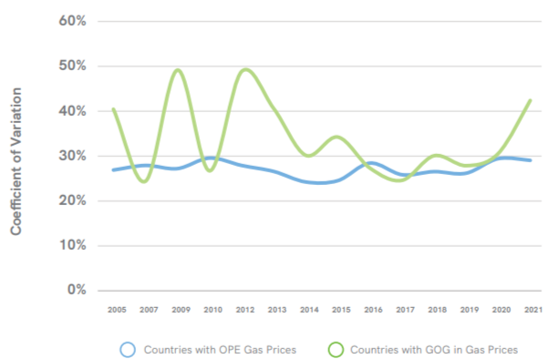  
**Figure 1.** Price Convergence for OPE and GOG Prices

Source: Wholesale Price Report (2022)

With relatively stable dynamics of contract prices linked to the price of oil and petroleum products, the dynamics of prices at gas hubs in Europe demonstrated a high degree of uncertainty and unpredictability, was non-stationary. Despite this fact, price convergence in European countries remained higher (Fig. 2), which is primarily related to the integrated gas market of the EU countries. The coefficient of variation in prices for natural gas sold under market pricing mechanisms for EU countries in 2021 turned out to be less than 25%, while for all other countries in the same year (including EU countries), the indicator was about 45-46% and indicated a high degree of variation, hence the divergence of world oil prices natural gas.

**Figure 2.** Price Convergence for Europe in 2005-2021

Source: Wholesale Price Report (2022)

Thus, despite the increased volatility of futures at the NBP hub in the UK, TTF in the Netherlands, the European gas market retained the convergence property, even under the condition of mutual non-stationarity of prices at these hubs, their linear combination presumably remained stationary due to the cointegration and coincidence of the general trend of these time series (Engle, Granger, 1987). Consequently, the stationary dynamics of natural gas prices may be characterized by less dispersion. If the price dynamics is unpredictable, then due to the property of co-integration of temporary prices for natural gas, it is possible to achieve their joint stationarity, which is possible thanks to the integrated natural gas market that has developed in the EU. The convergence of prices was also manifested in the relationship between electricity and natural gas prices on European markets during the energy crisis of 2021-2022. (Uribe, et al, 2022).

Discussion of the problem of high natural gas prices during the energy crisis of 2021-2022 is conducted by various authors (Kotek, et al, 2022). Thus, to solve this problem in the EU, the implementation of the fifth PCI package adopted by the European Commission in November 2021 was undertaken, which was aimed at significantly reducing prices in the EU, especially in the eastern member states, most of which largely depend on a single source of natural gas supplies (Kotek, et al, 2022). Among these packages, the majority, about 67 out of 98 key projects, are related to electricity transmission and storage projects in Western Europe, Central-Eastern and Southern Europe, as well as in the Baltic States as part of their energy system interconnection projects, including 20 projects aimed at creating a new EU gas infrastructure (Enerdata, 2021).

In 2022, the EU adopted a Joint Gas Procurement Mechanism when gas prices in Asia reached a record high. Also in December 2022, the EU Energy Council adopted a temporary market correction mechanism to reduce excessive price volatility at European gas hubs. This mechanism provides for a ceiling limit on gas prices in the amount of the base price of LNG plus 35 euros/MWh and is activated if gas prices for a month in advance for three consecutive days exceed 180 euros/MWh and the gas hub price TTF price for a month in advance by 35 euros/MWh is higher than the price of LNG on the world market during the same three days (IEA, 2023).

Indeed, in order to overcome the increased volatility of natural gas prices, it is necessary to search for new effective mechanisms and methods of regulating natural gas pricing, and it is desirable that these mechanisms be coordinated with each other in order to achieve single market integration (Uribe, et al, 2022).

Convergence of prices is possible not only within individual regions, but also for the emerging global natural gas market in the process of universal integration and globalization. Let's take a look at the dynamics of natural gas prices after the global energy crisis in such key regions as Asia, Europe and North America (Fig. 3).

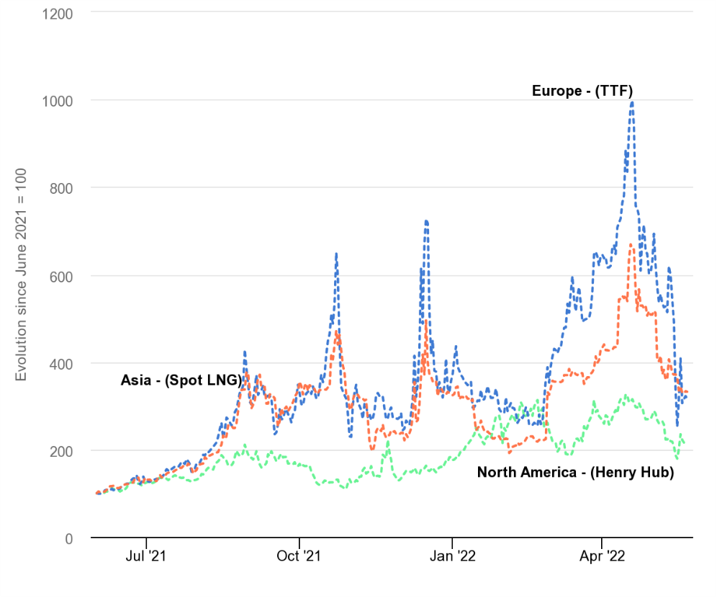

**Figure 3.** Evolution of key regional natural gas prices, June 2021-October 2022

Source: IEA (2022)

After prices on the Dutch TTF jumped more than 8.9 times on August 26, 2022, compared to June 2021, a trend towards convergence of prices and their even greater divergence became noticeable. Thus, until August 2022, the European natural gas market had a closer price relationship with the Asian market and similar dynamics in gas prices (Fig. 3), compared to the relatively isolated North American gas market. After the sharp increase in gas prices, the dynamics of prices for spot Asian gas and European TTF remained similar, but the discrepancy in absolute prices or interregional divergence became noticeable. By the end of 2022, the convergence of gas prices had become noticeable again after the attempts of the EU Energy Council to stabilize the dynamics of natural gas prices in conditions of high uncertainty. In turn, energy regulation can be considered a kind of strategic influence tool (Boute, 2022), which affects not only the convergence of world gas prices, but also the processes of forming a single gas market.

**4 Conclusion**

The analysis presented in the paper of the dynamics of time series for natural gas for various regions in the period before and after the energy crisis of 2021 indicates a decrease in the convergence of world prices for natural gas or the reverse trend – divergence. At the same time, the dynamics of prices for natural gas sold under the OPE mechanism with reference to the price of oil and petroleum products remained less volatile in comparison with prices for gas sold under the GOG mechanism, which is due to their greater exposure to market mechanisms during the energy crisis.

Despite the fact that Europe turned out to be the region most exposed to the energy crisis, price convergence in this region turned out to be higher, and price variation was not so significant (the coefficient of variation was less than 25%), due to the formed single natural gas market.

The energy crisis of 2021-2022 showed an increase in the divergence of world gas prices, which is an obstacle to the formation of a global natural gas market. Divergence of gas prices leads to a separation of interests in the creation of a unified gas infrastructure.

In the future, it is possible to return to intraregional convergence, however, with a greater level of price divergence between individual regions, if effective mechanisms for controlling natural gas prices are not adopted, which could strengthen the processes of formation of the global natural gas market and ensure its sustainable functioning.

**References**

*Journals:*

1. Boute, A. (2023). Shaping the Eurasian Gas Market: The Geopolitics of Energy Market Regulation. *Geopolitics,28*(5). <https://doi.org/10.1080/14650045.2022.2094778>. Q1
2. Chen, Juan & Xiao, Zuoping & Bai, Jiancheng & Guo, Hongling. (2023). Predicting volatility in natural gas under a cloud of uncertainties. *Resources policy*, 82(С). 103436. <https://doi.org/10.1016/j.resourpol.2023.103436>. Q1
3. Engle, R. F. & Granger, C. W. J. (1987). Co-integration and error correction: representation, estimation and testing. *Econometrica,* *55*, (2). <https://doi.org/10.2307/1913236>
4. Jaworski, A., Kuszewski, H., Ustrzycki, A., Balawender, K., Lejda, K. & Woś, P. (2018). Analysis of the repeatability of the exhaust pollutants emission research results for cold and hot starts under controlled driving cycle conditions. *Environmental Science and Pollution Research,* *25*. <https://doi.org/10.1007/s11356-018-1983-5>. Q1
5. Kotek, P., Selei, A., Toth, B., & Felsmann, B. (2023). What can the EU do to address the high natural gas prices? *Energy Policy*. 173. 113312. <https://doi.org/10.1016/j.enpol.2022.113312>. Q1
6. Landajo, M., Presno, M. J. & González, P. F. (2021). Stationarity in the Prices of Energy Commodities. A Nonparametric Approach. *Energies,* *14*, (11): 3324. <https://doi.org/10.3390/en14113324>. Q2
7. Mouchtaris, D., Sofianos, E., Gogas, P. & Papadimitriou, Th. (2021). Forecasting Natural Gas Spot Prices with Machine Learning. *Energies,* *14* (18). 5782. <https://doi.org/10.3390/en14185782>. Q2
8. Ruhnau, O., Stiewe, C., Müßel, J. & Hirth, L. (2023). Natural gas savings in Germany during the 2022 energy crisis. *Nature Energy*, *8*(6). <https://doi.org/10.1038/s41560-023-01260-5>. Q1.
9. Urazgaliev, V. Sh. & Titkov M. V. (2018). A gas component of energy security of Russia. *St Petersburg University Journal of Economic Studies*, *34*, (2), <https://doi.org/10.21638/11701/spbu05.2018.201>. Q2
10. Uribe, J., Mosquera-López, St. & Arenas, O. (2022). Assessing the relationship between electricity and natural gas prices in European markets in times of distress. *Energy Policy*, *166*. 113018. <https://doi.org/10.1016/j.enpol.2022.113018>. Q1

*Conference Proceedings*

1. Novikov, A., Urazgaliev, V. & Titkov, M. (2021). Prospects for the Formation of a Global Natural Gas Market: Price Analysis of European, Asian, American Gas Markets. *SHS Web of Conferences. Collection of Materials of the 19th International scientific conference. University of Zilina, SR, 92*. 07044. <https://doi.org/10.1051/shsconf/20219207044>.

*Websites*

1. Wholesale Price Report 2022, (2022, October) // <https://www.igu.org/resources/2022-wholesale-price-report>/
2. IEA Global Energy Crisis, (2022, October) // <https://www.iea.org/topics/global-energy-crisis>
3. Enerdata, European Commission adopts 5th list of energy Projects of Common Interest, (2021, November) // <https://www.enerdata.net/publications/daily-energy-news/european-commission-adopts-5th-list-energy-projects-common-interest.html>
4. IEA Gas Market Report, Q1-2023 (2023, November) // <https://www.iea.org/reports/gas-market-report-q1-2023>

1. Corresponding author: uvsh54@yandex.ru