The global energy transition's trends and contradictions
Vladimir Urazgaliev¹, Asadula Asadulaev¹ and Andrey Agashin¹
¹ St. Petersburg State University, Faculty of Economics, 7/9 Universitetskaya nab., St. Petersburg, 199034 Russia
Abstract
Research background. The energy component is the material basis for the development of global processes in the economy. In theoretical and practical terms, the modern process of transformation of this component is represented by the concept of "energy transition" that does not have an unambiguous interpretation in international legislative and regulatory documents, as well as among scientists involved in the study of this phenomenon. However, according to most analysts, there is no alternative to the energy transition in order to create a green economy and achieve indicators of carbon neutrality. Purpose of the article. The purpose of the article is to define the concept of the energy transition, classify the stages of its development, as well as quantitative verification of its parameters and assessment of possible options for achieving them in the short and medium term.
Methods. The authors carried out a comparative analysis of scenarios for the implementation of the energy transition, presented in the most authoritative international publications and in the expert conclusions of scientists and analysts.
Findings & Value added. Based on comparative assessments of international reports, reports and documents using the analysis of statistical data and indicators characterizing the existing processes in the field of international energy, the authors of the study identified and substantiated the positive and negative processes of the current stage of the energy transition and formulated possible predictive options for the transformation of these processes. The study substantiates the conclusion about the new qualitative specifics of the current international processes that consist in their force majeure nature, which, to a large extent, makes it difficult to predict the possible results and timing of the energy transition.
Keywords: energy transition, decarbonization, climate neutrality.
JEL Classification: Q32; Q42; Q47

1 Introduction
In the last decade, tensions have been intensified over the threats to the climate state of the planet in the process of the world economy development. In this regard, against the background of the fundamental changes development in the global energy system, the attention and interest of state and international structures, energy agents, experts, analysts and scientists to the analysis, evaluation and forecasting of these processes has sharply increased. This attention was embodied in the concept of "energy transition", which received quite heterogeneous interpretations of specific characteristics, along with an already well-established understanding of the essence of this phenomenon.
2 Definition and methodology
It is believed that the term "energy transition" was first proposed by the Czech-Canadian scientist Vaclav Smil (Smil, 2010). According to his concept, the energy transition is a change in the structure of primary energy consumption in the process of transition to a new state of the energy system, the quantitative criterion of which is a 10% change in the share of the main energy resource in the energy balance over 10 years.
There are 4 stages of energy transition:
- the first - the transition from biomass (wood) to coal (from 5% in 1840 to 50% in 1900);
- the second - the spread of oil (from 3% in 1915 to 45% in 1945);
- the third is a significant replacement of coal and oil in consumption by natural gas (from 3% in 1930 to 20% in 2017);
- the fourth transition is currently taking place. It is based on the fight against global climate change through the introduction of low-carbon and carbon-free energy technologies into the economy. This process is often called the process of decarbonization of the economy, and the energy transition itself is called the decarbonized energy system.
When characterizing the current stage of the energy transition, the "mainstream" is present in almost all studies of experts, analysts and scientists; only the emphasis on certain aspects of the transition differs. Thus, a number of authors pay special attention to the political (Bashir et al, 2022) and geopolitical (Bazilian et al, 2020) meanings of the ongoing global energy transition, and reveal the institutional and socio-technical nature of the energy future. Longhurst and Chilvers (Longhurst and Chilvers, 2019) provide policy recommendations to overcome emerging challenges in building sustainable energy systems using renewable energy sources (Zakeri et al, 2022). Many papers present a specific analysis of the economiс achievements of various countries on the path of the "green" transition: in Germany (Savio et al, 2022), Portugal (Carvalho et al, 2022), China (Chien et al, 2023), Russia (Rasoulinezhad et al , 2020; Mitrova, T., Melnikov, Y.,2019.), Vietnam (Siciliano, 2021), in Central and Eastern Europe (Apostu et al, 2022).
In our opinion, the energy transition is not associated with any technological revolution. It represents an emerging mechanism for the decarbonization of the economy through the constant increase of the "green" position in the global energy system, as opposed to changing its individual technologies or fuel sources. In many studies, it is the latter components that are the main focus.
The energy transition includes three parts and four components. The first ones are: the transition from the use of fossil energy resources and renewable energy sources (RES), the development of efficient technologies for energy saving and energy consumption, the transition from a centralized to a decentralized system of energy production. To the second: energy efficiency of the energy sector, its decarbonization, decentralization and digitalization. The main directions of the global energy transition are the path to sustainable and environmentally friendly energy.
3 Analytical Sources and Results
Let us turn to the data presented in the reports of analytical agents on the assessment of the global energy transition. Let's start with an analysis of its investment component. At the beginning of 2023, research company BloombergNEF (BNEF) presented its annual report on investments in green energy “Energy Transition Investment Trends” (NEF, 2023). It notes that in 2021 and 2022 there was a significant acceleration in the growth of investments in the energy transition (Fig. 1).
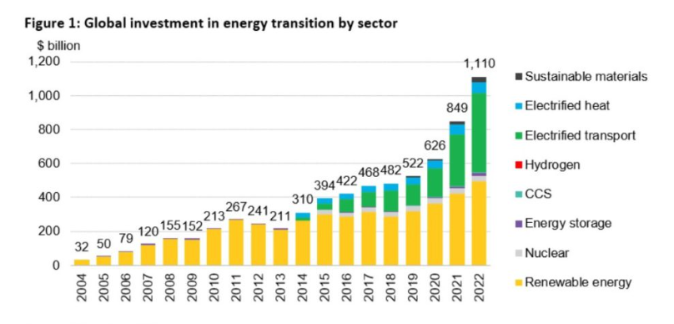
Figure 1. Global investment in energy transition
Source: World Energy Investment (2023)
With the exception of investments in nuclear energy, which remained at the same level, all other renewable energy sectors reached a record level of $495 billion, which is 17% more than in 2021. In 2022, investments in the production of electric vehicles and related infrastructure grew by 54% to $466 billion. The fastest growing sector in terms of investment was the production of hydrogen, where investments increased 3 times over the year, but in absolute terms they amounted to only $1.1 billion, which corresponds to 0.1% of the total investment in renewable energy.
The undisputed leader in investments in the energy transition is China, which more than doubled its investments over the year (from $266 billion in 2021 to $546 billion in 2022). The United States, which is in second place, lagged behind China in this indicator by almost 4 times. Germany retained third place in the top five countries, while the UK dropped to fifth place, ahead of France.
For comparison, the report provides data on global investment in fossil fuels, including exploration, transportation, processing and power generation. They, as well as investments in renewable energy, amounted to 1.1 trillion dollars in 2022.
Taking into account investments in the electrical network (274 billion), the total investment in the energy transition amounted to 1.38 trillion USD. However, according to BNEF, to achieve the world's net zero CO2 emissions trajectory by 2050 (BNEF Net Zero Scenario), these growth rates of global investment are insufficient; they must be increased by 3 times, i.e. by the end of the current decade to grow by an average of 4.55 trillion dollars per year
In May 2023, the International Energy Agency (IEA) also published a report on investments in the global energy sector (“World Energy Investment”, 2023), (IEA, 2023), containing a forecast for the current year. According to it, 2.8 trillion dollars will be invested in 2023. Out of them more than 1.7 trillion. will go to green energy: renewables, electric vehicles, grids, energy storage, nuclear power, low-emission fuels, heat pumps, efficiency improvements. Investments in coal, oil and gas increase slightly - just over 1 trillion USD (Fig.2).
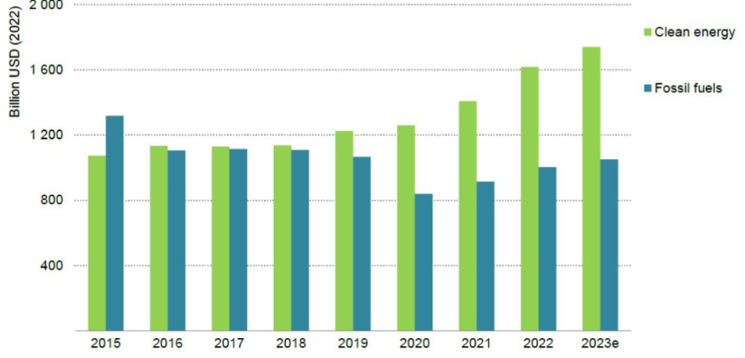
Figure 2. Global energy investment in clean energy and in fossil fuels, 2015-2023e
Source: World Energy Investment (2023)
For every dollar of investment in fossil fuels, clean energy is now worth $1.7, and 5 years ago this ratio was 1:1. At the same time, investments in solar energy will exceed investments in oil production for the first time. It is predicted that 90% of investments in 2023 will be in low-emission power generation technologies. As shown in the figure 3, investments in solar energy alone will significantly exceed investments in gas, coal, nuclear and hydro combined.
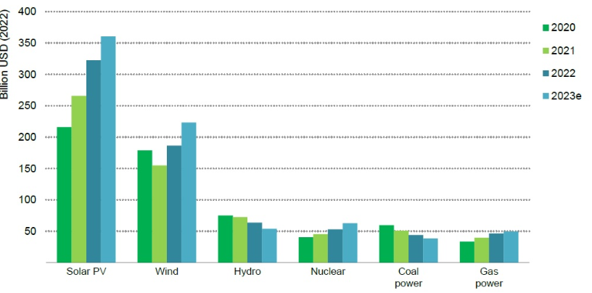
Figure 3. Global annual investment in the power generation by selected technology, 2020-2023e
Source: World Energy Investment (2023)
However, despite a slight increase in investments in fossil fuels in absolute terms, they will more than double in 2023 - the amount needed to achieve the Scenario IRA “Net-zero emission by 2050 case” (NSF). At the same time, the consumption of the main air pollutant - coal, will exceed the planned parameters of this Scenario by almost 6 times.
In June 2023, the IEA released a special report “Renewable Energy Market Update. Outlook for 2023 and 2024” (IEA, 2023). According to the Agency's statistics, in 2022 the global renewable generation capacity increased from 340 GW (i.e. by 13%). Of these, solar energy accounted for 220 GWh (35% growth). But in 2023, this record statistic will be exceeded and, according to the base scenario, will be 440 GWh. The global installed capacity of renewable energy will be by 2024 4,500 GWh.
Renewable energy indicators are presented in the report of the think tank Ember “European Electricity Review, 2023” (Ember, 2023). In 2022, wind and solar co-generation outpaced gas for the first time, generating 623 TWh or 22% of all electricity in the EU. Solar generation increased by 24% (39 TWh), wind by 8.6 (33 TWh). On a solar basis, the generation was 203 TWh, corresponding to 83% of the electricity produced in the EU. The share of gas in generation was 20% (i.e. an increase of 1% in 2021). Coal generation increased by 7% or 28 TWh. This growth is associated with a sharp drop in electricity generation by nuclear power and hydroelectric power plants, which in total fell by 185 TWh (minus 119 TWh and minus 66 TWh, respectively), which is about 7% of the generation of all EU electricity in 2022 (Fig.4).
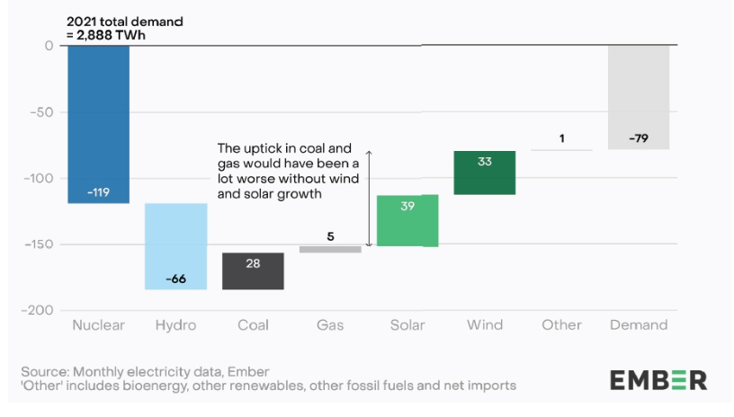
Figure 4. The EU’s coal generation rose due to a sizeable nuclear and hydro deficit, year-on-year change in EU-27 generation for 2022 (terawatt hours)
Source: EMBER (2023)
The reasons for the failure of nuclear energy were a severe crisis in the aging French nuclear industry with its low-maneuverability capacities, as well as the closure of three nuclear power plants in Germany at the end of 2021. Ember forecasts EU fossil fuel generation to fall by 211 TWh or 20% in 2023, while solar and wind power generation to rise by 86 TWh.
In 2023, The International Renewable Energy Agency (IRENA) released the annual compilation “Renewable Capacity Statistics, 2023” (IRENA, 2023). According to it, the capacity of power plants operating on the basis of world renewable energy increased by 295 GW, which is an absolute record in history. Of these, 60% were introduced in Asia. The total capacity of RES power plants was 3372 GW. The total capacity of the world energy sector increased from 38.5% to 40.2%. At the same time, the share of RES in the growth of global generating capacities for 2022 amounted to 83%
90% of new renewable energy capacity comes from solar and wind power plants. Solar energy grew by a record 191 GW (installed capacity was 1,053 GW) and wind by 75 GW (installed capacity - 899 GW). Hydropower capacity increased by 21 GW, bioenergy by 7.6 GW. Hydropower in terms of installed capacity (1393 GW) still ranks first among renewable energy sources.
The material basis for the energy transition is the presence of a sufficient amount of minerals. In 2021, the IEA released a specialized report “The Role of Critical Minerals in Clean Energy Transitions” (IEA, 2021). It recorded significant differences in the amount of resources required for the operation of traditional and "green" energy systems. For example, an electric car (in terms of kilograms per unit) requires on average 6 times more minerals than a conventional car, and an onshore wind plant (in terms of kilograms per MW) requires 9 times more minerals than a gas-fired power plant.
The types of mineral resources vary depending on the technologies used. Thus, rare earth materials are required for permanent magnets, without which the operation of electric motors and wind turbines is impossible. Nickel, cobalt, manganese, graphite, lithium are essential for battery performance, strength and durability. Electrical grids absorb huge amounts of copper and aluminum. At the same time, no technology related to electricity can work without copper.
According to IEA calculations in the Sustainable Development Scenario (SDS), the share of environmentally friendly technologies in the next 20 years will grow for copper and rare earth metals by more than 40%, for nickel and cobalt - by 60-70%, for lithium - by almost 90%.
The Stated Policies Scenario predicts a 2-fold increase in total mineral demand for green energy technologies by 2040. In Scenario (SDS), by 2040 the demand for lithium will increase by more than 40 times, for graphite, cobalt and nickel by 20-25 times, for copper for electrical networks by 2 times.
In July 2023, the IEA released a new report assessing the mineral base for the energy transition “Critical Minerals Market Review (IEA, 2023)”. It notes the essential ones necessary for "green energy": in 2021 they increased by 20%, in 2022 - by 30%. The market for these minerals has doubled in 5 years and reached $ 320 billion. It is predicted (Scenario NZE) that by 2050, global consumption of lithium will grow 13 times from the level of 2021, cobalt more than 3 times, nickel more than 2 times.
The Report also provides short-term projections up to 2030. Some minerals, such as cobalt and lithium, will be abundant, while others (pure lithium, battery nickel, a number of rare earth elements) may become scarce. At the same time, despite the relatively high intensity of emissions from the extraction and processing of minerals, this does not negate the obvious climate benefits of clean energy technologies.
Analysis of forecasts for the development of the energy transition involves an assessment of climate risks for the functioning of the global financial system. There are 2 main climate risks: the physical risk arising from the negative costs of climate change and the transition risk associated with the process of transition to a low-carbon economy (for example, depreciation of the assets of companies in carbon-intensive industries). To predict them, 8 central banks in 2017 created the Network Central Banks and Supervisors for Greening the Financial System (NGFS) association. By the summer of 2019, it already consisted of 39 participants, including the Central Banks of most of Europe, China, as well as the supranational institutions of the OECD, the World Bank, the International Finance Corporation, the EBRD. At the beginning of July 2020, 94 central banks and financial regulators were already the members of the NGFS, as well as 15 observers.
In April 2019, NGFS released the first dedicated climate risk report in the history of financial regulation (A call for action, 2019). It presents a scheme of the physical (Fig. 5) and transitional (Fig.6) climate risks algorithms.
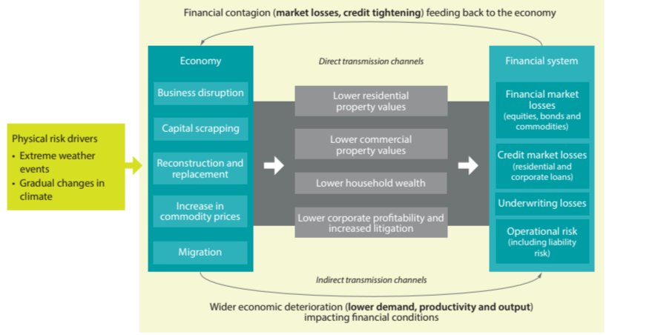
Figure 5. From physical risk to financial stability risks
Source: A call for action Climate change as a source of financial risk (2019)
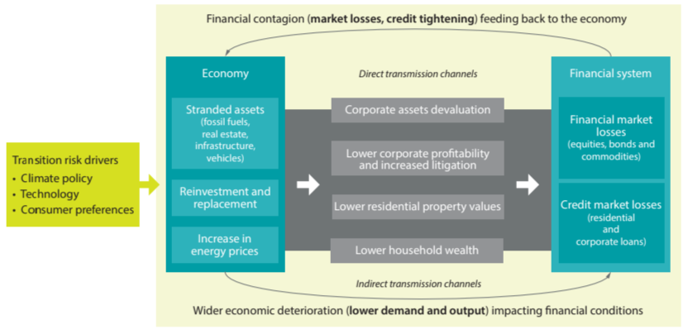
Figure 6. From transition risk to financial stability risks
Source: A call for action Climate change as a source of financial risk (2019)
The approach proposed by the NGFS is of undeniable value as a conceptual basis for climate risks in the process of energy transition.
4 Conclusion
The energy transition is not associated with any one technological revolution. The accumulated critical mass of a whole range of technological "green" innovations, both on the side of production and on the side of energy consumption, is leading to a gradual deep transformation of the entire energy sector. At its core, the energy transition is a mechanism for decarbonizing the economy through a constant increase of the “green” state in the global energy system, as opposed to changing its individual technologies or fuel sources.
From a conceptual point of view, energy transition is a way, form and result of the energy power transition, where the advantage of climate measurement of processes over economic ones will most likely lead to a redistribution of natural energy rent from energy exporting countries in favor of countries that do not have this rent.
The given data and assessments of the reports show that the share of RES in global energy is constantly growing and in 2020-2022 this process has accelerated to a record high.
It is problematic to assess the achievement of the energy transition goals in the medium term (by 2030) and even more so in the long term (by 2050).
The existing and projected problems of extraction and processing of minerals will not be able to have a significant negative impact on the development of the world energy sector along the path of energy transition. However, if the geopolitical situation reaches a force majeure level, which the world has recently come close to, then not only the energy transition, but the entire global economic system may plunge into massive crisis.
Force majeure of the world economy, stimulated by sanctions pressure. already leading to negative consequences. For normalization, it is necessary first of all to remove the force majeure of modern ecological processes through detente of international tension.
References
Journals:
- Savio, A., De Giovanni, L. & Guidolin, M. (2022). Modelling Energy Transition in Germany: An Analysis through Ordinary Differential Equations and System Dynamics. Forecasting, MDPI, 4(2), https://doi.org/10.3390/forecast4020025.Q1-Q2
- Carvalho, A., Riquito, M. & Ferreira, V. (2022). Sociotechnical imaginaries of energy transition: The case of the Portuguese Roadmap for Carbon Neutrality 2050, Energy Reports, 8(3), https://doi.org/10.1016/j.egyr.2022.01.138. Q2
- Bashir, M.F., Sadiq, M., Talbi, B. & Shahzad, L. (2022). An outlook on the development of renewable energy, policy measures to reshape the current energy mix, and how to achieve sustainable economic growth in the post COVID-19 era. Environmental Science and Pollution Research, 29, https://doi.org/10.1007/s11356-022-20010-w. Q1
- Zakeri, B., Paulavets, K., Barreto-Gomez, L., Gomez-Echeverri, L., Pachauri, S., Boza-Kiss, B., Zimm, C., Rogelj, J., Creutzig, F., Ürge-Vorsatz, D. & et al. (2022). Pandemic, War, and Global Energy Transitions, Energies, 15(17), https://doi.org/10.3390/en15176114. Q2
- Chien, F., Zhang, Y., Li, L. & Huang, Hiang-Chu (2023). Impact of government governance and environmental taxes on sustainable energy transition in China: fresh evidence using a novel QARDL approach. Environmental Science and Pollution Research, 30(2), https://doi.org/10.1007/s11356-023-25407-9. Q1
- Rasoulinezhad, Eh., Taghizadeh-Hesary, F., Sung, J. & Panthamit, N. (2020). Geopolitical Risk and Energy Transition in Russia: Evidence from ARDL Bounds Testing Method, Sustainability, 12(7), https://doi.org/10.3390/su12072689. Q2
- Siciliano, G., Wallbott, L., Urban, Fr., Dang, A. Ng. & Lederer, M. (2021). Low‐carbon energy, sustainable development, and justice: Towards a just energy transition for the society and the environment. Sustainable Development, 29(6). https://doi.org/10.1002/sd.2193 Q1
- Longhurst, N., & Chilvers, J. (2019). Mapping diverse visions of energy transitions: co-producing sociotechnical imaginaries. Sustainability Science, 14(4). https://doi.org/10.1007/s11625-019-00702-y. Q1
- Bazilian, M., Bradshaw, M., Gabriel, J., Goldthau, A., & Westphal, K. (2019). Four scenarios of the energy transition: Drivers, consequences, and implications for geopolitics. Wiley Interdisciplinary Reviews: Climate Change, 11(31). https://doi.org/10.1002/wcc.625. Q1
- Apostu, S. A., Panait, M., Balsalobre-Lorente, D., Ferraz D., & Rădulescu, I. G. (2022). Energy Transition in Non-Euro Countries from Central and Eastern Europe: Evidence from Panel Vector Error Correction Model. Energies, 15(23). https://doi.org/10.3390/en15239118. Q2
- Mitrova, T., Melnikov, Y. (2019). Energy transition in Russia. Energy Transit, 3 (1). https://doi.org/10.1007/s41825-019-00016-8

Book / Monograph
- Smil, V. (2010) Energy Transitions: History, Requirements, Prospects. ABC-CLIO, Santa Barbara, 2010.

Websites

- Network for Greening the Financial System First comprehensive report. (2019, April). A call for action Climate change as a source of financial risk. https://www.banque-france.fr/sites/default/files/media/2019/04/17/ngfs_first_comprehensive_report_-_17042019_0.pdf
- Critical Minerals Market Review (2023). https://www.iea.org/reports/critical-minerals-market-review-2023
- European Electricity Review (2023). https://ember-climate.org/insights/research/ european-electricity-review-2023/.
- BloombergNEF. (2023 January, 26). Global Low-Carbon Energy Technology Investment Surges Past $1 Trillion for the First Time. https://about.bnef.com/blog/ global-low-carbon-energy-technology-investment-surges-past-1-trillion-for-the-first-time/
- Renewable capacity statistics 2023, (2023 March) https://www.irena.org/Publications/ 2023/Mar/Renewable-capacity-statistics-2023/
- IEA. (2023). The Role of Critical Minerals in Clean Energy Transitions. https://www.iea.org/reports/the-role-of-critical-minerals-in-clean-energy-transitions/executive-summary
- World Energy Investment 2023 (2023). https://www.iea.org/reports/world-energy-investment-2023

Corresponding author: uvsh54@yandex.ru

