**APSAC 2024 and ENGW 2024**

**by**

**INTERNATIONAL ACADEMIC PUBLICATIONS**

[**www.iapub.org**](http://www.iapub.org)[**www.wseas.com**](http://www.wseas.com)

**Conference Place:**

**HOTEL DIANA  
Via Principe Amedeo, 4**

**00185, Rome, Italy**

**PHONE ++39.06.478681**

**FAX ++39.06.486998**

**web:** [**www.hoteldianaroma.com**](http://www.hoteldianaroma.com/)

**e-mail:** [**info@hoteldianaroma.com**](mailto:info@hoteldianaroma.com)

Sponsored by

[IAPUB.org](http://www.iapub.org/index.html)

**CONFERENCE PROGRAMME**

**Introduction**

**12 Top Reasons Why You Should Visit Rome in the Context of our Conference!**

**Why should you visit Rome? We have narrowed it down to twelve reasons:**

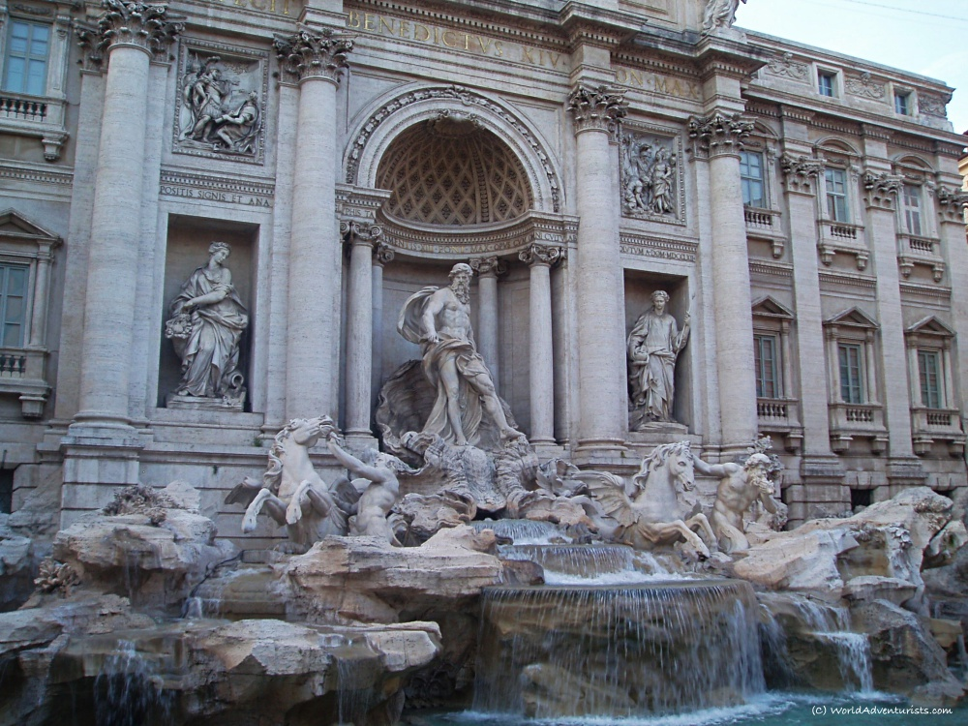The Trevi Fountain

### **The Fountains**

One of our favorite parts of visiting Rome is all the invaluable and detailed fountains. Rome is home to some of the most spectacular fountains in the world. Home to over 2000 fountains, Rome has more than any other city in the world from the monumental to the small drinking fountains.

The Trevi Fountain is perhaps the most famous, a late Baroque masterpiece, and it is certainly one of the most beautiful. The fountain is over 85 feet tall and 65 feet wide, and it is adorned with statues, bas-reliefs, and cascading waterfalls. People come from all over to throw a coin in, using the right hand over the left shoulder, in hopes of returning to the Eternal City.

The Fontana dei Quattro Fiumi is another masterpiece, representing four major rivers from around the world: the Nile representing Africa, the Danube representing Europe, the Ganges representing Asia, and the Río de la Plata representing the Americas.

These are just two of the incredible fountains that can be found in Rome – a city that truly celebrates water in all its forms.

It really is impossible to imagine Rome without thinking of its incredible fountains. Turning a corner as you wander the streets, the surprise of a grand fountain is always a welcome sight.

### **Rome Is Romantic**

There is something undeniably romantic about the city of Rome. Its ancient streets and stunning architecture have long captured the hearts and imaginations of people from around the world. Whether you are exploring the Vatican or gorging on delicious pasta in a cozy local restaurant, there is no shortage of ways to experience the romance of Rome.

Part of what makes this city, so alluring is its enduring appeal. Centuries after it was first founded, Rome still draws in tourists and locals alike with its rich history, vibrant culture, and breathtaking beauty. Whether you explore by day or night, beneath the gleaming sun or twinkling stars, there is always something new to discover here. From intimate dinners al fresco to charming street musicians serenading passersby, Rome truly embodies the idea of romance at every turn. Whether you have been planning a trip for months or have found yourself swept up by an unexpected encounter, it is certain that you will fall under the spell of this enchanting city. So set your sights on Rome and discover for yourself why it has captivated people for centuries.

Rome is also synonymous with romance. If you take the Italian word for Rome (Roma) and reverse it, you get ‘Amor’, meaning love. With the grandeur of Rome through its monuments, fountains, piazzas, and cobbled streets, Rome is one of the most romantic cities. Love fills the entire city with its hold of the past in the present.

After all, as they say, when in Rome…

### **Rome Heightens Your Senses**

There is something truly magical about the city of Rome. From the sounds of its bustling streets to the sights of its stunning buildings and breathtaking natural scenery, this ancient metropolis seems to have an almost mystical ability to heighten your senses. Whether you are exploring its many landmarks and museums, enjoying a leisurely stroll through one of its picturesque parks, or simply taking in the incredible smells of traditional cooking wafting through the air, there is always something new and wonderful to discover in Rome.

We felt like Rome made us more aware of all of our senses as we wandered around the Eternal City. Our **vision** from seeing some of the greatest masterpieces on earth, the extreme scale of the buildings, seeing the way the buildings glow during sunset and admiring the contrast of ancient and modern throughout the city. **Hearing** from the sounds of passionate Italian spoken and the melodies of street musicians. **Smell** from the delicious cuisine on each street as we wandered aimlessly. **Taste** from our endless stops for Gelato and our favorite authentic pasta finds that we could not get enough of. **Touch** for those first feelings of water from some of the most impressive fountains, to the cobbled streets beneath our feet.

### **The Flutter**

It is an incredible feeling to wander a place of such grandeur, and it is hard to explain the flutter you feel when you realize you’ve fallen in love with the city. It is that same kind of feeling you get as you admire the intricate and mind-blowing work of some of the most talented artists of all time. You’re sure to feel like you pale into insignificance, compared to their brilliance.

The flutter you feel when you fall in love with a city is like no other feeling. It’s the feeling of finally belonging somewhere; of being able to breathe easy and just be yourself. It’s the feeling of home. When you find a city that you love, it’s like finding a piece of yourself that you never knew was missing.

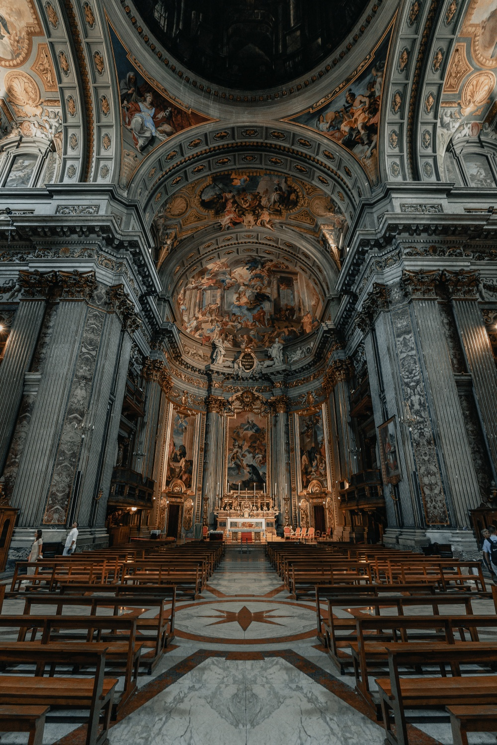  
Photo: Clay Banks – Upsplash – The Church of St. Ignatius of Loyola

### **Architecture**

If you have ever heard the expression “Rome wasn’t built in a day”, it is nothing short of mind-blowing to consider that thousands of years ago, Romans were able to build such stunning and timeless structures. You cannot think of Roman architecture without thinking of the world-famous [Roman Colosseum](https://worldadventurists.com/15-interesting-facts-colosseum-rome/), aqueducts, Roman Baths, basilicas, and cathedrals.

There are also unexplainable feats of architecture. The Pantheon is a masterpiece, built in the 120s AD. It is the largest free-standing concrete dome in the world, and nobody has been able to figure out how it exists as it does.

The architecture was important in unifying the Roman empire. Even more impressive, is the impact that Rome has had on architecture across the globe. Today, even in the US, many of the official buildings are influenced by Roman architecture.

The architecture of Rome is an eclectic mix of styles and influences, ranging from ancient classical forms to the grandeur of the Baroque period. The iconic domes and arches that adorn many buildings in the city are a testament to Rome’s status as a former imperial capital. Beyond its obvious aesthetic appeal, however, Rome’s architecture also offers a fascinating glimpse into the history and culture of this powerful and influential city. Whether exploring crumbling ruins at the base of the Colosseum or admiring majestic structures like St Peter’s Basilica, visitors to Rome will uncover layer upon layer of history in its magnificent architectural legacy. Simply put, Rome’s architecture is truly unforgettable.

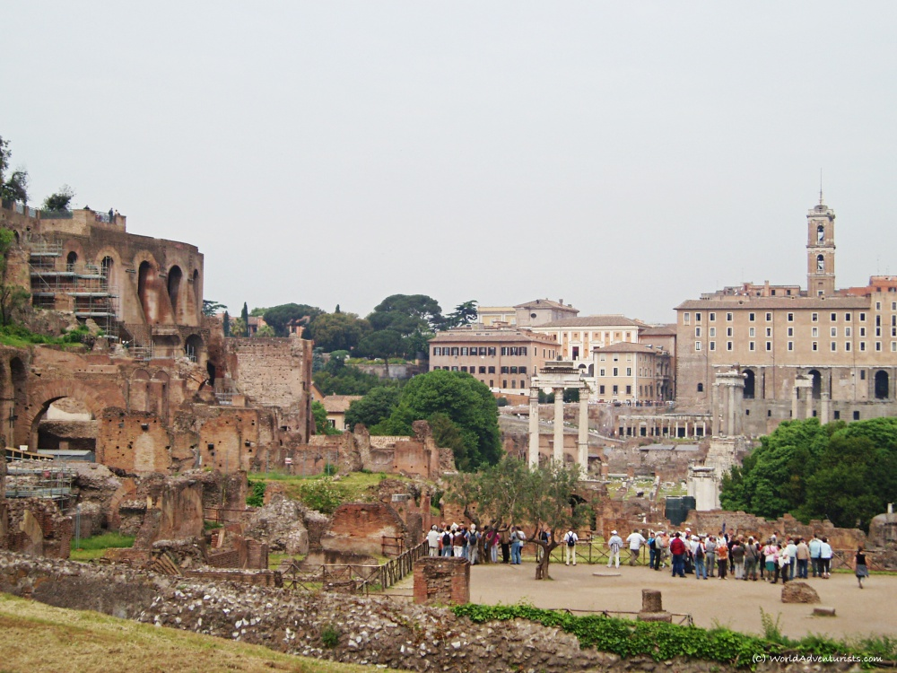Roman Forum

### **Age & History**

Rome is old. There really is not a simpler way to put it. You can see it around every corner you turn, the layers upon layers of history. Rome is one of the oldest and most well-preserved cities in the world. Founded in 753 BC, it has a rich history that is evident in its architecture and art. While much of the city has been modernized, there are still many ancient ruins to explore.

A great example of this is the Basilica of San Clemente. Preserving over 2000 years of history, you can admire the remarkable mosaics and frescoes, explore the Basilica of the fourth century and the world of Rome in the first century where there is still a pagan temple.

The Colosseum, for example, is a well-preserved amphitheater that was built in 80 AD. The Forum, another popular tourist spot, was once the center of Roman public life. And the Pantheon, a temple dedicated to all the gods, is one of the best-preserved Roman buildings. With so much to see and do, it’s no wonder that Rome is one of the most popular travel destinations in the world.

As you visit each historical building and sight, it is hard to not be amazed to be standing where the Romans walked thousands of years ago. There is so much history to learn about and walk along the path of.

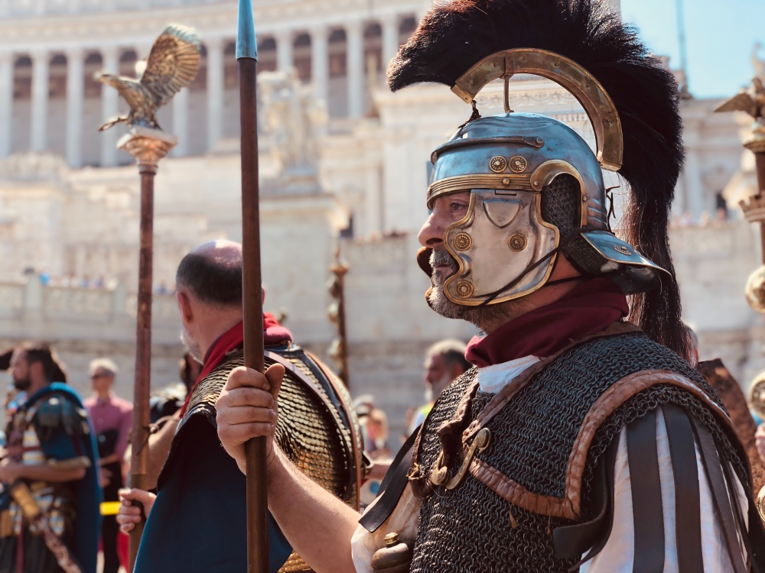Photo: Maria Dolores Vazquez – Unsplash – Medieval Costumes

### **Art & Culture**

Its ancient ruins and museums attract tourists from all corners of the globe, and its thriving artistic scene draws artists and creators from around the world. But what many people don’t realize is that one of the most characteristic aspects of Rome’s culture is its friendly, welcoming atmosphere. Whether you’re walking down the street or grabbing coffee at a café, you’ll find that locals are always happy to stop and chat, offering advice on where to go and what to see. And with so many festivals, outdoor markets, and cultural events happening throughout the year, it’s easy to feel right at home in this vibrant city. Whether you’re visiting Rome for the first time or returning after many years away, there’s no doubt that this unique city will welcome you with open arms into its friendly culture.

We really enjoyed soaking in the culture of the locals. Their friendliness, love for good food, and the importance of family time really hit home with us.

Even just a wander around the streets, you are bound to run into a breathtaking creation by a famous Italian artist. Timeless art is everywhere you look, and it is so inspiring to witness.

### **The Food**

The food of Rome is famous for its rich, bold flavors and incredible diversity. Whether you’re sampling traditional pasta dishes at a cozy trattoria or digging into delicious street fare from a food truck, there is something to satisfy every craving in this bustling city. Some of the most beloved dishes in Rome are those made with simple ingredients sourced from local farms and markets. Rich aged cheeses, seasonal fresh veggies, hand-made artisanal breads, and locally caught fish combine to create mouth-watering meals that can be enjoyed any time of day. When it comes to Italian cuisine, you will want to experience the true flavors of Italy in Rome. Be sure to explore all the amazing food it has to offer!

Do not forget about the Gelato, oh the flavors on flavors of Gelato. All washed down with some incredible Italian wine, sometimes even classy by drinking right out of the bottle (hey, we were backpacking, after all). The food in Rome is spectacular.

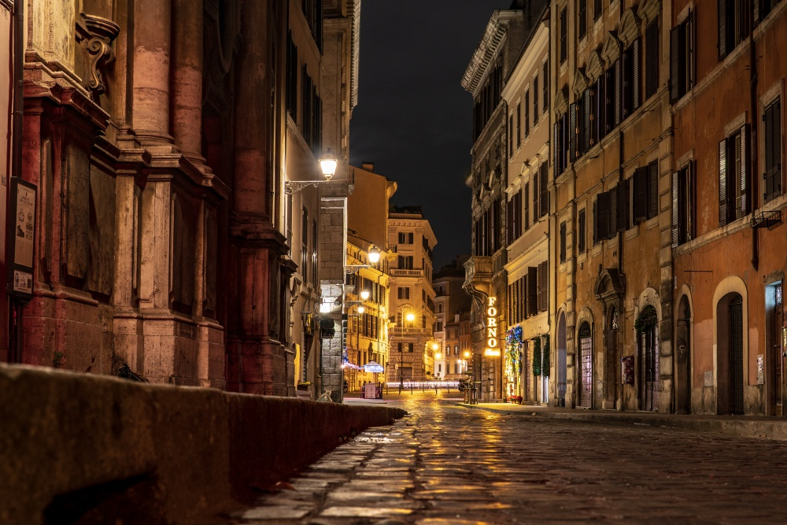Photo: Dylan Freedom – Unsplash

### **The Streets & Beauty**

All over Rome, you’ll find Piazzas or squares. They are always gorgeous, featuring impressive fountains and absolutely buzzing with people. It is a great spot to do some people watching as you witness social life unfold. Piazzas are a great spot to unwind and chill.

The streets take you to places you only imagined from the movies. Around each corner and down each narrow street, surprises unfold around you, with cobbled paths beneath your feet. Rome also tells so many stories through its well-worn, but remarkably preserved streets. Rome does not have the same pretty as say Paris; it has some grime and grit that gives great character and charm with all the secrets the walls and buildings still hold.

### **Easily Walkable**

When it comes to exploring a new city, nothing is more enjoyable than being able to walk from place to place. This is especially true of Rome, a city that has a rich history and many impressive sights to visit. Thanks to its compact size and historic layout, Rome is perfectly suited for pedestrian exploration. Whether you want to meander through quiet side streets or hustle down bustling main thoroughfares, you can get almost anywhere on foot. And with plenty of restaurants, bars, and shops along the way, there is always something interesting to see around every corner. If you’re planning your next vacation in the Eternal City, be sure to leave plenty of space in your suitcase for comfortable walking shoes – Rome is truly one of the best destinations for exploring on foot.

### **The Grand Amount Of #1 Sights**

In some cities, you’d be hard-pressed to find more than a couple of gems. Rome is full of gems to discover. It is impossible to walk too far without coming across another impressive artifact of the past. It feels like there is something impressive to find and learn around every corner. Rome is one of the most popular tourist destinations in the world, and it’s no wonder why. With its breathtaking architecture, ancient ruins, and historic monuments, this city has a wealth of impressive sights to see. Rome is full of gems to discover. Whether you’re exploring hidden corners or marveling at the towering pillars and arches of the Colosseum, exploring the intricate mosaics of Ancient Rome at the Pantheon, or wandering among the Villa Borghese gardens, there is something for everyone in Rome.

### **A City In The City**

By visiting Rome, and without requiring your passport to enter, you are able to visit the smallest country in the world: [Vatican City](https://worldadventurists.com/11-things-may-not-have-known-vatican/).

The city is encircled by a 2-mile border with Italy. An independent city-state, it covers just over 100 acres or 1/8 the size of New York’s Central Park.

Vatican City is one of the most fascinating places on Earth. Located within the borders of Rome, the tiny city-state is a true gem filled with incredible cultural and historical treasures. Perhaps most famous for its massive cathedral, St. Peter’s Basilica, Vatican City is renowned around the world as a center of faith and spirituality. Vatican City is the headquarters of the Roman Catholic Church and has major significance within the Christian world. It is also home to the Pope and endless pieces of iconic art and architecture.

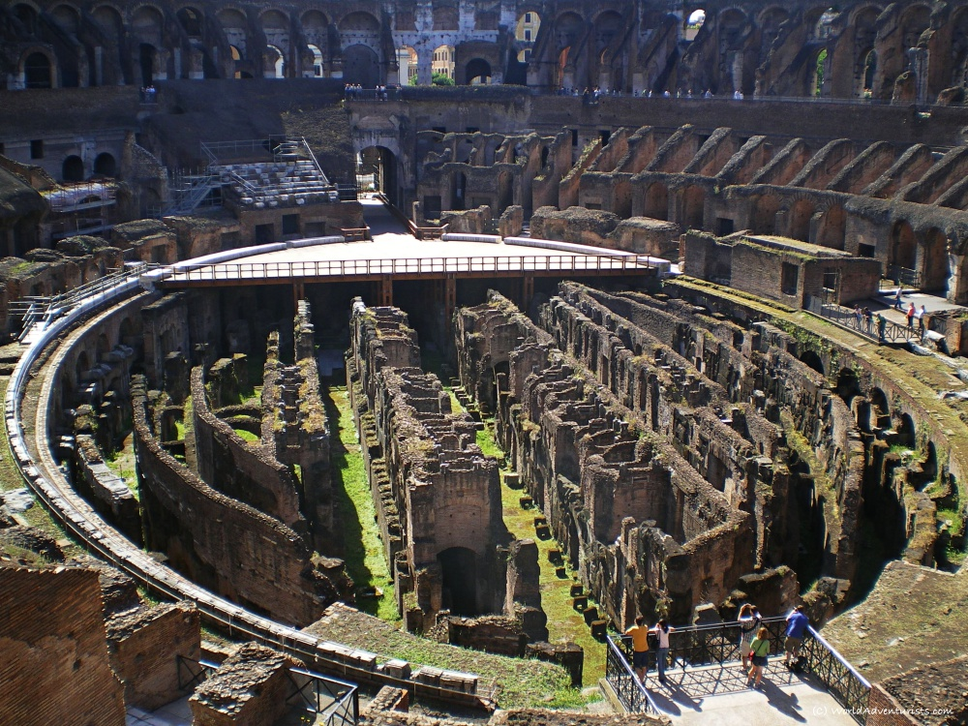Inside the Roman Colosseum

In summary, **Rome is worth the visit**. There is a good reason that tourists swarm Rome all year. Brimming with ancient history, Rome is one of the most impressive cities we have visited. We feel that Rome is truly an experience everyone should have the chance to witness. The city is full of the grandeur of times of the past and still holds onto that beauty today, even though thousands of years have passed. Usually, when a destination is as applauded as Rome is, there is some worry that it may fall short of your expectations. Rome is a city that exceeded any expectations we had. We hope that one day you will experience the excitement and anticipation that comes with exploring the Eternal City of Rome. Whatever your interest or passion may be, this enchanting city will surely sweep you off your feet with its gorgeous blend of history, culture, and natural beauty.

**CONFERENCE PROGRAMME**

**HOTEL DIANA   
Via Principe Amedeo, 4 00185  
Rome, Italy**

**Phone: ++39.06.478681 Fax ++39.06.486998   
 www.hoteldianaroma.com   
info@hoteldianaroma.com**

**Wednesday, June 19, 2024**

**20:00-22:00  
Welcome Cocktail at**

***Restaurant AQUILA NERA, Via Principe Amedeo 49-53, 00185, Rome***

**CONFERENCE PROGRAMME**

**HOTEL DIANA   
Via Principe Amedeo, 4 00185  
Rome, Italy**

**Phone: ++39.06.478681 Fax ++39.06.486998   
 www.hoteldianaroma.com   
info@hoteldianaroma.com**

**Thursday, June 20, 2024**

**08.00-18:00 (working hours of the Secretariat)**

**Registration**

**Distribution of the Conference bags**

**\* Certifications of Presentation and Receipts (Invoices) will be sent to you only by email**

| **Time: 08:00-08:20** |
| --- |
| **Local splines and the least squares method by I.G.Burova** |

| **Time: 08:20-08:040** |
| --- |
| **Analytical Explicit Formulas of Average Run Length of DEWMA Control Chart Based on Seasonal Moving Average Process by Rapin Sunthornwat, Yupaporn Areepong, Saowanit Sukparungsee** |

| **Time: 08:40-09:00** |
| --- |
| **Analysis Process Dispersion Variation Tracked Using a Mixed MA-EWMA Control Chart by Suganya phantu, Yupaporn Areepong, Saowanit sukparungsee** |

| **Time: 09:00-09:20** |
| --- |
| **Plenary Speech:**    **Óbuda University, Budapest**  **From Interaction to Integration: Spatial Revolution in Human-System Collaboration By Imre J. Rudas, Péter Galambos**  **It will be presented by**  **Prof. Imre J. Rudas, IEEE Life Fellow, IFSA Fellow, Óbuda University, Hungary** |

| **Time: 09:20-09:40** |
| --- |
| **Plenary Speech:**  **Effective Recommendation of Services Based on Weights Obtained from Implicit User Feedback By Xinyi Zeng, Haiyang Zhang, Nikola S. Nikolov, Ivan Ganchev**  **It will be presented by**  **Prof. Ivan Ganchev, University of Limerick Ireland  & University of Plovdiv “Paisii Hilendarski” Bulgaria** |

| **Time: 09:40-10:00** |
| --- |
| **Well-posedness of the optimal control problem related to degenerate**  **chemo-attraction models**  **by Sarah Serhal, Georges Chamoun, Mazen Saad, Toni Sayah** |

| **Time: 10:00-10:20** |
| --- |
| **Simulation of Simultaneous Confidence Intervals for All Differences of Signal to Noise Ratios of Log-Normal Distributions by Warisa Thangjai, Sa-aat Niwitpong, Suparat niwitpong** |

| **Time: 10:20-10:40** |
| --- |
| **Estimating the Confidence Interval for the Ratio of Coefficients of Variation of two Delta-Gamma Distributions**  **By Wansiri Khooriphan, Sa-aat Niwitpong, Suparat Niwitpong** |

| **Time: 10:40-11:00** |
| --- |
| **Improvement of the Sand Quality by Applying Microorganism Induced Calcium Carbonate Precipitation to Reduce Cement Usage by Sumonthip Kongtunjanphuk, Satharat Pianfuengfoo, Piti Sukontasukkul** |

| **Time: 11.00-11:20** |
| --- |
| **Bayesian Confidence Interval for Ratio of Means of Normal Distributions**  **by Warisa Thangjai, Sa-Aat Niwitpong, Jeerapa Sappakitkamjorn, Narudee Smithpreecha** |

| **Time: 11.20-11:40** |
| --- |
| **Normalization Technique and Weight Adjustment Analysis for Keystroke Vector Dissimilarity Authentication**  **by Tanapat Anusas-Amornkul, Naphat Bussabong** |

| **Time: 11.40-12:00** |
| --- |
| **Gauss–Legendre Numerical Integrations for Average Run Length Running on EWMA Control Chart with Fractionally Integrated MAX Process**  **by Wilasinee Peerajit** |

**Coffee-break: 12:00-12:30**

| **Time: 12.40-13:00** |
| --- |
| **Internet of things Authenticate and Behavior Monitoring Using Deep Learning in Smart Building /House**  **by Laila Abu Rashed, Mahmood Abdulrazzaq Alsaadi, Walid A. Salameh** |

| **Time: 13.00-13:20** |
| --- |
| **Development and demonstration of an improved hybrid machine learning algorithm for predicting Lagrangian trajectories in turbulent wall-bounded flows**  **by Lee Mortimer, Michael Fairweather** |

| **Time: 13.20-13:40** |
| --- |
| **Role of shear rate on adsorption conformation in polymer-induced flocculation simulations By Lee Mortimer, Michael Fairweather** |

| **Time: 13:40-14:00** |
| --- |
| **Exploring Novel Machine Learning Applications in Muography: A Promising Frontier**  **by Andrea Paccagnella, Vitaliano Ciulli, Raffaello D Alessandro, Catalin Frosin, Sandro Gonzi, Lorenzo Bonechi, Tommaso Beni, Diletta Borselli, Roberto Ciaranfi** |

| **Time: 14.00-14:20** |
| --- |
| **Langevin dynamic simulations for polymer conformation in shear and turbulent flows By Lauren Farndell, Lee Mortimer, Michael Fairweather** |

| **Time: 14:20-14:40** |
| --- |
| **A Comparative Study on Using Artificial Intelligence Technologies in the Nursing Domain By Darah Aqel, Ali Aldahoud, Abdel Ra Uof Abu Murad, Diana Abdalgani** |

| **Time: 14.40-15:00** |
| --- |
| **Application of computational methods in the design of novel compounds for potential application in plant protection By Vesna Rastija** |

**Coffee-break: 15:00-15:30**

**4th International Workshop on "MOdelling, SImulation and DAta Analysis in Engineering and Physics Applications" (MOSIDA 2024)**

**Organizers-Chairmen: Claudio Guarnaccia (UNISA), Domenico Rossi (UNISA)**

| **Time: 15.30-16:00** |
| --- |
| **Plenary Speech:   An Approximate Solution for Heat Transfer in the Entrance Region of Laminar Newtonian Pipe Flow By Gennaro Cuccurullo, Carmela Concilio, Domenico Rossi, Claudio Guarnaccia  It will be presented by**  **Prof. Gennaro Cuccurullo, University of Salerno, Italy** |

Articles for MOSIDA 2024

| **Time: 16:00-16:20** |
| --- |
| **Energy Variation Of Space Debris Considering Orbital Maneuvers And Ground-Based Laser**  **by Jorge Formiga, Denilson Santos, Rodolpho Moraes** |

| **Time: 16:20-16:40** |
| --- |
| **Application of a robust fuzzy control method on wind power systems**  **by Samir Bellarbi** |

| **Time: 16.40-17:00** |
| --- |
| **Integrating Vehicle Noise Emission Models into Eco-Routing for Smart Transportation: Implications in a Case Study**  **by Antonio Pascale, Aurora Mascolo, Domenico Rossi, Margarida Coelho, Claudio Guarnaccia** |

| **Time: 17:00-17:20** |
| --- |
| **A Machine Learning Approach for the Assessment of Road Traffic Noise: Comparison of Regressors**  **by Domenico Rossi, Aurora Mascolo, Daljeet Singh, Claudio Guarnaccia** |

| **Time: 17:20-17:40** |
| --- |
| **Assessment of the radon exhalation and the radiological risk due to natural radioactivity content in the “Pietra di Lecce” building material: a case study**  **by Francesco Caridi, Domenico Majolino, Valentina Venuti, Daniele Chiriu, Stefania Da Pelo, Giuliana Faggio, Giacomo Messina, Michele Guida, Maurizio Ponte, Silvestro Antonio Ruffolo** |

| **Time: 17:40-18:00** |
| --- |
| **Wire Breaking Acoustic Signal Experimental Detection and Analysis for Non-Destructive Testing and Structural Health Monitoring in Prestressed Reinforced Concrete Beams**  **by Antonella Bianca Francavilla, Domenico Rossi, Massimo Latour, Gianvittorio Rizzano, Claudio Guarnaccia** |

| **Time: 18:00-18:20** |
| --- |
| **Principal Component Analysis to identify parameters in MRgFUS treatment**  **by Lilla Bonanno, Augusto Ielo, Serena Dattola, Valentina Hartwig, Rosa Morabito, Simona Cammaroto, Chiara Smorto, Annalisa Militi, Carmelo Anfuso, Giuseppe Di Lorenzo, Chiara Sorbera, Amelia Brigandì, Antonio Cerasa, Alberto Cacciola, Silvia Marino, Angelo Quartarone, Giuseppe Acri** |

| **Time: 18.20-18:40** |
| --- |
| **Preliminary development of optical fiber sensors numerical models for aerospace systems monitoring**  **byAlessandro Aimasso, Matteo Bertone, Paolo Maggiore, Matteo Davide Lorenzo Dalla Vedova** |

| **Time: 18:40-19:00** |
| --- |
| **Morphological and physicochemical characterization of single-species bacterial biofilms probed by SEM, FTIR-ATR and µ-Raman techniques**  **by Giuseppe Paladini, Francesco Caridi, Domenico Majolino, Valentina Venuti, Paola Cardiano, Federica De Gaetano, Gabriele Lando, Rosanna Stancanelli, Silvana Tommasini, Cinzia Anna Ventura, Barbara Fazio, Cinzia**  **Lombardo, Mario Salmeri, Venerando Pistara’** |

| **Time: 19:00-19:20** |
| --- |
| **Assessment of the influence of the structural and geological features and dynamic behaviour to the indoor radon levels. A case study.**  **By Simona Mancini, Albina Cuomo, Domenico Guida, Serpil Akӧzcan Pehlivanoğlu, Nataša Todorovic, Michele Guida** |

| **Time: 19:20-19:40** |
| --- |
| **Exploratory Data Analysis on Inlet Flow, Outlet Flow and Water Level Time Series of Two Water Tanks in South Italy**  **by Domenico Rossi, Antonia Longbardi, Giacomo Viccione, Claudio Guarnacccia** |

| **Time: 19:40-20:00** |
| --- |
| **In situ temperature measurement during MRgFUS Quality Controls: a first approach**  **by Giuseppe Acri, Francesco Sergi, Davide Aloisio, Gianluca Salvatore Leonardi, Maria Antonietta D’avanzo, Barbara Testagrossa, Victorian Michele Ferro, Domenica Urzi’, Daniela Cavallaro, Simona Cammaroto, Lilla Bonanno, Carmelo Anfuso, Giuseppe Vermiglio, Valentina Hartwig** |

| **Time: 20.00-20:30** |
| --- |
| **Plenary Speech:  Focusing on ICT-management – how to use partnerships**  **by Seppo Sirkemaa   It will be presented by**  **Prof. Seppo Sirkemaa, University of Turku, Finland** |

**21:00-24:00  
Dinner in the Restaurant *AQUILA NERA, Via Principe Amedeo 49-53, 00185, Rome***

Additional Dinner Ticket for accompanying Persons: 35 EUR / person

**CONFERENCE PROGRAMME**

**HOTEL DIANA   
Via Principe Amedeo, 4 00185  
Rome, Italy**

**Phone: ++39.06.478681 Fax ++39.06.486998   
 www.hoteldianaroma.com   
info@hoteldianaroma.com**

**Friday, June 21, 2024**

**Time 09:00 - 11:00**

**Session: Environmental Research and Development**

**On-line Presentations**

| **Authors** | **Title** |
| --- | --- |

| **F.G. Lupianez** | **On Covering Properties in Intuitionistic Fuzzy Topological Spaces: A survey** |
| --- | --- |
| **Puja Sareen, Syed Rizwan Naqvi** | **Enhancing Employee Satisfaction through Employer Branding: An Empirical Study of the Indian Pharmaceutical sector using PLS-SEM** |
| **Boru Bedeya Jarso** | **Assessment of location factors impact on local coffee industries (Case of East Guji Zone (Nagele), Oromia, Ethiopia)** |
| **Tamer Sebaey, Harri Junaidi** | **Mechanical Characterization of Carbon-Aramid Fiber/Epoxy Hybrid Composite Laminates with the Presence of Defect** |
| **George N. Papageorgiou, Elena Tsappi** | **Conceptualizing a Performance Appraisal Model for Avatars in the Metaverse Workplace: A Structural Equation Modeling Approach** |
| **Rosa Huaraca Aparco, Fidelia Tapia Tadeo, María del Carmen Delgado Laime** | **Toxic and essential trace elements in cow s milk produced in high Andean areas in the Apurimac Region, Perú** |

**Time 11:30 - 15:00**

**Session: Computational and Applied Mathematics and Applications**

**On-line Presentations**

| **Authors** | **Title** |
| --- | --- |
| **Rizwan Rizwan** | **Existence theory and stability analysis of fractional Langevin equation** |
| **Alfredo Jose Constain Aragon** | **A New Equation of Mean Velocity in Flow, Its Verification and Consequences: H.B. Fischer s Experiment in the Caltech Canal.** |
| **Alfredo Jose Constain Aragon** | **Application of a new Mean Velocity equation of Flow in a natural stream of 8.5 m3/s, Its Verification and extrapolation: Copper Creck river, Virginia (USA).** |
| **Hassan Bediar,Sharifah Sakinah Syed, Mohamed Doheir, Abdulrazzak Ali Mohammad** | **Techniques Exploration to Relocation Information Between Relational and Report Information Stockpiling Models** |
| **Robab Kalanatari, Khashayar Rahimi, Saman Naderi Mezajin** | **Multi-Fractional Gradient Descent: A Novel Approach to Gradient Descent for Robust Linear Regression** |
| **Akoijam Jenick** | **A Review: Enhancing Recommender System through Advance Analytics in Social Recommender System.** |
| **Kittipong Tripetch, Banchop Sancharoen** | **A comparative analysis for a computer aided design (CAD) model of a full bridge regulator** |
| **Amid Hassan** | **Ethical Considerations in Autonomous System** |
| **Kristina Pavlova, Elisaveta Trichkova-Kashamova, Stanislav Dimitrov** | **Risk assessment on an agricultural farm** |
| **Vishal Kumar** | **Harnessing Machine Learning for Anticipating Product Demand Trends** |
| **Ritik Ranjan** | **Breast Cancer Detection Using Machine Learning** |
| **Reena Rani, Sunil Kumar, Neha Munjal** | **Near Infrared Spectroscopy as a tool to Classify groundwater on the basis of depth, region and source** |
| **Rajesh Kumar Mishra and Rekha Agarwal** | **Solar transient events and geomagnetic indices during solar cycles 20–25** |
| **Rekha Agarwal and Rajesh Kumar Mishra** | **Study of recent strong solar flare released by sun** |
| **Rajesh Singh , Dr. Mamta Bansal** | **Neurological Navigation:Unravelling BCI and Mobile Transport Fusion** |
| **Sandra Ferreira, Dário Ferreira** | **Enhancing Information-Based Modeling with Linear Methods for Prediction** |
| **Ahmen Nassim Moulai Khatir** | **Spartan 6 - XC6SLX9 FPGA implementation of analog waveforms generator by Direct Digital Synthesis (DDS)** |
| **Lyuben Nikolov, Adelina Aleksieva-Petrova** | **Threat Modeling Based on STRIDE Framework for Web Application** |
| **Kristina Bliznakova, Petar Petrov, Nikolay Dukov, Zhivko Bliznakov** | **Development of a Computational Phantom for Cone-Beam Computed Tomography Experiments** |
| **Hristina Shkodrova, Nikolay Dukov, Kristina Bliznakova** | **Study on Materials for Magnetic Resonance Imaging Phantom Creation** |

**CONFERENCE PROGRAMME**

**HOTEL DIANA   
Via Principe Amedeo, 4 00185  
Rome, Italy**

**Phone: ++39.06.478681 Fax ++39.06.486998   
 www.hoteldianaroma.com   
info@hoteldianaroma.com**

**Saturday, June 22, 2024**

**Excursion to Rome**