УДК 546.26-162, 549.211, 533.9.082.5

Morphology of craters formed on the surface of diamond plates when exposed to focused laser radiation

K. A. Irzhevsky¹, I. V. Klepikov^{1,2,3}, V.F. Lebedev⁴, A. V. Koliadin²

¹Saint Petersburg State University (SPBU) Saint Petersburg, Russia

² LLC NPL «Almaz» Saint-Petersburg, Russia

³MIREA — Russian Technological University (RTU MIREA), Moscow, Russia

⁴Saint Petersburg State University of Aerospace Instrumentation (SUAI), Saint Petersburg, Russia
kirillirjevskii01@mail.ru
Abstract

This work is dedicated to study of the morphology of craters formed on the surface of HPHT synthetic diamond plates under the influence of high-power laser radiation during their studies by Laser-induced breakdown spectroscopy (LIBS). Samples of diamond plates were irradiated with both individual laser pulses and a series of up to 30 pulses at one point. Analysis of the obtained results shows that the shape of the crater depends on several factors: the energy of the laser pulse, the number of pulses in the series and the crystallographic orientation of the plate. The influence of the energy of the laser pulse is manifested in the transition from the oval to the polygonal shape of the crater. The crystallographic orientation of the plate affects the shape of the polygonal crater: rectangular line– or point-bottomed depressions are formed in the direction of the cube ‹100›, and triangular flat–bottomed depressions are formed in the direction of the octahedron ‹111›.

Key words: HPHT diamond plates, LIBS, morphology, laser-induced crater
Introduction

When studying synthetic diamonds, their surface is often exposed to laser radiation. In particular, the method of laser-induced breakdown spectroscopy (LIBS) has been gaining popularity recently, due to its versatility, the possibility of studying the material without sample preparation, speed, high sensitivity and the possibility of simultaneous multi-element analysis [Hahn and Omenetto, 2010]. These features of the method have provoked its widespread use in the analysis of alloys in metallurgy and jewelry, archaeological sites, soils and much more [Gaudiuso et al., 2010]

Especially interesting is the use of LIES in the field of gemology to determine the geographical origin of gems. Thus, in a study by Kochelek et al. [2015], sapphires and rubies from various deposits are successfully identified. In another work by the same authors, McManus et al. [2020], a similar method is applied to natural diamonds, but this work was critically perceived by Smith et al. [2022] regarding the possible presence of impurity element spectra in the plasma spectra of the atmosphere surrounding the samples. The main limitation when using the LIBS method in gemology is the fact that it is partially destructive as a result of microablation of the substance by focused laser radiation. Koral et al. [2018] demonstrated the possibility of studying gems without visible destruction of the surface using a modified LIBS method, in which the amplification of the plasma spectrum of the sample under study is carried out due to the interaction of laser radiation with a film containing gold nanoparticles sputtered onto the sample surface under study.

The effect of low-power laser radiation on diamonds has been studied by many researchers [Cai et al., 2020, Zhang et al., 2020], while the effect of high-power radiation on the surface of diamonds has hardly been mentioned. The interrelation of different crystallographic orientation, defect-impurity composition, initial surface roughness with the morphology of newly formed surface structures is mostly ignored by scientists.

In the work of Lebedev et al. [2020], the distribution of impurities in various sectors and growth zones of synthetic diamond grown by the HPHT method was studied by the LIBS method. As a result of laser radiation exposure to diamond plates, craters were formed, the study of the morphology of which was the purpose of this papar. The latter represents the results of studying the micro- and macromorphology of the surface of the HPHT diamond plates exposed to focused laser radiation. Samples of the same physical type Ib, but with different crystallographic orientations ‹100›, ‹111› and with different surface roughness (natural facet and polished plate) were studied for the most complete understanding of the nature of the change in the surface of HPHT diamond.

Ablation of the surface of the samples was carried out by focused pulsed Nd3+: YAG laser radiation at a wavelength of 1064 nm with an energy density of about 1 kJ/cm2. The laser was started, its operation was synchronized with the spectrometer and plasma spectra were processed using proprietary software, and plasma spectra were recorded with an AvaSpec-ULS2048L fiber output spectrometer (Avates). To prevent the chemical interaction of the laser torch with the surrounding air, the samples were blown with a low-speed Ar jet. The plates were irradiated with both individual laser pulses and a series of pulses in the amount from 1 to 30 at one point of the surface. The Leica M205C optical microscope (OM), Quanta 200 3D scanning electron microscope (SEM) and Integra-Aura atomic force microscope (AFM) were used to analyze the features of micro- and macromorphology. The research was carried out in the Laboratory of Photonics and Quantum Technologies of SUAI and in the resource center "Microscopy and Microanalysis" of St. Petersburg State University.
HPHT [100] oriented type Ib diamond plate

The sample is a mechanically polished plane-parallel plate of a type Ib HPHT diamond grown in the Fe-Ni-C system, cut in the ‹100› direction through the central part of the crystal (fig. 1). The craters formed when exposed to laser radiation have both oval (Fig. 1a, b) and rectangular (fig. 1c, d) shape. Oval craters are shallow, their surface consists of flat-bottomed sections connected to each other by a stepped wave-like relief; the surface of the craters is covered with a large amount of graphitized material; the size of the craters is about 500 microns along the long axis and 200 along the short axis, which roughly corresponds to the size of the laser beam. The bottom of the rectangular craters is represented either by straight lines or by points to which the crater walls converge at an angle close to 45 degrees. The size of the craters is ~200–400 microns. In some cases, the continuation of the chips is visible, extending beyond the crater area (fig. 1c, d). Figure 2 shows an AFM image of the boundary between the polished surface of a diamond plate and an oval crater formed as a result of a single laser pulse. The surface of the crater is uneven, rough, covered with a large amount of graphitized material, and also dotted with clearly distinguished linear elements. The crater depth is close to 1 micron, and the root-mean-square surface roughness is Rq = 60 nm.
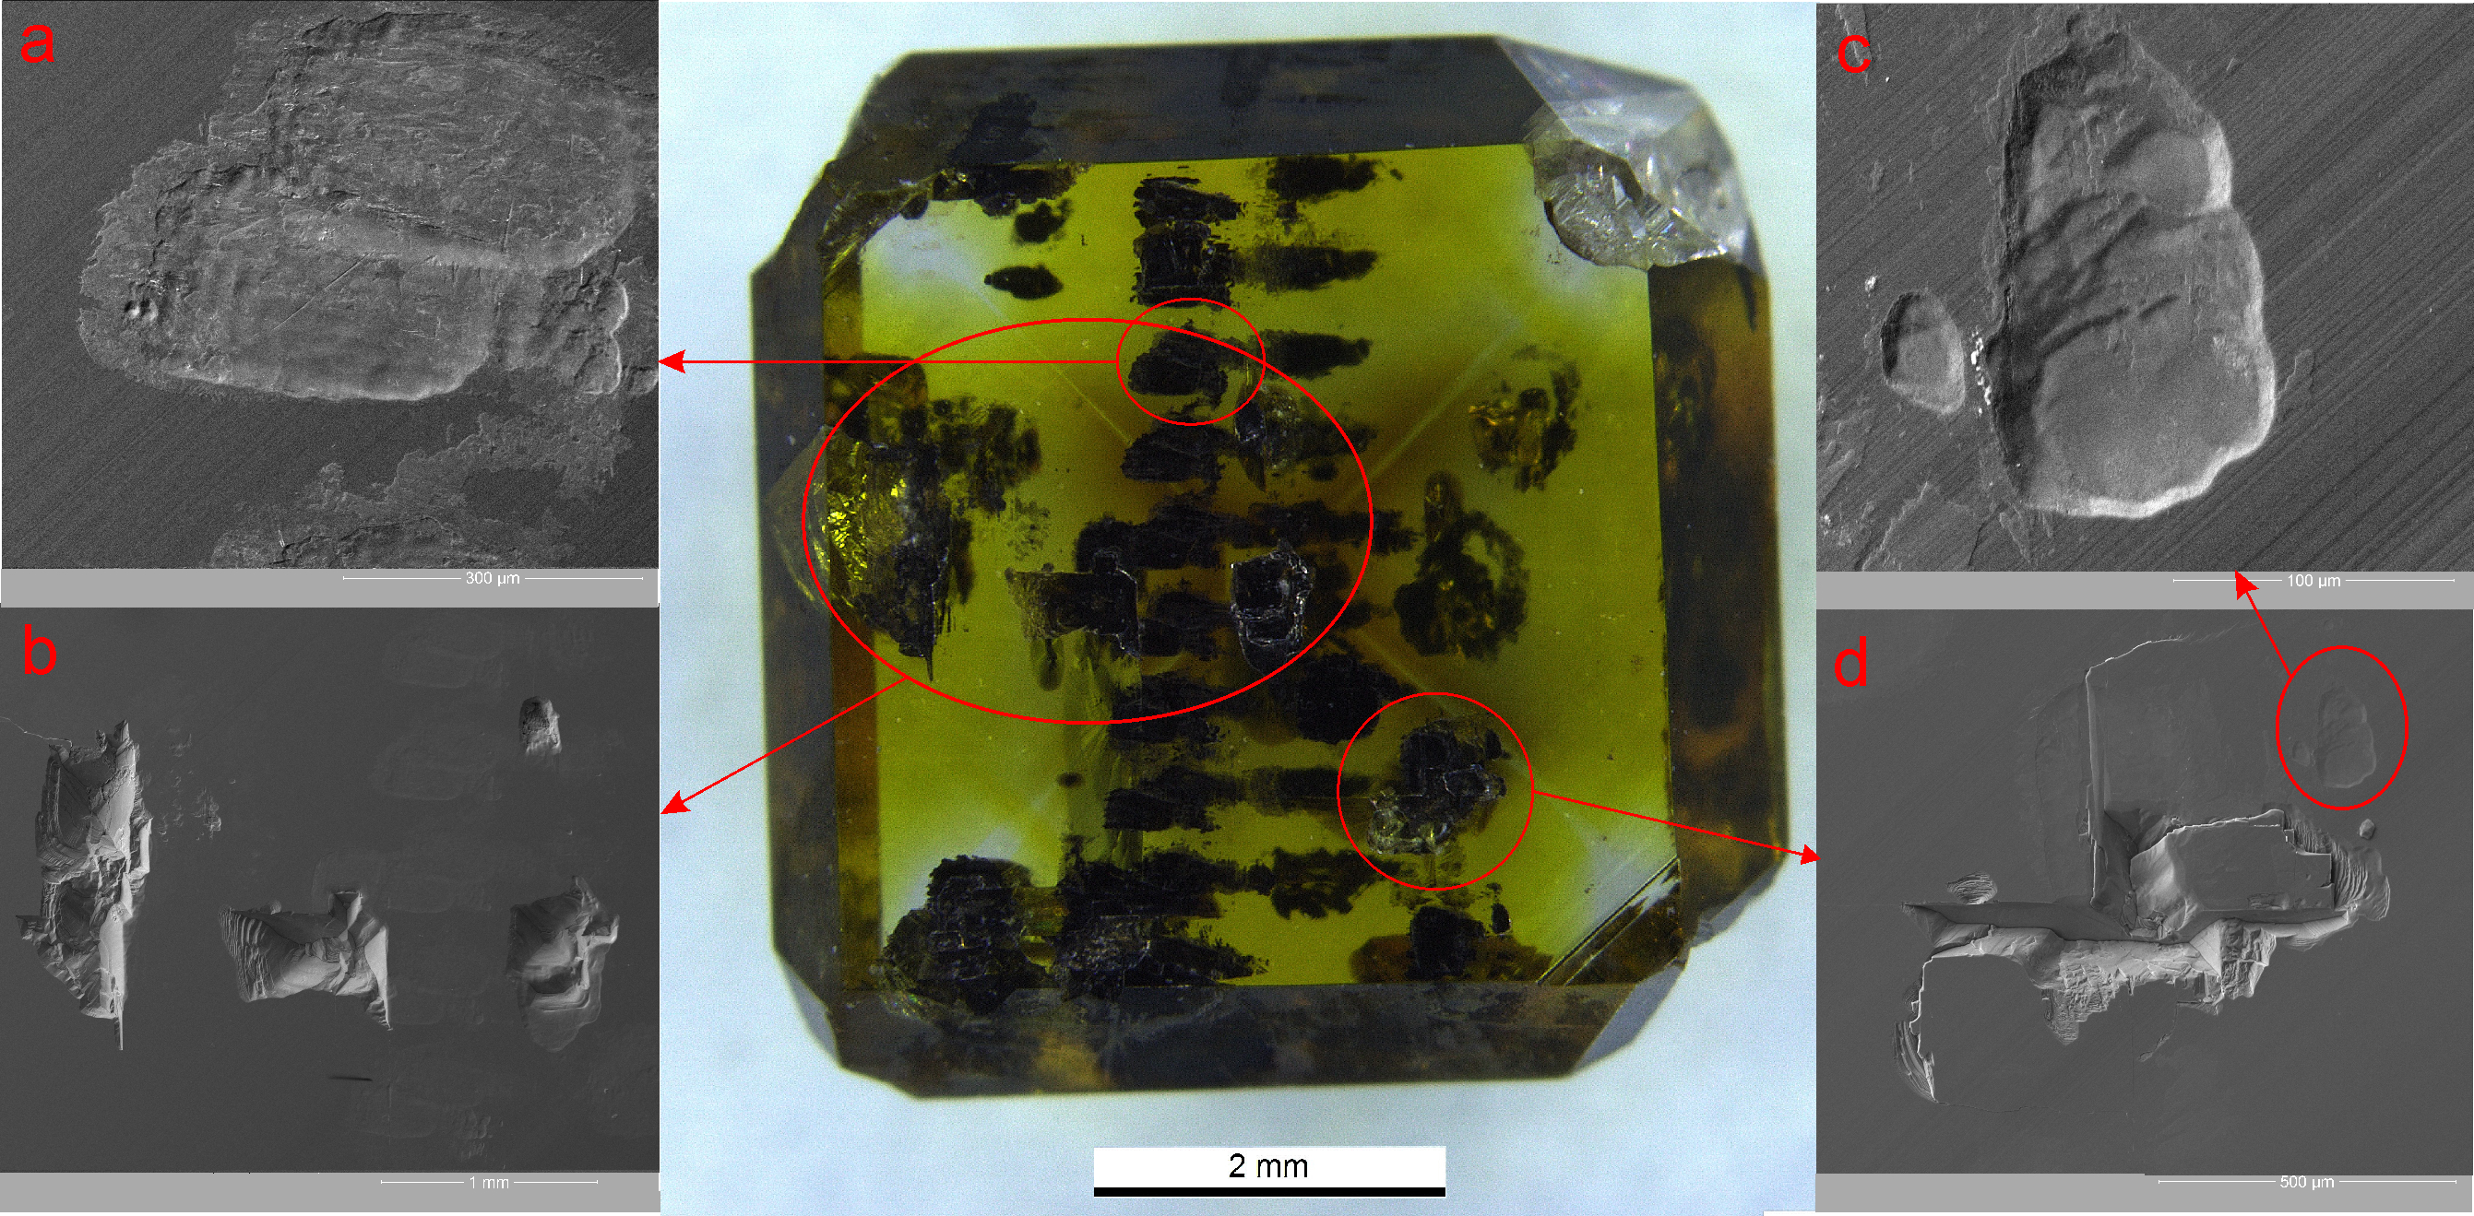
Figure 1. OM photo of type Ib HPHT [100] oriented plate and SEM images of laser craters on its surface: a) a double crater from a single beam passage "back and forth"; b) a single oval crater; c) quadrangular pyramidal depressions; d) polygonal depressions with divergent cracks

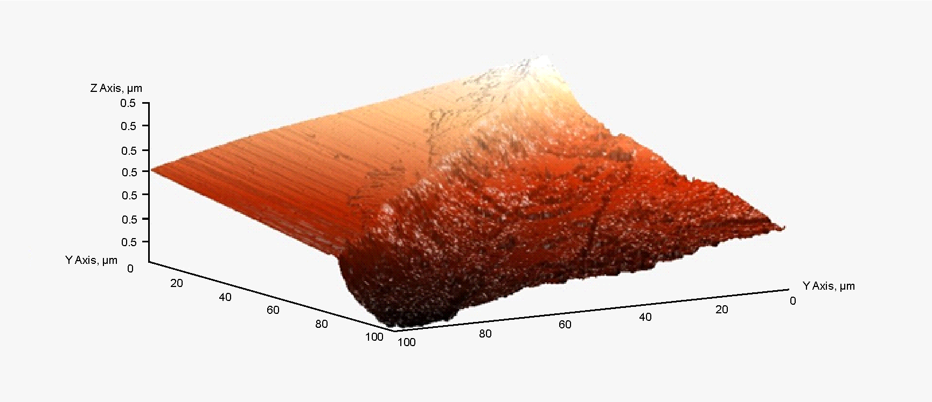
Figure 2. AFM image of oval crater boundary with polished surface of HPHT [100] oriented type Ib diamond plate.
HPHT [111] oriented type Ib diamond plate

The sample is represented by a cleavage-сut face {111} on the bottom (not shown in the picture), of a single crystal of HPHT type Ib diamond grown in the Fe-Co-C system. On the natural surface of the crystal (fig. 3), the hatching formed while the solidification of the catalyst metal melt is visible. The craters on the surface of the sample have an oval or triangular shape. Fig. 3a shows a crater formed by 30 laser pulses at one point. The surface of the crater, which is shown in Fig. 3a, has the shape of a triangle with sides approximately 1.4 mm. This surface is relatively uniform and flat-bottomed in the central part, contoured with a stepped relief. Inside a large triangular crater, a small oval crater is visible, probably formed as a result of a single pulse. Figure 3b shows an oval crater, the surface of which is complicated by small rounded depressions. The crater itself is much less deep than the craters on the [100] orientated plate. The size of the oval crater along the long axis is about 750 microns.
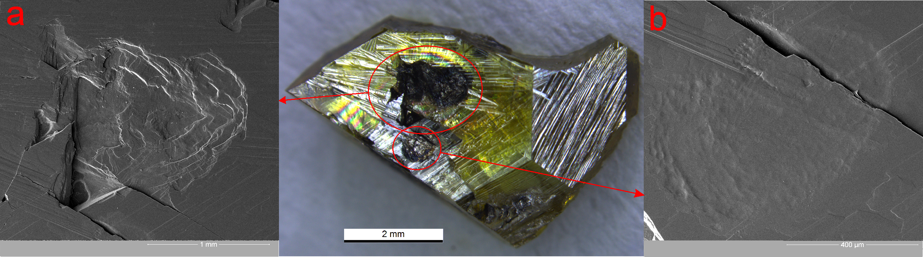
Figure 3. OM photo of HPHT [100] oriented type Ib diamond plate and SEM images of laser craters: a) huge flat - bottomed triangular crater, b) oval crater.

Discussion

Based on the data obtained, we conclude that the shape and depth of craters formed on diamond plates during interaction with laser radiation depends on several factors: 1) the radiation energy and the number of pulses per point; 2) the crystallographic orientation and the initial roughness of the surface of the diamond plate.

The influence of these factors is expressed in a change in the shape of the crater from oval to rectangular or triangular when a certain energy threshold is reached, at which chipping begins to occur in the "weak" direction in the diamond structure i.e., ‹111›. This is due to the largest interplane distances in the crystal lattice in this direction. In diamond, cleavage planes are located parallel to the faces of the octahedron {111} and form triangular-shaped structures. Thus, the craters on the faces of the octahedron {111} have the form of either flat-bottomed triangular or flat-bottomed with a "jagged" frame. Relative to the face of the cube {100}, the cleavage planes are arranged in the form of a quadrangular pyramid, which leads to the formation of craters of this shape (Fig. 1b). It is worth noting that the formation of chips is affected not only by the laser radiation energy, but also by the number of laser pulses, which makes the calculation of the moment of chip formation quite difficult and requires further research.
Conclusion

As a result of studying features of the effect of focused laser radiation on the surface of HPHT diamond plates, the following results obtained:

The shape of craters formed when focused laser radiation is applied to the diamond surface corresponds to the shape of the laser beam, which is oval in this case.

After exceeding a certain threshold of energy and/or number of pulses to a point, at place of formation of the crater, cleavage occurs in the ‹111› direction; the crater expands and begins to acquire a polygonal shape corresponding to the symmetry of the irradiated surface.

The morphology of a polygonal craters depends on the crystallographic orientation of the surface exposed to radiation: 1) on the cube {100} faces rectangular point- or line bottomed craters with smooth surface are formed; 2) on the octahedron {111} faces triangular flat-bottomed craters with step-like pattern are formed.

The work was carried out within the framework of the state assignment of the Ministry of Science and Higher Education of the Russian Federation (theme № FSFZ-2022-0006).
Bibliography list:

David W. Hahn and Nicol´o Omenetto. Laser-induced breakdown spectroscopy (libs), part i: Review of basic diagnostics and plasmaparticle interactions: Still-challenging issues within the analytical plasma community. volume 64. Society for Applied Spectroscopy, 2010. doi: 10.1366/000370210793561691Оптические системы с усилителями яркости / Под. ред. Г.Г. Петраша. – М.: Наука, 1991. – (Труды ФИАН, Т. 206) – 152 с.
- Rosalba Gaudiuso, Marcella Dell’Aglio, Olga de Pascale, Giorgio S. Senesi, and Alessandro de Giacomo. Laser induced breakdown spectroscopy for elemental analysis in environmental, cultural heritage and space applications: A review of methods and results, 8 2010. ISSN 14248220.
- Kristen A. Kochelek, Nancy J. McMillan, Catherine E. McManus, and David L. Daniel. Provenance determination of sapphires and rubies using laser-induced breakdown spectroscopy and multivariate analysis. American Mineralogist, 100:1921–1931, 8 2015. ISSN 19453027. doi: 10.2138/am-2015-5185
- Catherine E. McManus, Nancy J. McMillan, James Dowe, and Julie Bell. Diamonds certify themselves: Multivariate statistical provenance analysis. Minerals, 10:1–12, 10 2020. ISSN 2075163X. doi: 10.3390/min10100916.
- Evan M. Smith, Karen V. Smit, and Steven B. Shirey. Methods and challenges of establishing the geographic origin of diamonds. Gems and Gemology, 58:270–288, 9 2022. ISSN 0016626X. doi: 10.5741/GEMS.58.3.270.
- C. Koral, M. Dell’Aglio, R. Gaudiuso, R. Alrifai, M. Torelli, and A. De Giacomo. Nanoparticle-enhanced laser induced breakdown spectroscopy for the noninvasive analysis of transparent samples and gemstones. Talanta, 182:253–258, 5 2018. ISSN 00399140. doi: 10.1016/j.talanta.2018.02.001.
- V. F. Lebedev, D. V. Bulyga, and A. V. Koliadin. Analysis of the impurity composition of synthetic hpht diamonds by laser-induced breakdown spectroscopy under conditions of laser-induced surface modification. Technical Physics Letters, 46: 413–415, 5 2020. ISSN 10906533. doi: 10.1134/S1063785020050107
- Jianwen Cai, Xuetao Pan, Hongchun Yuan, Yafeng Zhang, Fei Meng, and Meifeng Zhang. Experimental study of diamond ablation based on femtosecond laser. Optik, 217, 9 2020. ISSN 00304026. doi: 10.1016/j.ijleo.2020.164838.
- Zhen Zhang, Quanli Zhang, Qiwen Wang, Honghua Su, Yucan Fu, and Jiuhua Xu. Investigation on the material removal behavior of single crystal diamond by infrared nanosecond pulsed laser ablation. Optics and Laser Technology, 126, 6 2020. ISSN 00303992. doi: 10.1016/j.optlastec.2020.106086.

