



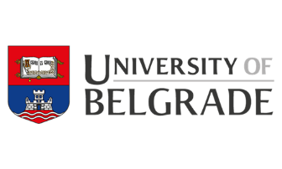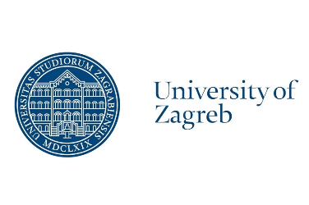

**CONFERENCE PROGRAMME**

**(Mis)Perceptions of the European Union in the Western Balkans**

**Integrating the Western Balkans into the European Union:**

**Perceptions, misperceptions, current challenges**

**Jean Monnet (ERASMUS+) Project -** **https://euperceptions.unipg.it/**

**University of Perugia/University of Belgrade/University of Zagreb**

**Belgrade, 7-8 April 2022**

**Aeroklub, Uzun Mirkova 4**

**DAY I. Thursday, 7 April**

**9,30:** Welcome addresses

Ivan Vujačić, University of Belgrade, President, Forum for International Relations, European Movement in Serbia

Nicola Bertolini, Head of Cooperation, European Union delegation to the Republic of Serbia

Sonja Licht, President, Foundation BFPE for a Responsible Society

***Session 1 (10 am - 11,30 am)***

Chair: Milica Uvalić (University of Perugia)

Milica Uvalić (University of Perugia): “Bridging the gap in European Union – Western Balkan perceptions”

Jovan Teokarević (Faculty of Political Sciences, University of Belgrade): “The Deterioration of the EU Image in the Western Balkans”

Will Bartlett (European Institute, London School of Economics): “How perceptions and misperceptions influence the allocation of European Overseas Development Assistance (ODA) to the Western Balkans”

**Discussion**

**Coffee break (11,30 am – 12 am)**

***Session 2 (12 am – 1,30 pm)***

Chair: Max Brändle (Friedrich Ebert Stiftung, Belgrade)

Stefano Bianchini (University of Bologna): “Yugoslav partition and Post-War EU integration: The role of Italy 1990-2022”

Gordana Đurović (Faculty of Economics, University of Montenegro): “The perception of the EU and its policies through European integration SWOT analysis: a view from Montenegro”

Ivan Vujačić (Faculty of Economics, University of Belgrade, former Ambassador to USA, 2002-2009): “The US in the Western Balkans – Reluctant, Late and Distant Involvement”

**Discussion**

**Lunch: 1, 30 – 3,00 pm**

***Session 3 (3,00 – 5,00 pm)***

Chair: Maria Giulia Amadio Viceré (European University Institute, Florence & Luiss University, Rome)

Dušan Reljić (SWP - German Institute for International and Security Affairs, Berlin/Brussels): “The endless perspective – Why EU enlargement in southeast Europe came to nothing”

Jelena Vasiljević (Institute for Philosophy and Social Theory, University of Belgrade), "Democratization from below? Lessons learnt from bottom-up civic initiatives in the Western Balkans"

Ditmir Bushati (Chairman of the Board, Adriatic Security Forum), “Security and EU integration challenges in the Western Balkans”

Matteo Bonomi (Institute of International Affairs, IAI, Rome): “EU political challenges in the Western Balkans”

**Discussion**

**DAY II. Friday, 8 April**

***Session 4 (10 am – 11,30 am)***

Chair: Jelica Minić (President, European Movement in Serbia)

Nedžma Džananović Miraščija (Faculty of Political Sciences, University of Sarajevo), “BiH and EU: Mission Impossible Franchise”

Gëzim Krasniqi (University of Edinburgh, UK), “Pro EU, no matter what: EU (mis)perceptions in Kosovo”

Renzo Daviddi (former EU official): “Moving BiH towards European Union membership: A daunting task”

**Discussion**

**Coffee break (11,30 am– 12 am)**

***Session 5 (12am – 1,30 pm)***

Chair: Srđan Majstorović (European Policy Centre - CEP, Belgrade)

Jelena Džankić (European University Institute, Florence): “Perceptions and misperceptions of EU conditionality in the Western Balkans: a case of a ‘capability-expectationsgap’”?

Vladimir Međak (European Movement in Serbia), “EU conditionality: Is it effective in Serbia?”

Simonida Kačarska (Director, European Policy Institute, Skopje): “Reinforcing or conflicting? Conditionality and political socialization in the EU accession process in the Republic of North Macedonia”

**Discussion**

**1,30 pm – 3,00 pm: Lunch**

***Session 6 (3,00 pm – 4,30 pm)***

Chair: Duško Lopandić (Forum for International Relations, European Movement in Serbia, former Ambassador to EU)

Aleksandra Krstić (Faculty of Political Sciences, University of Belgrade): “Love and hate relationship: media framing of the official political communication about the EU in Serbia’s media”

Dejan Jović (Faculty of Political Sciences, University of Zagreb): **"**From Western Balkans to EU (and back): Croatia's perceptions on Europe and the Balkans"

Srđan Bogosavljević (University of Belgrade): “The foggy future of the Balkans in or out of the EU”

**Discussion**

***End of conference***